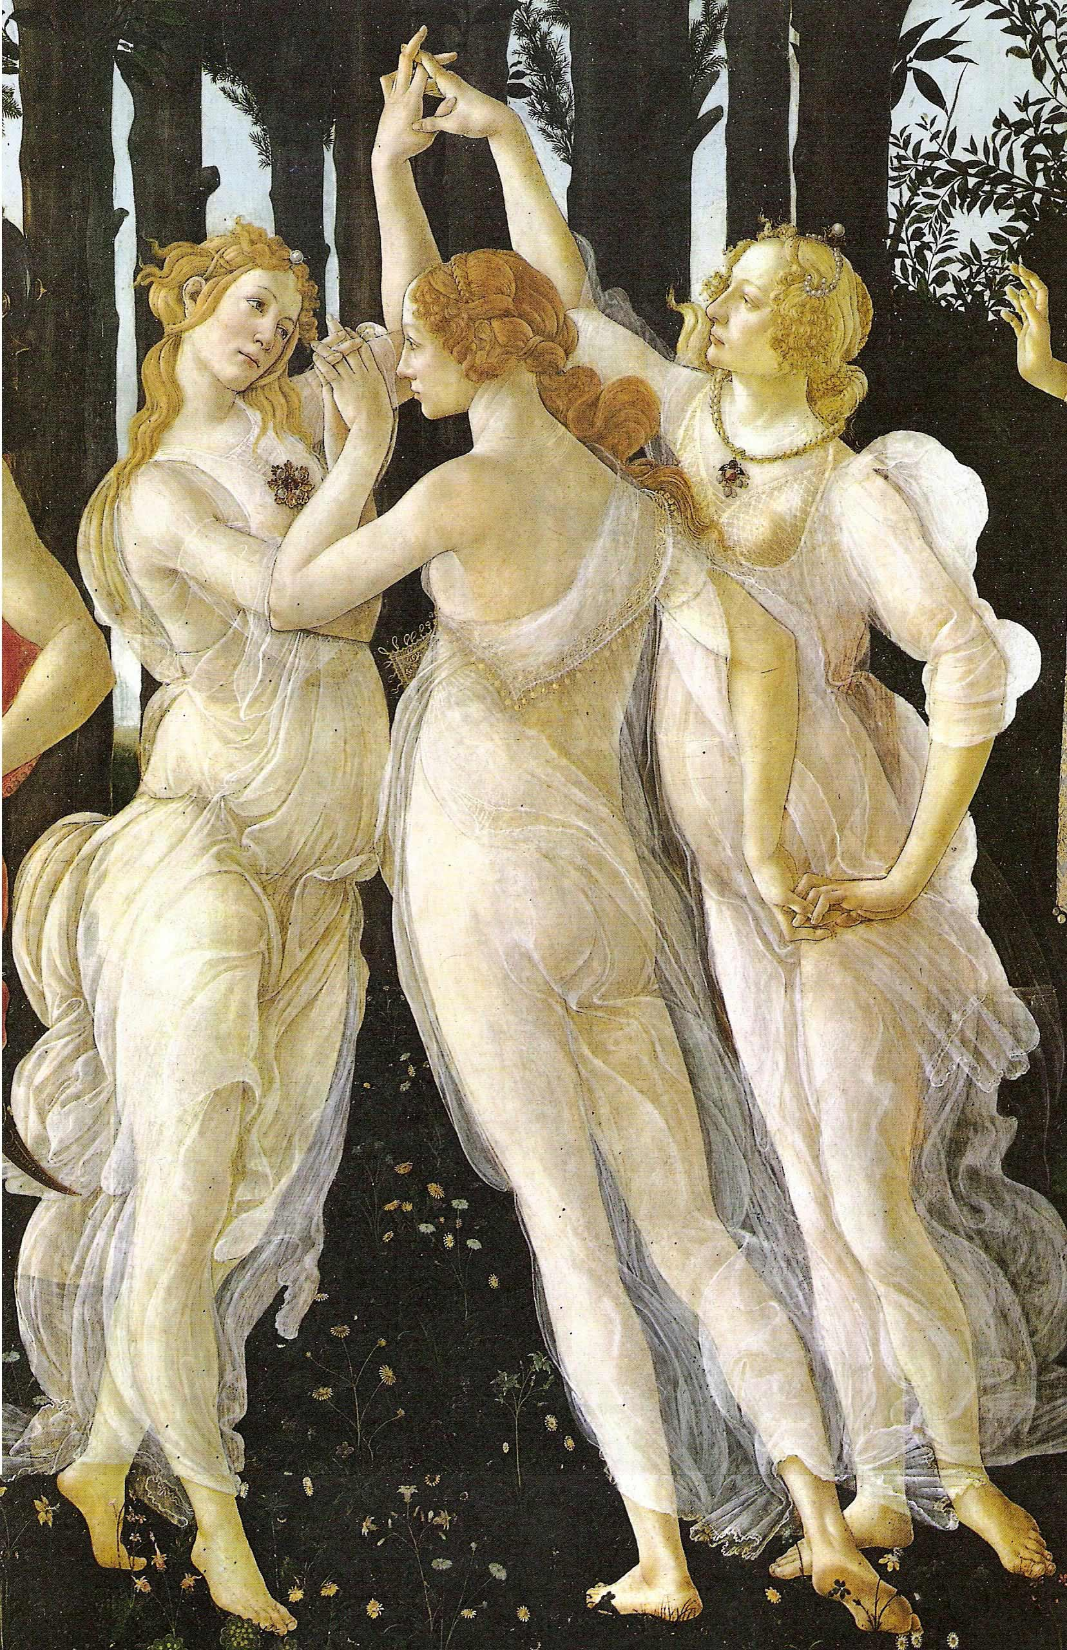
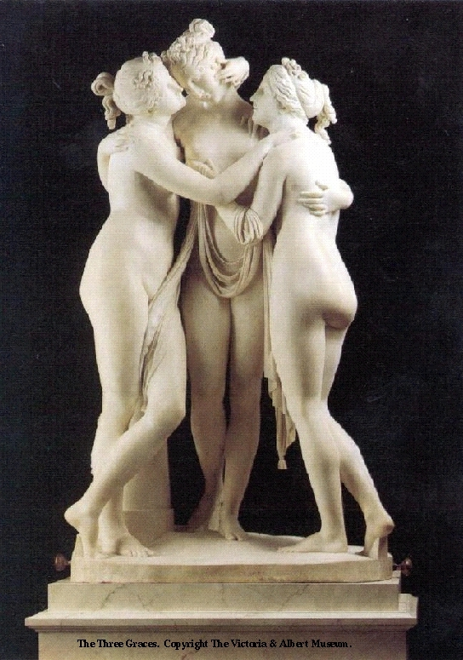
Date: 30/07/2026
To: The Italian Team! JMD YAS MMz RAH
From: HEM
Re: International Business week

CIAO BELLE!!

The provisional arrangement is for the following (JMD LPV MMz have experience of the programme):

Room, time, group | Mon | Tue | Weds
B27  0925-1030 5-8  1055-1200 13-16  1255-1400 21-24  1425 – 1530 29-32 | LPV + RAH + MMz  HEM floating | RAH + YAS first half /  RAH + MMz second half  HEM start off with this group, then float! | RAH + MMz  HEM start off with this group, then float!
B28  0925-1030 1-4  1055-1200 9-12  1255-1400 17-20  1425 – 1530 25-28 | JMD + YAS  HEM floating | JMD + MMz first half,  JMD + YAS second half  HEM floating | JMD + YAS  HEM floating

I enclose the provisional ‘pack’ for the Italian sessions + the key CD ROMs (Italian Expressions + Italian Essentials) which we use. I also attaching the evaluation which I put together last year.

New for this year are:
- a PowerPoint for you to use to present each stage via the data projector
- ‘Italian in no time’ – 3 audio cd roms of an audio file I have just bought from Audible.co.uk just in case anyone is keen enough to try out a three-hours listening experience. I listened to it in the car on a return trip to Bournemouth, and I thought it was quite good!
- ‘Rapid Italian’ Volume 1: another downloaded programme with music! (1 hour)
- TaskMagic listening exercise to help reinforce pronunciation of language for the video clip (personal introduction) + business intro and closure

I will provide all of the resources and will be coming around to all groups and will take the lead / support wherever needed! In true Italian style, my mobile will be on and with me at all times
____________________

Main way you can prepare yourselves for first session =
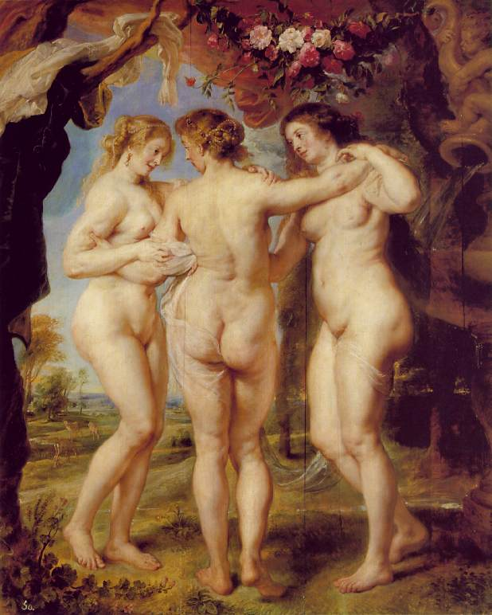
- FOR ORGANISATION: read through the Powerpoint + associated hand-outs
- FOR TECHNICAL EXPERTISE (!!): recognise the alphabet (below) + numbers 1-20. (on phrase sheets & using cd roms).

CDROMs should be quite self explanatory … click on item, click on flag to hear it, click on microphone to record yourself, click on loudspeaker to hear yourself, click in box to ‘clear’.

Enjoy yourselves!

Alphabet … all with stress on first bit
A | Ah
B | Bee
C | Chee
D | Dee
E | Aye
F | Effa
G | Gee
H | aka
I | Ee
J | ee-lunga
K | kapa
L | Ella
M | Emma
N | Enna
O | oh
P | pee
Q | Koo
R | erre
S | Essa
T | Tee
U | Oo
V | Vee
W | Vee-doppia
X | eecks
Y | eepsilon
z | tsata

