

ASSOCIATION FOR LANGUAGE LEARNING: LONDON REGION BRANCH
www.all-london.org.uk

All are invited to come along to:
The ALL London January Event 2010
on

Saturday January 23rd 2010 9.30 –1.00
to be held at
University of Westminster
www.westminster.ac.uk + www.linksintolanguages.ac.uk 309 Regent Street, London W1B 2UW
(2 mins from Oxford Circus, 'Turn right at Top Shop!')
and afterwards to the
Annual General Meeting (free) 1.00 – 1.30
Provisional Outline Programme:
9.30 | Registration & tea/coffee and biscuits – the committee will be there to welcome you!
9.55- 10.15 | Plenary– Helen Myers, Chair of ALL London. Welcome & Introductions incl committee members, University / Links staff, and sponsors
10.20- 11.10 | 'Outstanding lessons and flashes of brilliance' Sara Sullivan - Well known AST, SSAT Lead Practitioner and Head of the extremely successful languages' department of Woodlands School (Performing Arts College), Essex, Sara will share with us some of her ideas for raising achievement amongst learners, and - incidentally - impressing inspectors!!.  OR  Which course should I choose for my students? Alternatives to GCSE and A level. Gill Beckett With special responsibility for 14-19 CILT, Gill has an outstanding knowledge of courses available, and a great way of sharing it. She will present an overview before taking individual questions about the new courses. (Repeat of CILT 14-19 session] [OR BBC talk – see below]
11.15 -11.45 | Comfort break / top-up of coffee / chance to ‘network’ / view info sent from corporate members including CILT. Thanks to 'The Ardmore Group' www.theardmoregroup.com and 'Sanako' www.sanako.co.uk, sponsors of this event!
11.50 -12.40 | "Launch - Create - Celebrate" - a project-based approach to the New Secondary Curriculum Vincent Everett- HOD at Northgate High School, author and frequent contributor of good sense and fantastic teaching ideas to ALL conferences and electronic fora talks about how he has transformed his curriculum. We've been asking him for ages to present and are delighted he can at last make it!  OR  'What can the BBC offer you?' Johann Le Calvez an enthusiastic and engaging member of the BBC web team will give an overview of the BBC's treasures for language teachers. [OR Gill’s talk]
12.40 | Round-up – Branch notices / ALL events / issue of INSET certificates
1.00 – | Job Application Clinic for PGCE Students. 'What are schools looking for?'
1.30 | OR  Annual General Meeting - Chaired by Helen Myers 1. Election /confirmation of committee members; 2. Reports from the Chair, Secretary, Treasurer, Languages Committees (Community, French, German, IT, Italian, Spanish); 3. Response to issues raised by Management Board; 4. Issues to be raised with the Management Board (please give advance notice of issues you wish to raise in writing before the event if possible); 5. AOB to be decided!
& next? | Oxford Street. Sales. Need we say more?!! OR 1.45 – 2.30 a repeat of the CILT 14-19 session Helen Myers gave on ‘The Challenges of Controlled assessment’ – an overview of issues and ambiguities in the new GCSE specifications and some practical suggestions for tackling them.
£5 – students - £10 – members (incl retired) and associate members (or people who join on the day),
£15 – group members, £25 – non-members; FREE to University of Westminster students.

As refreshments will be provided, it would be very helpful to know how many people are intending to attend. Please send or email the application form below to Kathleen Merino, by Friday January 15th; otherwise send an email with the information to her.
PLEASE NOTE: To cut down costs and administration time, we won’t send confirmation unless you particularly ask for it... if you have paid, assume you have a place unless you hear otherwise!
If you need any more information please ask. Thanks.

Application Form

To: Mrs Kathleen Merino, 11 Tavistock Road, Edgware, HA8 6DF
OR, if no time to send form, email info to her: kathleen.merino@btinternet.com
Urgent queries: contact Helen Myers via Ashcombe school, 01306 886312
London January Event (+ AGM) ; Saturday 23rd January '10, 0930 -1300, (+ 1.00-1.30) University of Westminster
Name
Establishment
Work Telephone Number
Home Address

Home Telephone Number
E-mail
How did you hear about this event?

£25 – non-members, (why not join on the day and get £15 refunded?!) £15 – group members,
£10 – members and associate members (NB ALL offers Students and NQTs Associate Membership for free! Fill in the online form here:http://www.all-languages.org.uk/associate_membership_form.asp ) £5 - students

*Please delete as appropriate.

I enclose cheque (payable to ALL-LRB) to the value of £__________ as payment for (No.)_________ persons as listed below (BLOCK CAPITALS please):

Name ________________________________________ Member/Group member / Non-Member /Associate member*
Preferred Sessions (put in order 1/2/3) :Sara Sullivan: ___ Gill Beckett: ____ Vincent Everett: ______Johann Le Calvez _____ Helen Myers**_

Name ________________________________________ Member/Group member / Non-Member /Associate member*
Preferred Sessions (put in order 1/2/3) :Sara Sullivan: ___ Gill Beckett: ____ Vincent Everett: ______Johann Le Calvez _____ Helen Myers **_

Name ________________________________________ Member/Group member / Non-Member /Associate member*
Preferred Sessions (put in order 1/2/3) :Sara Sullivan: ____ Gill Beckett: ___ Vincent Everett: ______Johann Le Calvez ______Helen Myers**_

**= tick if you’d like to attend Helen’s session.

MEMBERS + GROUP MEMBERS (but observers welcome!): AGM 1.00 – 1.30(free)
* I would like to offer to join the committee. Please contact me to discuss what this involves.
* These are issues which I would like to raise: (continue overleaf if necessary)
Please note that we deliberately keep down the cost of courses by subsidising them from ALL funds: we feel that members ought to receive value for the money paid in subscription fees to the Association. Fees charged do not, in any way, reflect the quality of courses offered! NQTs and PGCE students: Consider joining as an Associate Member!
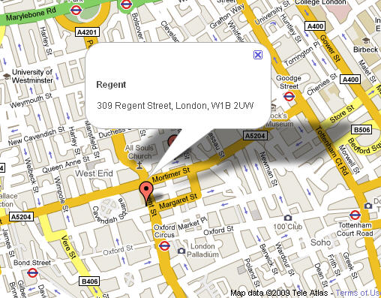
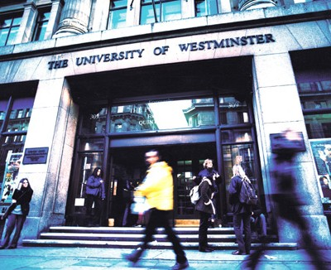
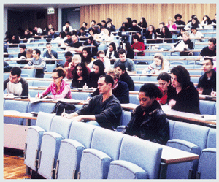
Regent
309 Regent Street, London W1B 2UW
Oxford Circus underground tube station:

From King's Cross/St Pancras,
- Victoria line southbound towards Brixton (Approx 11 minutes)

From Waterloo:
- Bakerloo line northbound towards Harrow.
(Approx 7 minutes)

From Victoria:
- Victoria Line towards Walthamstow /Seven Sisters
- (Approx 5 minutes)

Directions: University of Westminster, 309 Regent Street, London W1B 2UW, UK: www.westminster.ac.uk
Plan your journey by visiting www.tfl.gov.uk/journeyplanner or call 0207 222 1234 for up-to-date travel news

