

ASSOCIATION FOR LANGUAGE LEARNING: LONDON REGION BRANCH
www.all-london.org.uk

All are invited to come along to:
The ALL London January Event 2011
on

Saturday January 22nd 2011 9.30 –1.00
and afterwards to the
Annual General Meeting (free) 1.00 – 1.30
Venue: Portland Hall, Little Titchfield Site, University of Westminster London W1W 7UW
Provisional Outline Programme:
9.30 | Registration & tea/coffee and pastries – the committee will be there to welcome you!
9.55- 10.15 | Plenary– Helen Myers, Chair of ALL London. Welcome & Introductions incl committee members, University / Links staff, and sponsors
10.20- 11.10 | ‘Raising Achievement Sky High in MFL - 20 top tips’ Sara Sullivan - Well known AST MFL and Assistant Head Teacher in charge of Teaching and Learning at the Woodlands School (Performing Arts College), Essex, will share with us some of her ideas for raising achievement amongst learners. Guaranteed to enthuse everyone!  OR  'What can the BBC offer you?' Oonagh Jaquest, Editor of BBC Languages will give an overview of BBC resources for language teachers and a preview of some new initiatives, including learner profiling tools and a brand new course for 2011.
11.15 -11.45 | Comfort break / top-up of coffee / chance to ‘network’ / view info sent from corporate members, speakers, the European Commission (loads of freebies!) and Language Institutes. Sponsored by Vocabexpress and Sanako.
11.50 -12.40 | Wendy Adeniji talks from great experience about How ICT Tools can support Innovative Curriculum Design. Wendy is a teacher and trainer, specialising in the use of ICT in MFL teaching. We welcome her back after her very popular sessions in the past  OR  'What can the BBC offer you?' repeat of session above
12.40 | Round-up – Branch notices / ALL events / issue of INSET certificates
1.00 – | Job Application Clinic for PGCE Students. 'What are schools looking for?'
1.30 | OR  Annual General Meeting - Chaired by Helen Myers 1. Election /confirmation of committee members; 2. Reports from the Chair, Secretary, Treasurer, Languages Committees (Community, French, German, IT, Italian, Spanish); 3. Response to issues raised by Management Board; 4. Issues to be raised with the Management Board (please give advance notice of issues you wish to raise in writing before the event if possible); 5. AOB to be decided!
& next? | Explore London and catch the last of the sales!
FREE to ALL student associate members; £5 – non-associate students; £10 – members (incl retired) and associate members (or people who join on the day),
£15 – group members, £25 – non-members;.

As refreshments will be provided, it would be very helpful to know how many people are intending to attend. Please send or email the application form below to Sarah Bowley, by Friday January 14th; otherwise send an email with the information to her.
PLEASE NOTE: To cut down costs and administration time, we won’t send confirmation unless you particularly ask for it... if you have paid, assume you have a place unless you hear otherwise!
If you need any more information please ask. Thanks.

Application Form

To: Mrs Sarah Bowley, The Ashcombe School, Dorking, RH4 1LY Urgent queries: 01306 886312
OR, if no time to send form, email info to her: info@ashcombe.surrey.sch.uk
London January Event (+ AGM) ; Saturday 22nd January '11, 0930 -1300, (+ 1.00-1.30) University of Westminster
Name
Establishment
Work Telephone Number
Home Address

Home Telephone Number
E-mail
How did you hear about this event?

£25 – non-members, (why not join on the day and get £15 refunded?!) £15 – group members,
£10 – members and associate members (Fill in the online forms to join here: here: http://www.all-languages.org.uk/join/join_us/ ) £5 – students; Free: associate students

*Please delete as appropriate.

I enclose cheque (payable to ALL-LRB) to the value of £__________ as payment for (No.)_________ persons as listed below (BLOCK CAPITALS please):

Name ________________________________________ Member/Group member / Non-Member /Associate member*

Name ________________________________________ Member/Group member / Non-Member /Associate member*

Name ________________________________________ Member/Group member / Non-Member /Associate member*

MEMBERS + GROUP MEMBERS (but observers welcome!): AGM 1.00 – 1.30(free)
* I would like to offer to join the committee. Please contact me to discuss what this involves.
* These are issues which I would like to raise: (continue overleaf if necessary)
Please note that we deliberately keep down the cost of courses by subsidising them from ALL funds: we feel that members ought to receive value for the money paid in subscription fees to the Association. Fees charged do not, in any way, reflect the quality of courses offered! NQTs and PGCE students: Consider joining as an Associate Member
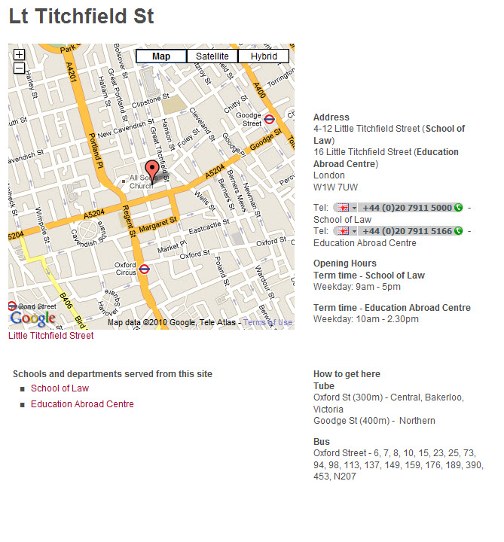
Map / directions http://www.westminster.ac.uk/about/how-to-find-us/lt-titchfield-st

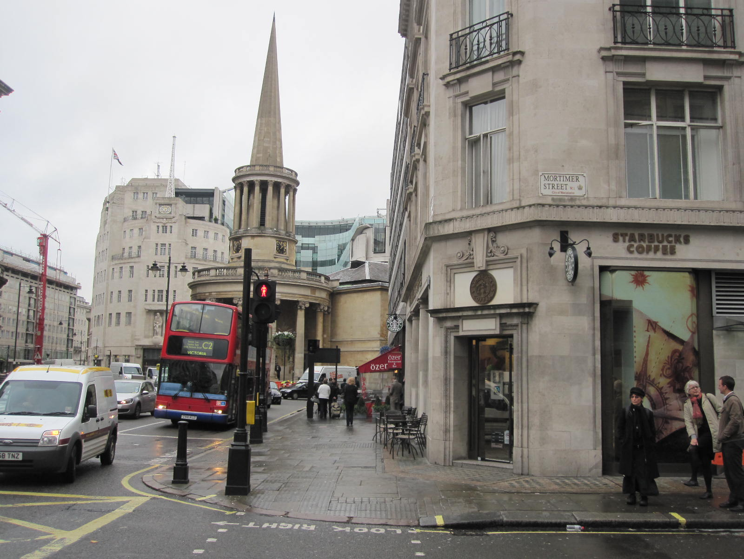
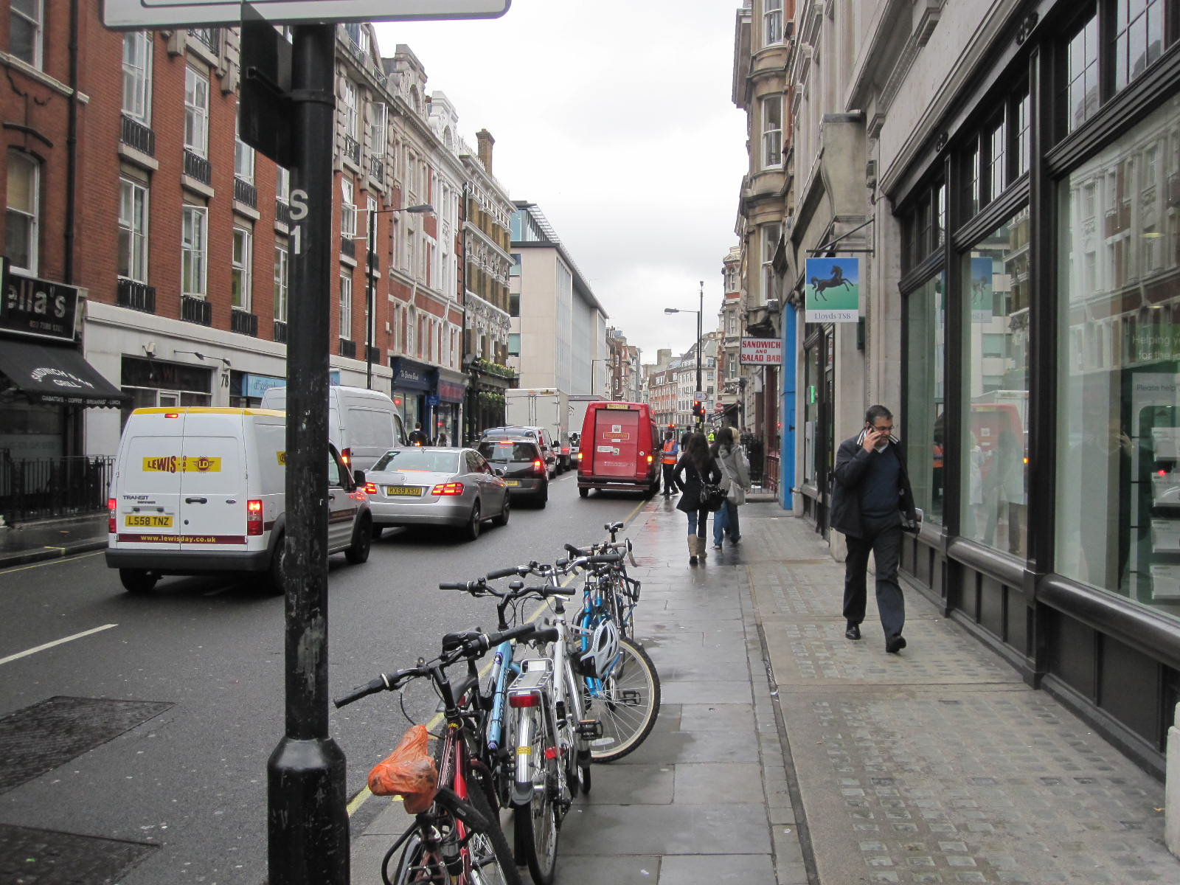
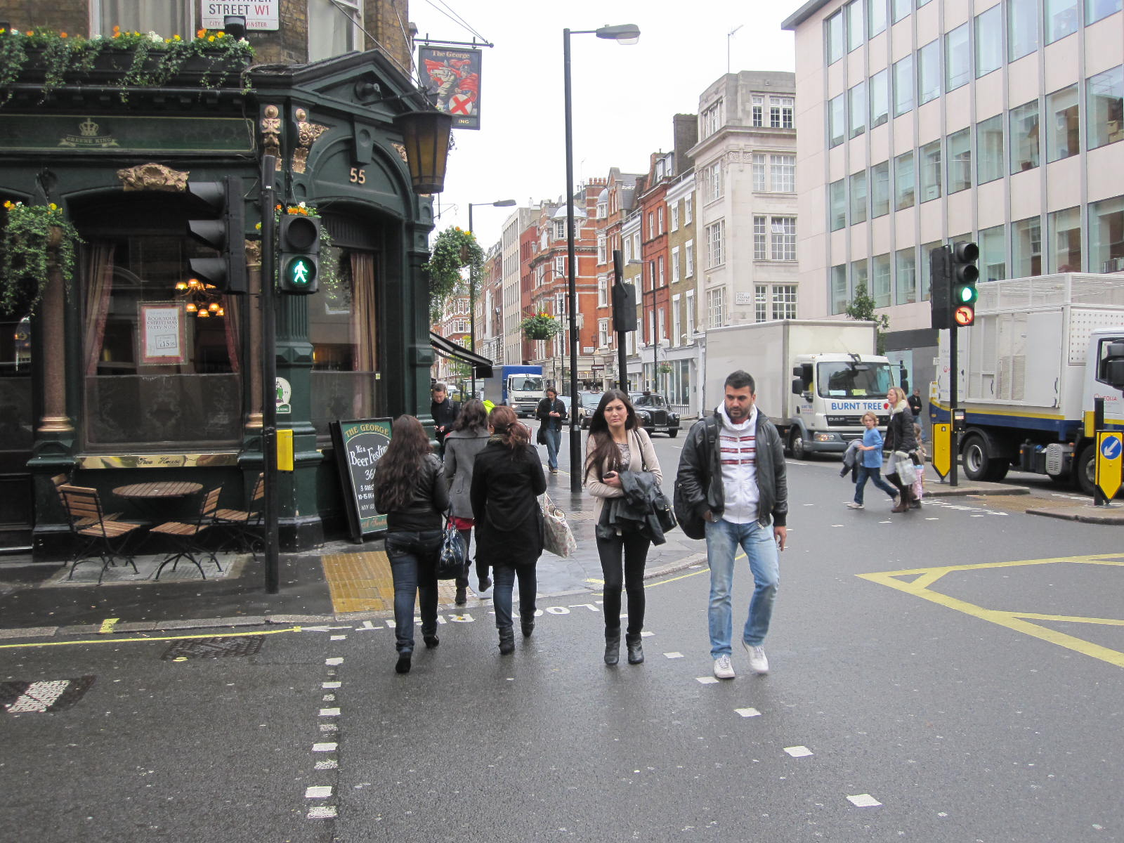
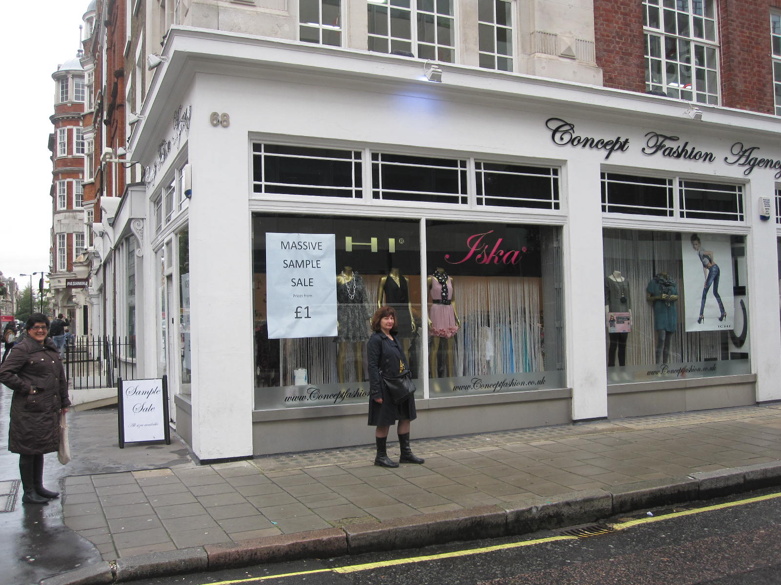

From Oxford Circus:
1 Walk up Regent Street towards All Souls Church in the distance
(Top Shop on your right)
2. Turn right into Mortimer Street and walk down
3. Turn left into Great Portland Street
4. Turn right into Little Titchfield Street, and
5. the university building is on your left.

1
2
3
4
5

