 | ASSOCIATION FOR LANGUAGE LEARNING  LONDON REGION BRANCH  www.all-london.org.uk

 | You are invited to  The ALL London June Event  on
Saturday June 16th 2012, 9.30 until whenever you like!
to be held at
[check all-london.org.uk website for exact location nearer the time! It will be in London!]
FREE SNACKS FOR THOSE WHO BOOK IN ADVANCE

Provisional Outline Programme

9.30 | Registration & tea/coffee and biscuits – the committee will be there to welcome you!  Exhibition opens (Our corporate sponsors have contributed to the cost of this event - thank you!)
10.00 | Plenary–  Helen Myers, Chair of ALL London. Welcome & Introductions & invitation to future ‘webinars’ in our dedicated Adobe room Hosts and sponsor welcomes
10.15- 11.05 | ‘Sowing Seeds for Spontaneous Speaking’ – James Stubbs, http://www.jamesstubbslanguages.co.uk/#  Teacher and trainer for MFL teachers, will talk about the methods he uses to get learners really talking naturally in the target language from their very first lessons. People still talk about the wonderful session James did 2 years ago: we just had to have him back! Guaranteed to keep you spellbound!
11.05 -11.25 | EXHIBITION + comfort break / top-up of coffee / chance to ‘network’ / view info sent from corporate members including the European Commission.
11.30-12.20 | 'The myth of multi-tasking and the force of focus'Jeremy Harmer, http://jeremyharmer.wordpress.com/ Internationally renowned writer and teacher/teacher-trainer for English to speakers of other languages. We are absolutely delighted that Jeremy has accepted our invitation to speak to us and know that his session about how to focus student attention will inspire teachers of any language. We especially hope to attract and meet up with colleagues and friends from the TESOL community.
12.20 – 12.50 | EXHIBITION + SNACKS – more chances to ‘network’!
12.50-1.40 | 'Keeping the plates spinning’ ‘Rachel Hawkes, http://www.rachelhawkes.com/ ALL network coordinator for South Cambridgeshire and Assistant Head, Comberton College Teachers need something of the 'acrobatic' about them to press all the right buttons with students. Not every idea needs to be rocket science, but it's the right combination of tasks at the right time for the right students that creates an effective combination for learning. This session will combine ideas old and new to help us. We so admire Rachel for the wealth of ideas and energy she has, and really look forward to hearing her once more!
1.45 – 3.30 | Language Specific get-togethers and ‘Show and Tell’ for the rest! Organised by ALL Language Committees. (Including: World languages – Steven Fawkes; Russian – Kathleen Riddell, Shirley Kliment-Temple, Spanish)
& next? | Why not take advantage of this venue to visit Somerset House or engage in some retail therapy in The West End? [Your family could go to the Trooping of the Colour during the morning. http://www.trooping-the-colour.co.uk/calendar.htm]

Refreshments throughout the day generously provided by our ALL Corporate Sponsors including: Vocab Express, Sanako, Network for Languages
☺ COME ALONE, OR BRING YOUR ‘TEAM’ ... YOU WILL ALL BE WELCOME! ☺
REGISTRATION FORM
Please send in the application form below along with payment by Tuesday 12th June 2012 to secure you a definite place and a free snack token.
You can turn up on the day, but we prefer to know in advance if at all possible to help with catering. It it is ESSENTIAL to PAY in advance if you would like free snacks.

PLEASE NOTE: To cut down costs and administration time, (as ALL London is run by volunteers) we won’t send confirmation unless you particularly ask for it... assume you have a place if you have paid unless you hear otherwise! If you need any more information please ask. Thanks.

Application Form

To: Mrs Sarah Bowley, The Ashcombe School, Ashcombe Road, Surrey RH4 1LY
OR, if no time to send form, email info to her: langcoll@ashcombe.surrey.sch.uk
London ALL June Event; Saturday 16th June 2012, Venue
Name
Establishment
Work Telephone Number
Home Address

Home Telephone Number
E-mail
How did you hear about this event?

£25 – non-members, (why not join on the day and get £15 refunded?!) £15 – group members,
£10 – members,& students £5 – student members

Lunch MUST be booked in advance and will only be provided free if payment for the event has been made by 12th June.

I enclose cheque (payable to ALL-LRB) to the value of £__________ as payment for (No.)_________ persons as listed below (BLOCK CAPITALS please):

Name _____________________student/Student Member/Member/Group / Non-Member / with lunch /no lunch/attending afternoon

Name _____________________student/Student Member/Member/Group / Non-Member / with lunch /no lunch/attending afternoon

Name _____________________student/Student Member/Member/Group / Non-Member / with lunch /no lunch/attending afternoon

Name _____________________student/Student Member/Member/Group / Non-Member / with lunch /no lunch/attending afternoon

Please tick this box if you do NOT wish your details to be passed on to the national ALL office □

Please note that we deliberately keep down the cost of courses by subsidising them from ALL funds: we feel that members ought to receive value for the money paid in subscription fees to the Association. Fees charged do not, in any way, reflect the quality of courses offered! NQTs and PGCE students: Consider joining to save your pennies (& pounds) / euros (?) later!

Travel directions web link:
xxxxxx

The ALL London January Event
June 16th 2012 9.30 onwards

Directions to Room D602, Clement House, London School of Economics
Nearest tubes – Holborn, Temple, Charing Cross,

LSE, Houghton Street, London WC2A 2AE, England UK ,
Tel: +44 (0) 20 7405 7686

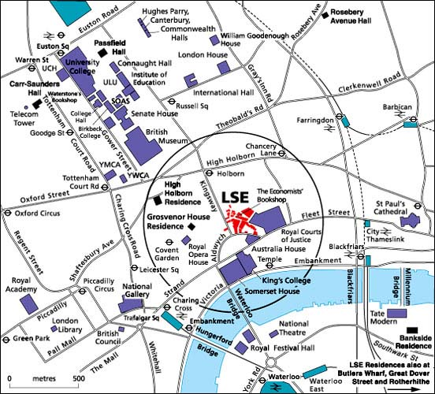

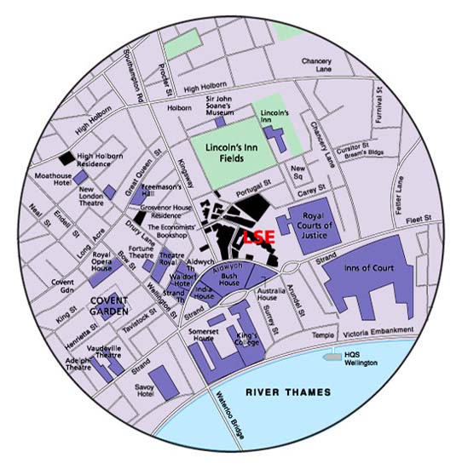

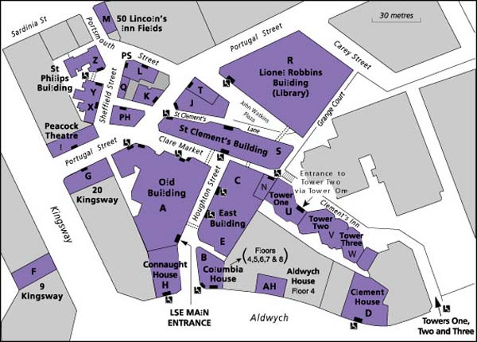
Clement House
Sixth Floor
D602

(Has disabled access + lifts)

