
.

ASSOCIATION FOR LANGUAGE LEARNING: LONDON REGION BRANCH
www.all-london.org.uk

All are invited to come along to:
The ALL London January Event 2013
on
Saturday January 19th 2013 9.30 –1.00

and afterwards to the
Annual General Meeting (free) 1.00 – 1.30
Venue: Brunei Suite, Russell Square Campus, SOAS
School of African and Oriental Studies, University of London, Thornhaugh Street, Russell Square, London, WC1H 0XG, Tel +44 (0) 2076372388 www.soas.ac.uk
visit tfl.gov.uk for travel directions or http://www.soas.ac.uk/visitors/location/travel/
Tube: Russell Square (Piccadilly Line) – approx 5 minute walk; Buses: 7, 68, 91, 168 and 188 stop on Russell Square; 10, 24, 29, 73 and 134 stop on Tottenham Court Road (north bound) or Gower Street (south bound).

Provisional Outline Programme – Check www.all-london.org.uk for up-dates:
9.30 | Registration & tea/coffee and biscuits – the committee will be there to welcome you!
9.55- 10.00 | Plenary– Helen Myers, Chair of ALL London. Welcome & Introductions incl committee members, SOAS staff, and sponsors
10.00- 1045 | ‘The value of languages’ 2 talks to remind us why we do it all!  (1) Renata Albuquerque - works for Routes into languages, aiming to get more students to study languages at a higher level and  (2) Flight Sgt Paul Hughes- (winner of Linguascope ‘Language Personality 2011’) who comes highly recommended by our committee who have heard him enthuse about how languages can be used in ‘the real world’.
10.50 – 11.35 | ‘Bringing languages to life’ Liz Black, experienced teacher and trainer, an AST at Stokesley school talks about her latest ideas for keeping all types of learners engaged and motivated through interesting contexts. Very well known as an excellent speaker ‘with her feet on the ground’, we are delighted that Liz is coming south to speak to us !
11.40 – 12.05 | Comfort break / top-up of coffee / chance to ‘network’ / view info sent from corporate members, speakers, the European Commission (loads of freebies!), Language Institutes and our sponsors.
12.10 –  1.00 | ‘Active Language Learning’ We welcome back Juliet Park, Director MFL for Yewlands family of schools, renowned trainer, author and former Lead Practitioner. Techniques for developing the micro-skills in listening, speaking, reading and writing as well as boosting literacy skills such as speed reading, correction coding and language analysis. The activities demonstrate active learning and tick the boxes regarding the new OFSTED framework.
1.00  –  1.30 | Job Application Clinic for PGCE Students. 'What are schools looking for?' with Nick Mair, Dulwich College. A ‘Must’ for trainee teachers preparing CVs, applications and interviews.
OR
Annual General Meeting - Chaired by Helen Myers 1. Election /confirmation of committee members; 2. Reports from the Chair, Secretary, Treasurer, Languages Committees (Community, French, German, IT, Italian, Spanish); 3. Response to issues raised by Management Board; 4. Issues to be raised with the Management Board (please give advance notice of issues you wish to raise in writing before the event if possible); 5. AOB to be decided!
& next? | Visit the British Museum, explore London and catch the last of the sales!
FREE to students who are members of ALL; £5 – non-member students; £10 – members (incl retired) or people who join on the day), £15 – group members, £25 – non-members

As refreshments will be provided, it would be very helpful to know how many people are intending to attend. Please send or email the application form below to Sarah Bowley, by Friday January 11th; otherwise send an email with the information to her.
PLEASE NOTE: To cut down costs and administration time, we won’t send confirmation unless you particularly ask for it... if you have paid, assume you have a place unless you hear otherwise!
If you need any more information please ask. Thanks.

Application Form

To: Mrs Sarah Bowley, The Ashcombe School, Dorking, RH4 1LY Urgent queries: 01306 886312
OR, if no time to send form, email info to her: info@ashcombe.surrey.sch.uk
London January Event (+ AGM) ; Saturday 19th January '13, 0930 -1300, (+ 1.00-1.30) SOAS
Name
Establishment
Work Telephone Number
Home Address

Home Telephone Number
E-mail
How did you hear about this event?

£25 – non-members, (why not join on the day and get £15 refunded?!) £15 – group members,
£10 – members and students who are not members £5 – students; Free: Student members. Follow this link to join beforehand: http://www.all-languages.org.uk/join/join_us

*Please delete as appropriate.

I enclose cheque (payable to ALL-LRB) to the value of £__________ as payment for (No.)_________ persons as listed below (BLOCK CAPITALS please):

Name _________________________________ Member/Group member / Student Non-Member /Student member *

Name _________________________________ Member/Group member / Student Non-Member /Student member *

Name _________________________________ Member/Group member / Student Non-Member /Student member *

Name _________________________________ Member/Group member / Student Non-Member /Student member *

MEMBERS + GROUP MEMBERS (but observers welcome!): AGM 1.00 – 1.30(free)
* I would like to offer to join the committee. Please contact me to discuss what this involves.
* These are issues which I would like to raise: (continue overleaf if necessary)
Please note that we deliberately keep down the cost of courses by subsidising them from ALL funds: we feel that members ought to receive value for the money paid in subscription fees to the Association. Fees charged do not, in any way, reflect the quality of courses offered!
Travel directions web link:
http://www.soas.ac.uk/visitors/location/travel/

The ALL London January Event
January 19th 2013 9.30 onwards

Venue: Brunei Suite, Russell Square Campus, SOAS
School of African and Oriental Studies, University of London, Thornhaugh Street, Russell Square, London, WC1H 0XG, Tel +44 (0) 2076372388
www.soas.ac.uk
visit tfl.gov.uk for travel directions or http://www.soas.ac.uk/visitors/location/travel/

Tube: Russell Square (Piccadilly Line) – approx 5 minute walk; Buses: 7, 68, 91, 168 and 188 stop on Russell Square; 10, 24, 29, 73 and 134 stop on Tottenham Court Road (north bound) or Gower Street (south bound)

We would advise you not to come by private car: parking spaces are scarce and expensive in this area of London.
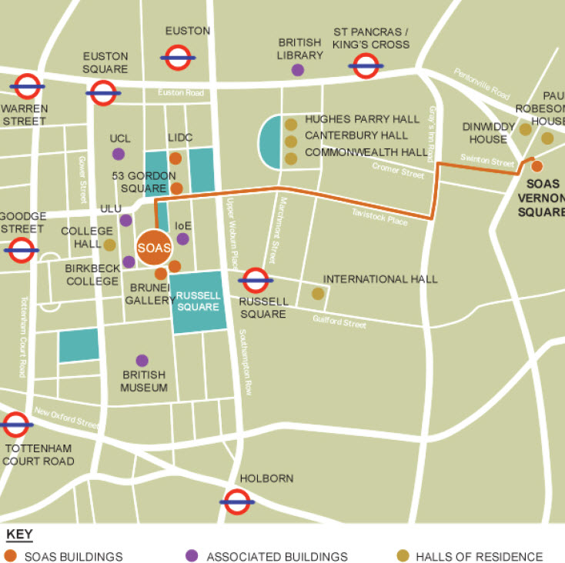
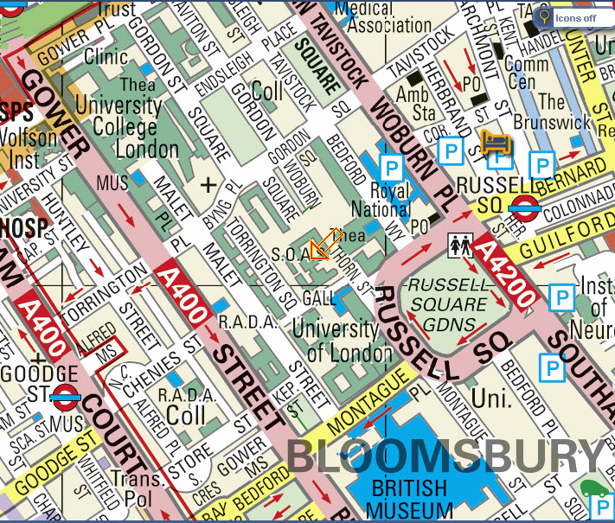
1
5

