

ASSOCIATION FOR LANGUAGE LEARNING: LONDON REGION BRANCH
www.all-london.org.uk

All are invited to come along to:
The ALL London June Event 2014
on

Saturday June 14th 2014 9.30 –1.30
Venue: Brunei Suite, Russell Square Campus, SOAS
School of African and Oriental Studies, University of London, Thornhaugh Street, Russell Square, London, WC1H 0XG, Tel +44 (0) 2076372388 www.soas.ac.uk
visit tfl.gov.uk for travel directions or http://www.soas.ac.uk/visitors/location/travel/
Tube: Russell Square (Piccadilly Line) – approx 5 minute walk; Buses: 7, 68, 91, 168 and 188 stop on Russell Square; 10, 24, 29, 73 and 134 stop on Tottenham Court Road (north bound) or Gower Street (south bound).

Provisional Outline Programme – Check www.all-london.org.uk for up-dates
9.30 | Registration & tea/coffee and biscuits – the committee will be there to welcome you!
9.55- 10.00 | Plenary– Helen Myers, Chair of ALL London. Welcome & Introductions incl committee members, SOAS staff, and sponsors
10.00- 1050 | ‘On being ‘Outstanding for OFSTED’ Tim Crapper, Head of French at Aylesbury Grammar School, part of an MFL department rated ‘outstanding’ by OFSTED in April 2012. Tim says: 'We regarded and regard ourselves as ‘normal’, so I hope this talk will be both informative and reassuring. We teach French, German, Spanish, Italian, Japanese within the MFL family, and Latin is also taught.' We invited him after hearing his engaging, convincing and 'outstanding' talk in 2012, and are delighted he can join us in London  OR  'Speaking spontaneously in the MFL Classroom' Dr Colin Christie IoE lecturer in Languages in Education, subject leader for the PGCE Languages course and well-known speaker with a gently persuasive manner, will look at simple techniques to encourage learners to speak spontaneously in the target language. He will also consider classroom contexts in which the target language can be used. Examples will be in French.
1055 – 11.45 | 'Practical solutions for all' René Koglbauer, ALL President Elect will share a variety of teaching strategies which can be used by ALL our language community! We are honoured that René is travelling all the way from the north to join us as he prepares for his 2-year stint at the top!
11.45 – 12.15 | Comfort break / top-up of coffee / chance to ‘network’ / view info sent from corporate members, ALL, Language Institutes and our sponsors. Share views with your President Elect!
12.15 – 1.05 | 'Speaking spontaneously in the MFL Classroom' (see above)  OR  Enrich your curriculum. Liz Fotheringham, ALL London committee member, teacher and trainer How can less widely taught languages be introduced to enrich both the whole-school and languages curriculum? Renowned for her comprehensive approach, Liz will look at practical teaching strategies and tools that can be applied to any language, whether less widely taught or not. She will take Chinese as a case study.
1.05 –1.30 | British Academy Schools Language Awards - Anne Breivik will share information about how to get money for promoting languages. Participants will be offered refreshments and inspiration to stimulate you at the end of a packed morning!
& after? | Visit the British Museum, explore London and catch the last of the sales!
EARLY BIRD RATE: (received by June 9th) FREE to students who are members of ALL; £5 – non-member students; £10 – members (incl retired) or people who join on the day), £15 – group members, £25 – non-members
Register and pay online http://tinyurl.com/alljuneevent14 or see overleaf
LATE BIRDS: an additional £5!

As refreshments will be provided, it would be very helpful to know how many people are intending to attend. Please send or email the application form below to Sarah Bowley, by Monday June 9th in order to qualify for the 'Early Bird' rate; otherwise send an email with the information to her. Payment after June 9th will be £5 more per ticket.
PLEASE NOTE: To cut down costs and administration time, we won’t send confirmation unless you particularly ask for it... if you have paid, assume you have a place unless you hear otherwise! We can give receipts at the event. If you need any more information please ask. Thanks.

Application Form

To: Mrs Sarah Bowley, The Ashcombe School, Dorking, RH4 1LY Urgent queries: 01306 886312
OR, if no time to send form, email info to her: langcoll@ashcombe.surrey.sch.uk
London June Event ; Saturday 14th June 2014, 0930 -1330, SOAS
Name
Establishment
Work Telephone Number
Home Address
Home Telephone Number
E-mail
How did you hear about this event?

£25 – non-members, (why not join on the day and get £15 refunded?!) £15 – group members,
£10 – members and students who are not paid members £5 – students; Free: Student members. Follow this link to join beforehand: http://www.all-languages.org.uk/join/join_us

*Please delete as appropriate.

I enclose cheque (payable to ALL-LRB) to the value of £__________ as payment for (No.)_________ persons as listed below (BLOCK CAPITALS please):

Name _________________________________ Member/Group member / Student Non-Member /Student member *

Name _________________________________ Member/Group member / Student Non-Member /Student member *

Name _________________________________ Member/Group member / Student Non-Member /Student member *

Name _________________________________ Member/Group member / Student Non-Member /Student member *

MEMBERS + GROUP MEMBERS
* I would like to offer to join the committee. Please contact me to discuss what this involves.
* These are issues which I would like to raise: (continue overleaf if necessary)
Please note that we deliberately keep down the cost of courses by subsidising them from ALL funds: we feel that members ought to receive value for the money paid in subscription fees to the Association. Fees charged do not, in any way, reflect the quality of courses offered!
Travel directions web link:
http://www.soas.ac.uk/visitors/location/travel/

The ALL London June Event 2014
June 14th 2014, 1000-1330 (Doors open approx. 0930)

Venue: Brunei Suite, Russell Square Campus, SOAS
School of African and Oriental Studies, University of London, Thornhaugh Street, Russell Square, London, WC1H 0XG, Tel +44 (0) 2076372388
www.soas.ac.uk
visit tfl.gov.uk for travel directions or http://www.soas.ac.uk/visitors/location/travel/

Tube: Russell Square (Piccadilly Line) – approx 5 minute walk; Buses: 7, 68, 91, 168 and 188 stop on Russell Square; 10, 24, 29, 73 and 134 stop on Tottenham Court Road (north bound) or Gower Street (south bound)

We would advise you not to come by private car: parking spaces are scarce and expensive in this area of London.
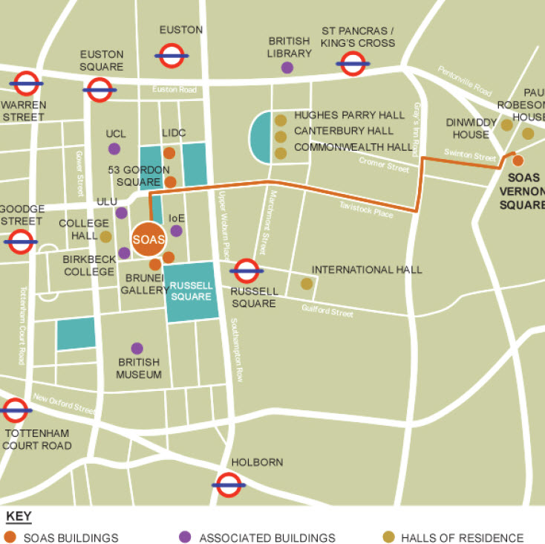
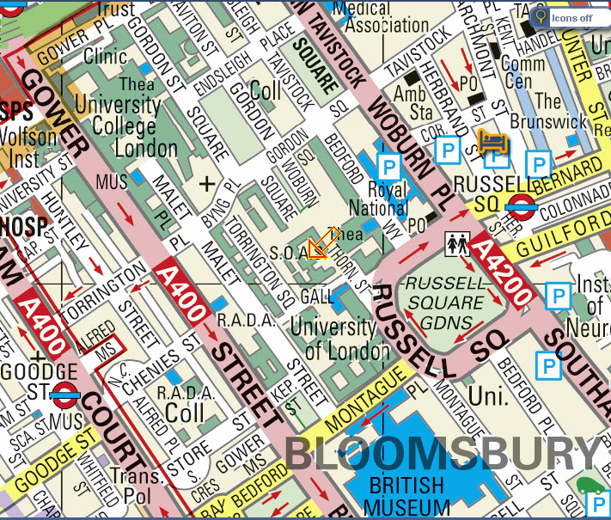

ASSOCIATION FOR LANGUAGE LEARNING
1
LONDON REGION BRANCH
www.all-london.org.uk
Twitter: @ALLLondon007
Facebook: www.facebook.com/Groups/ALLLondon
National Website: www.all-languages.org.uk

ALL London Diary

London-based events run by ALL London + friends!
Please check our website and the national website for updates and full information, and register for events on Eventbrite. (Links given below).

The website will give on-going dates for our online 'get-togethers' which will take place online in our Webinar Room at http://lancelot.adobeconnect.com/all-london No software download required! Enter as Guest; Type your real name; No passcode needed; (Do not enter with a login and password)

Committee members: Please keep in touch via our ALL London Committee Yahoo group
http://groups.yahoo.com/group/all_londoncommittee/
ALL members: Please join the forum we moderate: http://groups.yahoo.com/group/mflresources follow us on Twitter and join our Facebook group (see links above)

Any queries, please feel free to contact
Helen Myers, helenmyers007@gmail.com Twitter: @HelenMyers

Saturday 14th June 14  10 -1 | ALL London June Event [Brunei Suite- SOAS ] To include Colin Christie (IoE), René Koglbauer (Network for Languages North East), Liz Fotheringham (ALL London committee member, teacher and advisor) & Tim Crapper (Aylesbury Grammar School) Information and registration here: http://tinyurl.com/alljuneevent14
Saturday 28th June 14  1030 - 1530 | ALL London Technology Saturday at The Ashcombe School, sponsored by Sanako, special guest Joe Dale. Information and registration here: http://tinyurl.com/alllondonict
Friday 4th July  1930 - 2030 14 | Webinar with Dominic McGladdery Information and registration here: http://tinyurl.com/alllondondmg
* Tuesday 15th July 14 | * LRB online Committee Meeting in Webinar Room
Saturday 27th September 10.30 - 11.30 am | Webinar with Suzi Bewell 'Literature for Languages' Information and registration here: http://tinyurl.com/alllondonsb
* Tuesday 9th Sep 14 | * LRB Committee Meeting 1730-1900, Linguascope, E2 7PR
Monday 6th October 14 | Student Teacher Reception including 'Make friends with Language Assistants'! Institute of Education 1730 - 1900
Saturday18th October 14 | Language Show Live, Olympia Central: Show and Tell session at the end of the day, followed by Social Evening at the Hand & Flower, 1 Hammersmith Road
* Thurs 4th Dec 14 | * LRB Committee Meeting 1730-1900, Linguascope, E2 7PR
Saturday 17th January | The January Event (Topics will include literature & assessment)
* Tue 3rd March 2015 | * LRB Committee Meeting 1730-1900, Linguascope, E2 7PR
* Thu 21st May 2015 | * LRB Committee Meeting 1730-1900, Linguascope, E2 7PR
Saturday 13th June 2015 | The June Event
* Thu 16th July 2015 | * LRB Committee Meeting 1730-1900, Linguascope, E2 7PR
* For committee members only. Please contact Helen Myers if you would like to join us

