

ASSOCIATION FOR LANGUAGE LEARNING: LONDON REGION BRANCH
www.all-london.org.uk

All are invited to come along to:
The ALL London Technology Saturday at Ashcombe 2014
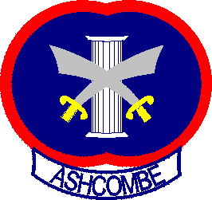

on
Saturday June 28th 2014 10.30 –3.30
(Late arrivals and early leavers welcome too!)
Venue: The Ashcombe School, Dorking
The Ashcombe School, Ashcombe Road, Dorking, Surrey RH4 1LY , Tel +44 (0) 1306 886312 www.ashcombe.surrey.sch.uk

What is it?
All are invited to attend a free Technology day! Come along to a 'hands-on' experience of a wide range of practical ideas and activities in which technology can support language learning in and outside school, however much or little access you have to equipment and resources. There will be something for everyone! (all sectors - all ages - all abilities - all languages) and we especially welcome Primary teachers and TEFL friends from all over the world! Free coffee and buffet lunch thanks to our Sponsor, 'Sanako'. We will be accommodated in 2 computer rooms (each fitted with 34 computers with access to a wide range of software) and a classroom with wifi access.

Who is in charge?
Hosts for the day:
- Joe Dale, world- renowned ICT Independent Consultant and special friend of ALL London!
- Helen Myers, ALL London Chair, Assistant Head & ML Teacher at Ashcombe
- Simon Tunmore, ML teacher and IT/music enthusiast at Ashcombe

How do I reserve?
Book soon! Places limited to 90. Pay £20 online before midnight Monday 23rd June and receive full refund if you attend the day: http://tinyurl.com/alllondonict14 This helps us to plan catering and avoid wasted places. [Please complete form below if unable to pay online]

How do I get there? (see next page for maps and details)
BY TRAIN: Very easy access to 2 nearby stations - Dorking Mainline or Dorking Deepdene- 5 minutes' walk from the stations. 50 minutes on a stopping train from Waterloo or Victoria. Direct trains to Guildford (20 minutes) and Reading (1 hour) (so avoiding need to go via London)
BY PLANE: 25 minutes on a direct train from Gatwick
BY CAR: 10 minutes from M25 Junction 9 turn off for Leatherhead (Saturday less busy!) Lots of free parking at school.

What will we do exactly?
The exact programme will be arranged when we have final numbers, but core activities will include:
- Using published resources (popular ICT-based courses both commercial and free)
- Creating your own resources (audio, video, text)
- Tapping ICT for engaging and culture-enhancing activities
- Stimulating independent language learning
- Using mobile devices (phones, pads) in and outside the classroom (workshop led by Joe Dale)
- A chance to 'play' in the last session and try out ideas introduced in earlier sessions

All delegates will be able to experience how these activities can be managed within a language lab environment and the 'community' of an online group.

As refreshments will be provided, it would be very helpful to know how many people are intending to attend. Please send or email the application form below to Sarah Bowley, by Tuesday June 24th in order to qualify for the 'Early Bird' rate; otherwise send an email with the information to her. Payment after June 24th will be £20.
PLEASE NOTE: To cut down costs and administration time, we won’t send confirmation unless you particularly ask for it... if you have paid, assume you have a place unless you hear otherwise! We can give receipts at the event. If you need any more information please ask. Thanks.

Application Form

To: Mrs Sarah Bowley, The Ashcombe School, Dorking, RH4 1LY Urgent queries: 01306 886312
OR, if no time to send form, email info to her: langcoll@ashcombe.surrey.sch.uk
ALL London Technology Saturday; Saturday 28th June 2014, 1030 -1530, The Ashcombe School
Name
Establishment
Work Telephone Number
Home Address
Home Telephone Number
E-mail
How did you hear about this event?

£20 - refunded on the day if you attend

*Please delete as appropriate.

I enclose cheque (payable to ALL-LRB) to the value of £__________ as payment for (No.)_________ persons as listed below (BLOCK CAPITALS please):

Name _________________________________ Member/Group member / Student Non-Member /Student member *

Name _________________________________ Member/Group member / Student Non-Member /Student member *

Name _________________________________ Member/Group member / Student Non-Member /Student member *

Name _________________________________ Member/Group member / Student Non-Member /Student member *

MEMBERS + GROUP MEMBERS
* I would like to offer to join the committee. Please contact me to discuss what this involves.
* These are issues which I would like to raise: (continue overleaf if necessary)
Please note that we deliberately keep down the cost of courses by subsidising them from ALL funds: we feel that members ought to receive value for the money paid in subscription fees to the Association. Fees charged do not, in any way, reflect the quality of courses offered!
Travel directions web link:
http://www.ashcombe.surrey.sch.uk/04-info/03-getting-to-school.shtml

The ALL London Technology Saturday - June 28th 2014, 1030-1530

Venue: The Ashcombe School, Dorking
The Ashcombe School, Ashcombe Road, Dorking, Surrey RH4 1LY , Tel +44 (0) 1306 886312 www.ashcombe.surrey.sch.uk
visit tfl.gov.uk for travel directions or http://www.ashcombe.surrey.sch.uk/04-info/03-getting-to-school.shtml
Stations: Dorking Mainline or Dorking Deepdene - approx 5 minute walk;
Plenty of car parking on a Saturday! See below for maps.

Please use Main Entrance, then follow signs to Language College area.
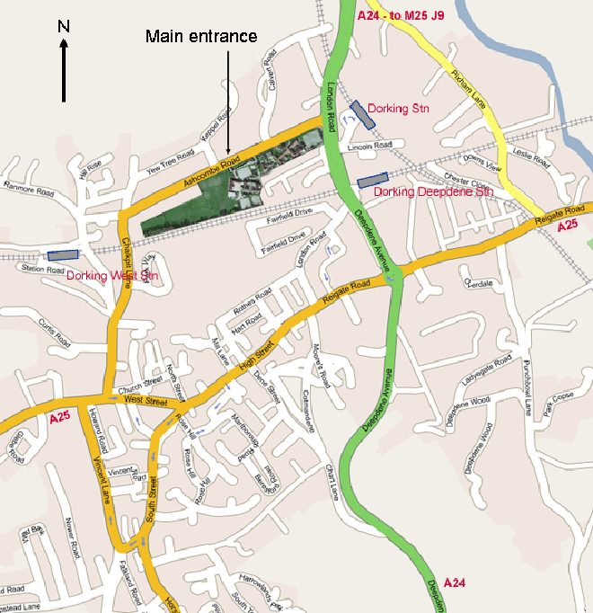
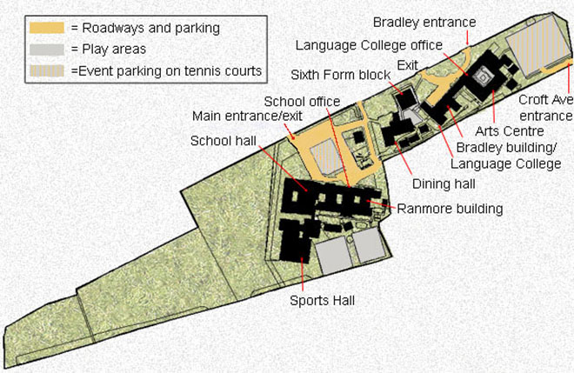

ASSOCIATION FOR LANGUAGE LEARNING
1
LONDON REGION BRANCH
www.all-london.org.uk
Twitter: @ALLLondon007
Facebook: www.facebook.com/Groups/ALLLondon
National Website: www.all-languages.org.uk

ALL London Diary

London-based events run by ALL London + friends!
Please check our website and the national website for updates and full information, and register for events on Eventbrite. (Links given below).

The website will give on-going dates for our online 'get-togethers' which will take place online in our Webinar Room at http://lancelot.adobeconnect.com/all-london No software download required! Enter as Guest; Type your real name; No passcode needed; (Do not enter with a login and password)

Committee members: Please keep in touch via our ALL London Committee Yahoo group
http://groups.yahoo.com/group/all_londoncommittee/
ALL members: Please join the forum we moderate: http://groups.yahoo.com/group/mflresources follow us on Twitter and join our Facebook group (see links above)

Any queries, please feel free to contact
Helen Myers, helenmyers007@gmail.com Twitter: @HelenMyers

Saturday 14th June 14  10 -1 | ALL London June Event [Brunei Suite- SOAS ] To include Colin Christie (IoE), René Koglbauer (Network for Languages North East), Liz Fotheringham (ALL London committee member, teacher and advisor) & Tim Crapper (Aylesbury Grammar School) Information and registration here: http://tinyurl.com/alljuneevent14
Saturday 28th June 14  1030 - 1530 | ALL London Technology Saturday at The Ashcombe School, sponsored by Sanako, special guest Joe Dale. Information and registration here: http://tinyurl.com/alllondonict14
Friday 4th July  1930 - 2030 14 | Webinar with Dominic McGladdery Information and registration here: http://tinyurl.com/alllondondmg
* Tuesday 15th July 14 | * LRB online Committee Meeting in Webinar Room
Saturday 27th September 10.30 - 11.30 am | Webinar with Suzi Bewell 'Literature for Languages' Information and registration here: http://tinyurl.com/alllondonsb
* Tuesday 9th Sep 14 | * LRB Committee Meeting 1730-1900, Linguascope, E2 7PR
Monday 6th October 14 | Student Teacher Reception including 'Make friends with Language Assistants'! Institute of Education 1730 - 1900
Saturday18th October 14 | Language Show Live, Olympia Central: Show and Tell session at the end of the day, followed by Social Evening at the Hand & Flower, 1 Hammersmith Road
* Thurs 4th Dec 14 | * LRB Committee Meeting 1730-1900, Linguascope, E2 7PR
Saturday 17th January | The January Event (Topics will include literature & assessment)
* Tue 3rd March 2015 | * LRB Committee Meeting 1730-1900, Linguascope, E2 7PR
* Thu 21st May 2015 | * LRB Committee Meeting 1730-1900, Linguascope, E2 7PR
Saturday 13th June 2015 | The June Event
* Thu 16th July 2015 | * LRB Committee Meeting 1730-1900, Linguascope, E2 7PR
* For committee members only. Please contact Helen Myers if you would like to join us

