

ASSOCIATION FOR LANGUAGE LEARNING: LONDON REGION BRANCH
www.all-london.org.uk

All are invited to come along to:
The ALL London January Event 2015
on
Saturday January 17th 2015 9.30 –1.00

and afterwards to the
Annual General Meeting (free) 1.00 – 1.30
Venue: DLT - Kamran DJAM Lecture Theatre, Russell Square Campus, SOAS
School of African and Oriental Studies, University of London, Thornhaugh Street, Russell Square, London, WC1H 0XG, Tel +44 (0) 2076372388 www.soas.ac.uk
visit tfl.gov.uk for travel directions or http://www.soas.ac.uk/visitors/location/travel/
Tube: Russell Square (Piccadilly Line) – approx 5 minute walk; Buses: 7, 68, 91, 168 and 188 stop on Russell Square; 10, 24, 29, 73 and 134 stop on Tottenham Court Road (north bound) or Gower Street (south bound).
Provisional Outline Programme – Check www.all-london.org.uk for up-dates:
0930 | Registration & tea/coffee and biscuits – the committee will be there to welcome you!
10.00-- 10.40 | ‘Primary Up-date’ Nadine Chadier & Sylvia Bartlett-Rawlings,  OR  'Secondary Up-date' Nick Mair and Helen Myers,  All speakers are teachers and managers who have a passion for languages and represent teachers at a national level. They will bringing you up to date with national requirements currently and for the future, and will share good practice which you can use on Monday!
10.45-11.30 | ‘Language taster’ SOAS teachers Taste one of the more 'unusual' languages SOAS has to offer and experience what they could bring to your school. (There will be choice!)
11.30 – 12.00 | Comfort break / top-up of coffee / chance to ‘network’ / view info sent from corporate members, speakers, and our sponsors.
12.00-12.55 | Using literature' Steven Fawkes, ALL membership officer and Fellow, working in CPD, teacher training and education.  What does ‘Literature’ mean for pupils in key stages 2 and 3? What do Language teachers do with texts? How can they stimulate language learning? Steven always delights us with his intelligent,thoughtful and entertaining sessions. He will talk about the outcomes of the ALL Literature Project with interactive examples for Primary and Secondary teachers in a range of languages.
1300 1330 | Job Application Clinic for Students. 'What are schools looking for?' with Nick Mair, Director of Languages, Dulwich College, Chair ISML, Vice Chair ALL London A ‘Must’ for trainee teachers preparing CVs, applications and interviews from an experienced and inspiring teacher and manager!
OR
Annual General Meeting - Chaired by Helen Myers 1. Election /confirmation of committee members; 2. Reports from the Chair, Secretary, Treasurer, Languages Committees (Community, French, German, IT, Italian, Spanish); 3. Response to issues raised by Management Board; 4. Issues to be raised with the Management Board (please give advance notice of issues you wish to raise in writing before the event if possible); 5. AOB to be decided!
& next? | Visit the British Museum, explore London and catch the last of the sales!
EARLY BIRD: £10 – Students, FLAs, ALL individual members (incl retired) or people who join on the day.
£15 – group members, £28 – non-members. Free to Students how have joined ALL
After Sunday 11th January, £5 extra

As refreshments will be provided, it would be very helpful to know how many people are intending to attend. Please register on Eventbrite: ____________________ or send or email the application form below to Sarah Bowley, by Friday January 9th; otherwise send an email with the information to her.
PLEASE NOTE: To cut down costs and administration time, we won’t send confirmation unless you particularly ask for it... if you have paid, assume you have a place unless you hear otherwise!
If you need any more information please ask. Thanks.

Application Form

To: Mrs Sarah Bowley, The Ashcombe School, Dorking, RH4 1LY Urgent queries: 01306 886312
OR, if no time to send form, email info to her: langcoll@ashcombe.surrey.sch.uk
London January Event (+ AGM) ; Saturday 17th January '15, 0930 -1300, (+ 1.00-1.30) SOAS
Name
Establishment
Work Telephone Number
Home Address

Home Telephone Number
E-mail
How did you hear about this event?

£28 – non-members, (why not join on the day and get £18 refunded?!) £15 – group members,
£10 – members, students and FLAs. Free for Student ALL members. Follow this link to join beforehand: http://www.all-languages.org.uk/join/join_us

*Please delete as appropriate.

I enclose cheque (payable to ALL-LRB) to the value of £__________ as payment for (No.)_________ persons as listed below (BLOCK CAPITALS please):

Name _________________________________ Member/Group member / Non-Member /FLA*

Name _________________________________ Member/Group member / Non-Member /FLA*

Name _________________________________ Member/Group member / Non-Member /FLA*

Name _________________________________ Member/Group member / Non-Member /FLA*

MEMBERS + GROUP MEMBERS (but observers welcome!): AGM 1.00 – 1.30(free)
* I would like to offer to join the committee. Please contact me to discuss what this involves.
* These are issues which I would like to raise: (continue overleaf if necessary)
Please note that we deliberately keep down the cost of courses by subsidising them from ALL funds: we feel that members ought to receive value for the money paid in subscription fees to the Association. Fees charged do not, in any way, reflect the quality of courses offered!
Travel directions web link:
http://www.soas.ac.uk/visitors/location/travel/

The ALL London January Event
Saturday January 17th 2015 9.30 onwards

Venue: Kamran DJAM Lecture Theatre, Russell Square Campus, SOAS
School of African and Oriental Studies, University of London, Thornhaugh Street, Russell Square, London, WC1H 0XG, Tel +44 (0) 2076372388
www.soas.ac.uk
visit tfl.gov.uk for travel directions or http://www.soas.ac.uk/visitors/location/travel/

Tube: Russell Square (Piccadilly Line) – approx 5 minute walk; Buses: 7, 68, 91, 168 and 188 stop on Russell Square; 10, 24, 29, 73 and 134 stop on Tottenham Court Road (north bound) or Gower Street (south bound)

We would advise you not to come by private car: parking spaces are scarce and expensive in this area of London.
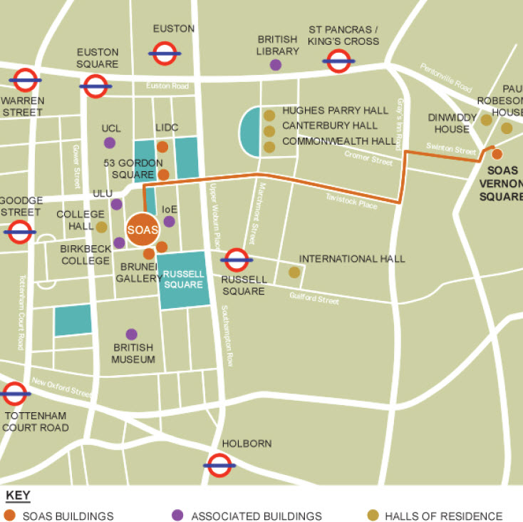
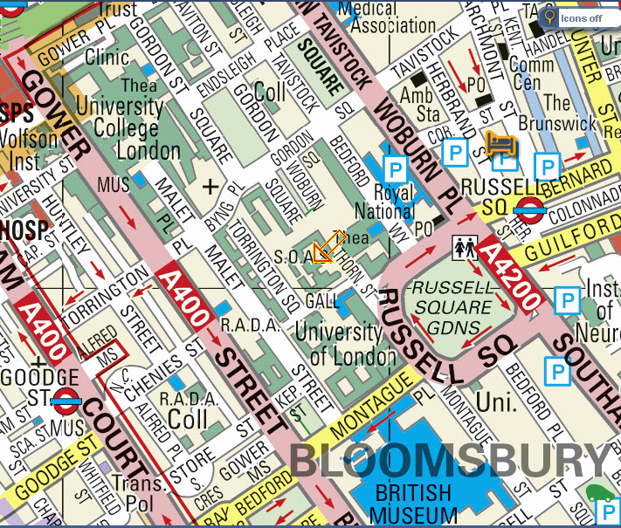
1
5
1
5

