

ASSOCIATION FOR LANGUAGE LEARNING: LONDON REGION BRANCH
www.all-london.org.uk

The ALL London June Event 2016
on

Saturday June 11th 2016 9.30 –1.30
Venue: Brunei Suite, Russell Square Campus, SOAS

Outline Programme
9.30 | Registration & Exhibition. Tea/coffee and biscuits – the committee will be there to welcome you!  Exhibitors / contributors to delegate packs: AQA, European Schoolbooks, Goethe Instutut, Linguascope, Mini Flashcards, Sociedad Mixta para la promocion del Turismo de Valladolid, This is Language and Vocab Express.
10.00- 10.25 | Plenary and Language Taster– Helen Myers, Chair of ALL London. Welcome & Introductions incl committee members, Renata Albuquerque (SOAS), and sponsors
10:30 – 11.25 | B102: 'Literature inspires' Dr Colin Christie IoE lecturer in Languages in Education, subject leader for the PGCE Languages course The UCL IOE 2014 British Academy Schools Language Award, ‘London Partnership Launches Literature’, generated 70+ two lesson sequences based on a literary text. With the kind permission of student teachers, Colin will explore some of their ideas and highlight examples of how literature might inspire spontaneous talk.  OR  Primary Get-together led by Nadine Chadier and Sylvie Bartlett-Rawlings Up-date on resources for primary from our lively ALL duo!
11.30 – 12:00 | EXHIBITION Comfort break / top-up of coffee / chance to ‘network’ / view info sent from corporate members, ALL, Language Institutes and our sponsors.
12.05– 1.00 | B102: 'Speaking and writing GCSE' (Wendy Adeniji) Vice Principal, Dixons Kings Academy and consultant for Ofqual, Wendy is long-standing popular AL London presenter and we can be guaranteed that this session will be packed with fantastic ideas as we prepare for the new GCSE.  OR  Primary Get-together led by Nadine Chadier and Sylvie Bartlett-Rawlings Up-date on resources for primary from our lively ALL duo!
& after? | Visit the British Museum, explore London
EARLY BIRD: (Register before Tuesday 7th June): Free to students who are members of ALL or first-time primary teachers; £10 – ALL individual members and non-member students; £15 – group members, £28 – non-members

After Tuesday 7th June, prices will be an additional £5.
As refreshments will be provided, it would be very helpful to know how many people are intending to attend. Please send or email the application form below to Sarah Bowley, to reach her by Wednesday June 8th 2016 in order to qualify for the 'Early Bird' rate; otherwise send an email with the information to her. Payment for applications sent after Tuesday 7th June will be £5 more per ticket.
PLEASE NOTE: To cut down costs and administration time, we won’t send confirmation unless you particularly ask for it... if you have paid, assume you have a place unless you hear otherwise! We can give receipts at the event. If you need any more information please ask. Thanks.

Application Form

To: Mrs Sarah Bowley, The Ashcombe School, Dorking, RH4 1LY Urgent queries: 01306 886312
OR, if no time to send form, email info to her: langcoll@ashcombe.surrey.sch.uk
London June Event ; Saturday 11th June 2016, 0930 -1330, SOAS
Name
Establishment
Work Telephone Number
Home Address
Home Telephone Number
E-mail
How did you hear about this event?

£28 – non-members, (why not join on the day and get £15 refunded?!) £15 – group members,
£10 – members and students who are not paid members; Free: Student members and first-time primary teachers. Follow this link to join beforehand: http://www.all-languages.org.uk/join/join_us

*Please delete as appropriate.

I enclose cheque (payable to ALL-LRB) to the value of £__________ as payment for (No.)_________ persons as listed below (BLOCK CAPITALS please):

Name _______________________________Member/Group member / Student Non-Member /Student member/ First time primary teacher *

Name _______________________________Member/Group member / Student Non-Member /Student member/ First time primary teacher *

Name _______________________________Member/Group member / Student Non-Member /Student member/ First time primary teacher *

Name _______________________________Member/Group member / Student Non-Member /Student member/ First time primary teacher *

MEMBERS + GROUP MEMBERS
* I would like to offer to join the committee. Please contact me to discuss what this involves.
* These are issues which I would like to raise: (continue overleaf if necessary)
Please note that we deliberately keep down the cost of courses by subsidising them from ALL funds: we feel that members ought to receive value for the money paid in subscription fees to the Association. Fees charged do not, in any way, reflect the quality of courses offered!
Travel directions web link:
http://www.soas.ac.uk/visitors/location/travel/

The ALL London June Event 2016
June 11th 2016, 1000-1330 (Doors open approx. 0930)

Venue: Brunei Suite, Russell Square Campus, SOAS
School of African and Oriental Studies, University of London, Thornhaugh Street, Russell Square, London, WC1H 0XG, Tel +44 (0) 2076372388
www.soas.ac.uk
visit tfl.gov.uk for travel directions or http://www.soas.ac.uk/visitors/location/travel/

Tube: Russell Square (Piccadilly Line) – approx 5 minute walk; Buses: 7, 68, 91, 168 and 188 stop on Russell Square; 10, 24, 29, 73 and 134 stop on Tottenham Court Road (north bound) or Gower Street (south bound)

We would advise you not to come by private car: parking spaces are scarce and expensive in this area of London.
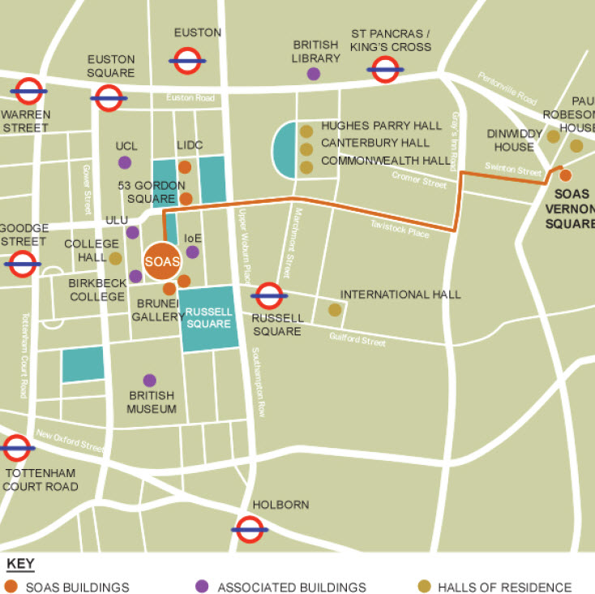
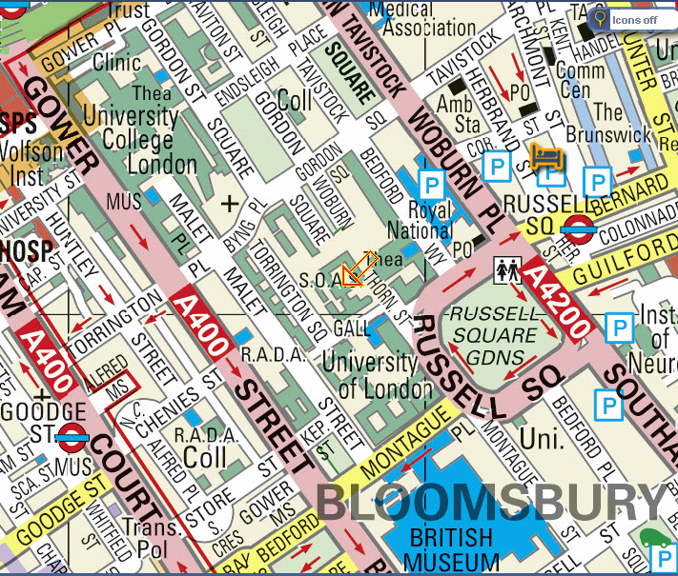
1

