Group members: Please copy & distribute amongst your ‘team’:


ASSOCIATION FOR LANGUAGE LEARNING
LONDON REGION BRANCH
www.all-london.org.uk

- Want to hear some uplifting stories about teaching languages from some inspiring speakers?
- Would you like to spread your circle of friends in the Languages World, put faces to names and share some good ideas with them ‘in the flesh’?
You are invited to
The ALL London January Event
on
Saturday January 27th 2007 9.30 –1.00
to be held at
The London School of Economics
D602, Clement House, Houghton Street, London WC2A 2AE (Nearest tube stations: Holborn, Temple, Charing Cross)
£20 – non-members, £7 – group members, £5 – members and associate members (or people who join on the day),
and afterwards to the
Annual General Meeting (free) 1.00 – 1.30
Outline Programme:
9.30 | Registration & tea/coffee and biscuits – the committee will be there to welcome you!
10.00 | Whizzo ICT Tricks– Joe Dale, Leader of French at Nodehill Middle School on The Isle of Wight , SST Lead Practitioner and well-known general ‘whizz’ on all things ICT, shares a wealth of ideas which have transformed language teaching in his own school and in the classes of the many people who have been inspired by him. You will be itching to try out his ideas, and he’s great at maintaining communication after the events.
10.55 | Top Tips from our Postbag! Committee members will introduce themselves and select some Top Tips supplied by you!
11.15 | Comfort break / top-up of coffee / chance to ‘network’ / view info sent from corporate members including CILT
11.45 -12.40 | Spicing up with Songs, Music, Rhythm and even movement! Rachel Hawkes and Leigh McClelland talk about the use of music to support language learning. Rachel is an AST and SSAT Lead Practitioner who contributes a wonderful range of ideas and resources to the Language Community. Leigh is Head of Languages and works with Rachel at Comberton Village College in Cambridgeshire. Their sense of fun and boundless energy are guaranteed to leave a lasting impression!
12.40 | Round-up –Branch notices / ALL events / issue of INSET certificates
1.00 – 1.30 | Annual General Meeting - Chaired by Helen Myers 1. Election /confirmation of committee members; 2. Reports from the Chair, Secretary, Treasurer, Languages Committees (Community, French, German, IT, Italian, Spanish); 3. Response to issues raised by Management Board; 4. Issues to be raised with the Management Board (please give advance notice of issues you wish to raise in writing before the event if possible); 5. AOB to be decided!
& next? | Why not take advantage of this nice central venue, just a few minutes from Somerset House for the cultured and Covent Garden for the last of the sales!

☺ COME ALONE, OR BRING YOUR ‘TEAM’ ... YOU WILL ALL BE WELCOME! ☺
Next event: Saturday June 16th 2007 ... see website for details.
As refreshments will be provided, it would be very helpful to know how many people are intending to attend. Please send or email the application form below to Alison Owen, by Friday January 19th; otherwise send an email with the information to her. There is a limit on places available, so please book early to avoid disappointment, and check on the website for up-dates on numbers before you set out without a reserved place.
PLEASE NOTE: To cut down costs and administration time, we won’t send confirmation unless you particularly ask for it... if you have paid, assume you have a place unless you hear otherwise!
If you need any more information please ask. Thanks.

Application Form
To: Mrs Alison Owen, The Ashcombe School, Ashcombe Road, Dorking RH4 1LY OR, if no time to send form, email info to her: ao@ashcombe.surrey.sch.uk or phone 01306 886312
London January Event (+ AGM) ; Saturday 27th January, 0930 -1300, (+ 1.00-1.30) LSE
Name
Establishment
Work Telephone Number
Home Address

Home Telephone Number
E-mail
How did you hear about this event?

£20 – non-members, (why not join on the day and get £15 refunded?!) £7 – group members,
£5 – members and associate members (NB ALL offers Students and NQTs Associate Membership for free! Fill in the online form here:http://www.all-languages.org.uk/associate_membership_form.asp )

*Please delete as appropriate.

I enclose cheque (payable to ALL-LRB) to the value of £__________ as payment for (No.)_________ persons as listed below (BLOCK CAPITALS please):

Name ________________________________________ Member/Group member / Non-Member /Associate member*

Name ________________________________________ Member/Group member / Non-Member / Associate member*

Name ________________________________________ Member/Group member / Non-Member / Associate member

Here’s my ‘top tip’:

MEMBERS + GROUP MEMBERS (but observers welcome!): AGM 1.00 – 1.30(free)
* I would like to offer to join the committee. Please contact me to discuss what this involves.
* These are issues which I would like to raise: (continue overleaf if necessary)

Please note that we deliberately keep down the cost of courses by subsidising them from ALL funds: we feel that members ought to receive value for the money paid in subscription fees to the Association. Fees charged do not, in any way, reflect the quality of courses offered! NQTs and PGCE students: Consider joining as an Associate Member!

The ALL London January Event
January 27th 2007 0930-1330

Directions to Room D602, Clement House, London School of Economics
Nearest tubes – Holborn, Temple, Charing Cross,

LSE, Houghton Street, London WC2A 2AE, England UK ,
Tel: +44 (0) 20 7405 7686

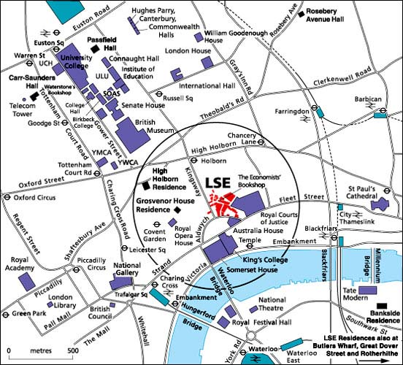

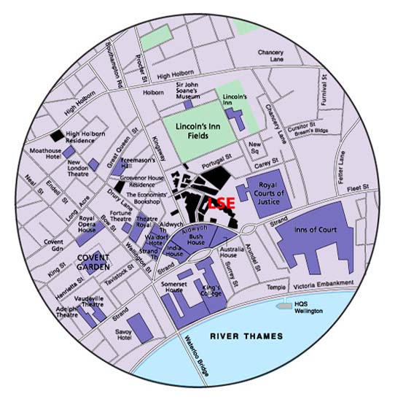

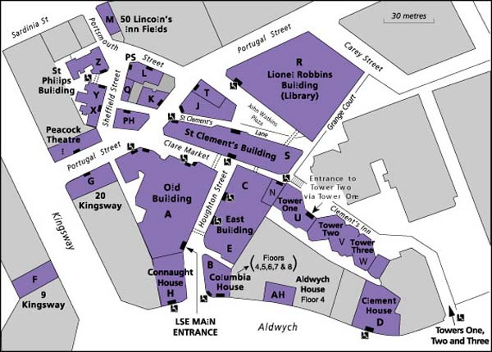
Clement House
Sixth Floor
D602

(Has disabled access + lifts)

