

ASSOCIATION FOR LANGUAGE LEARNING
LONDON REGION BRANCH
www.all-london.org.uk

Following last year's sell-out event with over 120 participants, you are invited to
The ALL London January Event 2008
on
Saturday January 26th 2008 9.30 –1.00
to be held at
The London School of Economics
The Hong Kong Theatre, Ground Floor, Clement House, Aldwych, London WC2A 2AE
(Nearest tube stations: Holborn, Temple, Charing Cross)
and afterwards to the
Annual General Meeting (free) 1.00 – 1.30
Outline Programme:
9.30 | Registration & tea/coffee and biscuits – the committee will be there to welcome you!
9.55- 10.15 | Plenary– Helen Myers, Chair of ALL London. Welcome & Introductions incl committee members & sponsors
10.20- 11.10 | 'Top tips for tip top MFL teachers' & 'Making them love it!'Sara Sullivan -. Well known AST, SSAT Lead Practitioner and Head of the extremely successful languages' department of Woodlands School (Performing Arts College), Essex, Sara will share with us some of her secrets for raising achievement amongst learners, and - especially important in the current climate -making them want to choose to continue. Can you afford to miss out on this?! OR 'Learn Spanish!' Jen Sutton, Head of TLA /MFL Davenant Foundation School, and RSA demonstrates a teaching method [based on Michel Thomas principles] she uses with adult learners. Highlighted in Dearing's Review, the approach is attracting a great deal of interest in the language world (Places limited for this session)
11.15 -11.45 | Comfort break / top-up of coffee / chance to ‘network’ / view info sent from corporate members including CILT.  Thanks to 'Advance Materials' & 'The Language Factory' who are sponsoring this event!
11.50 -12.40 | Creative uses of the Interactive Whiteboard– Wendy Adeniji talks about the best practice in using the interactive whiteboard to encourage pupil use of the target language, introduce and practise vocabulary and structures and play games. Wendy is a teacher and trainer, specialising in the using ICT in MFL teaching. She runs training for schools and Local Authorities and is a consultant for CILT, the QCA and BBC Education. Her sessions are always popular!
12.40 | Round-up –Branch notices / ALL events / issue of INSET certificates
1.00 – 1.30 | Annual General Meeting - Chaired by Helen Myers 1. Election /confirmation of committee members; 2. Reports from the Chair, Secretary, Treasurer, Languages Committees (Community, French, German, IT, Italian, Spanish); 3. Response to issues raised by Management Board; 4. Issues to be raised with the Management Board (please give advance notice of issues you wish to raise in writing before the event if possible); 5. AOB to be decided!
& next? | Why not take advantage of this nice central venue, just a few minutes from Somerset House for the cultured and Covent Garden for a bite to eat and the last of the sales!

£10 – members and associate members (or people who join on the day),
£15 – group members, £25 – non-members
As refreshments will be provided, it would be very helpful to know how many people are intending to attend. Please send or email the application form below to Kathleen Merino, by Friday January 18th; otherwise send an email with the information to her. There is a limit on places available, so please book early to avoid disappointment, and check on the website for up-dates on numbers before you set out without a reserved place.
PLEASE NOTE: To cut down costs and administration time, we won’t send confirmation unless you particularly ask for it... if you have paid, assume you have a place unless you hear otherwise!
If you need any more information please ask. Thanks.

Application Form

To: Mrs Kathleen Merino, 11 Tavistock Road, Edgware, HA8 6DF [Tel: 020 8952 5150]
OR, if no time to send form, email info to her: kathleen.merino@btinternet.com
London January Event (+ AGM) ; Saturday 26th January, 0930 -1300, (+ 1.00-1.30) LSE
Name
Establishment
Work Telephone Number
Home Address

Home Telephone Number
E-mail
How did you hear about this event?

£25 – non-members, (why not join on the day and get £15 refunded?!) £15 – group members,
£10 – members and associate members (NB ALL offers Students and NQTs Associate Membership for free! Fill in the online form here:http://www.all-languages.org.uk/associate_membership_form.asp )

*Please delete as appropriate.

I enclose cheque (payable to ALL-LRB) to the value of £__________ as payment for (No.)_________ persons as listed below (BLOCK CAPITALS please):

Name ________________________________________ Member/Group member / Non-Member /Associate member*
Preferred Sessions (put in order 1/2) :Sara Sullivan: _______ Jen Sutton: ________

Name ________________________________________ Member/Group member / Non-Member / Associate member*
Preferred Sessions (put in order 1/2) :Sara Sullivan: _______ Jen Sutton: ________

Name ________________________________________ Member/Group member / Non-Member / Associate member
Preferred Sessions (put in order 1/2) :Sara Sullivan: _______ Jen Sutton: ________

MEMBERS + GROUP MEMBERS (but observers welcome!): AGM 1.00 – 1.30(free)
* I would like to offer to join the committee. Please contact me to discuss what this involves.
* These are issues which I would like to raise: (continue overleaf if necessary)

Please note that we deliberately keep down the cost of courses by subsidising them from ALL funds: we feel that members ought to receive value for the money paid in subscription fees to the Association. Fees charged do not, in any way, reflect the quality of courses offered! NQTs and PGCE students: Consider joining as an Associate Member!

The ALL London January Event
January 26th 2008 1000-1300

Directions to The Hong Kong Theatre, D1, Ground Floor, Clement House, London School of Economics, Aldwych
Nearest tubes – Holborn, Temple, Charing Cross,

LSE, Aldwych, London WC2A 2AE, England UK ,
Tel: +44 (0) 20 7405 7686

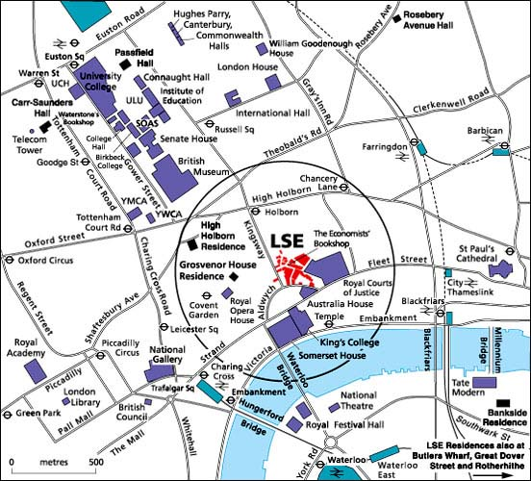

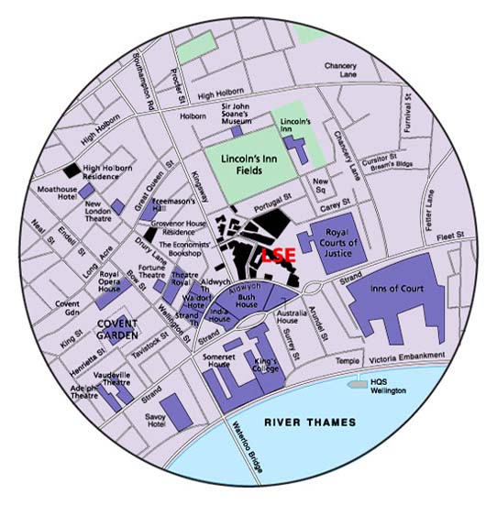

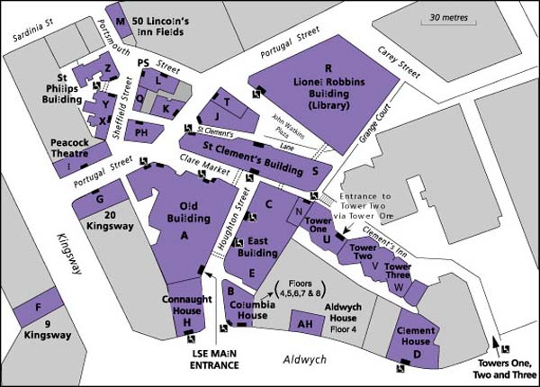
Clement House
D1, Ground Floor
The Hong Kong Theatre

