

ASSOCIATION FOR LANGUAGE LEARNING: LONDON REGION BRANCH
www.all-london.org.uk

All are invited to come along to:
The ALL London February Event 2009
on
Saturday February 7th 2009 9.30 –1.00

to be held at
The London Met University, The Graduate Centre
166-220 Holloway Road, London N7 8DB
(Opposite Holloway Road underground station, 5 mins from St Pancras / Kings Cross)
and afterwards to the
Annual General Meeting (free) 1.00 – 1.30
Outline Programme:
9.30 | Registration & tea/coffee and biscuits – the committee will be there to welcome you!
9.55- 10.15 | Plenary– Helen Myers, Chair of ALL London. Welcome & Introductions incl committee members, London Met staff & sponsors
10.20- 11.10 | 'Making the best use of individualised language learning through ICT' Wendy Adeniji talks from great experience about structuring pupils' independent use of computers, including efficient and effective use of language labs. As well as being ALL's network co-ordinator for West Yorkshire and RSA for the NSC, Wendy is a teacher and trainer, specialising in the use of ICT in MFL teaching. We welcome her back after her very popular session last year.  OR  'Making languages work' Juliet Park, RSA for the NSC, SSAT Lead Practitioner and director of a Language College in Sheffield talks about how she has tripled numbers at KS4 and raised attainment and motivation through the highly successful alternative NVQ qualification, the inspirational materials she uses and how she has piloted funded work experience abroad. A well-known member of ALL, Juliet comes highly recommended!  OR  'Let's Network: AS/A2 languages' A chance for you to meet with others who are faced with new specifications with a view to establishing a 'self-help' group! A gathering co-ordinated by members of the London ALL committee who will feed back ideas at the round-up.
11.15 -11.45 | Comfort break / top-up of coffee / chance to ‘network’ / view info sent from corporate members including CILT. Thanks to 'SANAKO', sponsors of this event!
11.50 -12.40 | 'A pot pourri for all' Rachel Hawkes, ALL network co-ordinator for Cambridge, SSAT LP, and Assistant Head, describes a selection of strategies which engage language learners of all ages and abilities, underpinned by the extensive research she has conducted into why they work! People are still singing her songs and her praises following her fantastic June 07 appearance!  OR Wendy Adeniji OR Juliet Park (see above)
12.40 | Round-up – Branch notices / ALL events / issue of INSET certificates
1.00 – 1.30 | Annual General Meeting - Chaired by Helen Myers 1. Election /confirmation of committee members; 2. Reports from the Chair, Secretary, Treasurer, Languages Committees (Community, French, German, IT, Italian, Spanish); 3. Response to issues raised by Management Board; 4. Issues to be raised with the Management Board (please give advance notice of issues you wish to raise in writing before the event if possible); 5. AOB to be decided!  OR Another chance to hear Juliet Park if you want to take advantage of 3 of the 4 sessions!
& next? | Why not take advantage of a travel card to visit the range of attractions London has to offer?
£10 – members (incl retired) and associate members (or people who join on the day),
£15 – group members, £25 – non-members; FREE to London Met students.
As refreshments will be provided, it would be very helpful to know how many people are intending to attend. Please send or email the application form below to Kathleen Merino, by Friday January 30th; otherwise send an email with the information to her. There is a limit on places available, so please book early to avoid disappointment, and check on the website for up-dates on numbers before you set out without a reserved place.
PLEASE NOTE: To cut down costs and administration time, we won’t send confirmation unless you particularly ask for it... if you have paid, assume you have a place unless you hear otherwise!
If you need any more information please ask. Thanks.

Application Form

To: Mrs Kathleen Merino, 11 Tavistock Road, Edgware, HA8 6DF
OR, if no time to send form, email info to her: kathleen.merino@btinternet.com
London February Event (+ AGM) ; Saturday 7th February '09, 0930 -1300, (+ 1.00-1.30) London Met
Name
Establishment
Work Telephone Number
Home Address

Home Telephone Number
E-mail
How did you hear about this event?

£25 – non-members, (why not join on the day and get £15 refunded?!) £15 – group members,
£10 – members and associate members (NB ALL offers Students and NQTs Associate Membership for free! Fill in the online form here:http://www.all-languages.org.uk/associate_membership_form.asp )

*Please delete as appropriate.

I enclose cheque (payable to ALL-LRB) to the value of £__________ as payment for (No.)_________ persons as listed below (BLOCK CAPITALS please):

Name ________________________________________ Member/Group member / Non-Member /Associate member*
Preferred Sessions (put in order 1/2/3/4) :Wendy Adeniji: _______ Juliet Park: ________ Rachel Hawkes: ________ AS/A2: ________

Name ________________________________________ Member/Group member / Non-Member /Associate member*
Preferred Sessions (put in order 1/2/3/4) :Wendy Adeniji: _______ Juliet Park: ________ Rachel Hawkes: ________ AS/A2: ________

Name ________________________________________ Member/Group member / Non-Member /Associate member*
Preferred Sessions (put in order 1/2/3/4) :Wendy Adeniji: _______ Juliet Park: ________ Rachel Hawkes: ________ AS/A2: ________

MEMBERS + GROUP MEMBERS (but observers welcome!): AGM 1.00 – 1.30(free)
* I would like to offer to join the committee. Please contact me to discuss what this involves.
* These are issues which I would like to raise: (continue overleaf if necessary)
Please note that we deliberately keep down the cost of courses by subsidising them from ALL funds: we feel that members ought to receive value for the money paid in subscription fees to the Association. Fees charged do not, in any way, reflect the quality of courses offered! NQTs and PGCE students: Consider joining as an Associate Member!

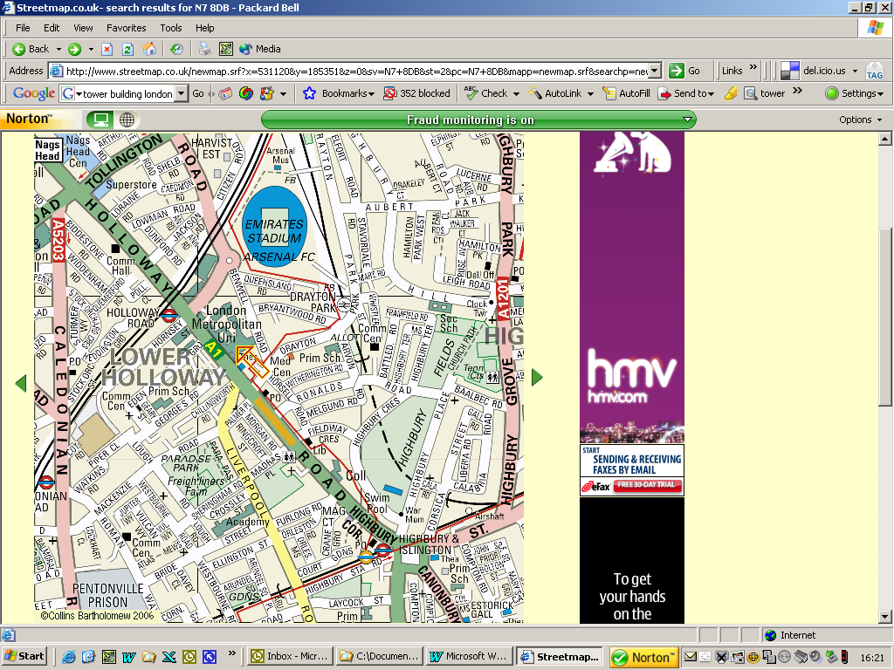
The Graduate Centre
166-220 Holloway Road, London N7 8DB
(Opposite Holloway tube station, then walk down a little, 5 mins from St Pancras / Kings Cross)
Holloway Road underground tube station:

From King's Cross/St Pancras,
- Piccadilly line towards Cockfosters or Arnos Grove. Zones 1 & 2. (Approx 5 minutes)

From Waterloo:
- Northern line towards Edgware.
- Change at Leicester Square.
- Piccadilly line towards Cockfosters. (Approx 20 minutes)

From Victoria:
- Victoria Line towards Walthamstow /Seven Sisters
- Change at King's Cross/St Pancras
- Piccadilly line towards Cockfosters or Arnos Grove. (Approx 20 minutes)

Directions: The Graduate Centre, London Met, 166-220 Holloway Road London N7 8DB:
http://www.londonmet.ac.uk/about/graduate-centre.cfm

