Please copy & distribute to your contacts:

 | ASSOCIATION FOR LANGUAGE LEARNING  LONDON REGION BRANCH&  CRANFORD COMMUNITY COLLEGE  A Specialist Language College | 
www.all-london.org.uk

- Come along to hear some top-class speakers, guaranteed to give you good ideas and strategies!
- Become part of an on-going support group in a friendly, relaxed atmosphere
You are invited to
 | The ALL & Cranford  'Community Languages Event'
on
Saturday December 1st 2007 9.30 –1.00
followed by free lunch & music
to be hosted by
Cranford Community College – A Specialist Language College
High Street, Cranford, Hounslow TW5 9PD www.cranford.hounslow.sch.uk
Map; http://www.cranford.hounslow.sch.uk/contact/contact.htm
Easy access, just south of junction 3 of the M4.
Bus (lines pass through rail links): 105 (Heathrow/Greenford) 435 (Heathrow/Southall)
Cost: £15 [PGCE/GTP Students: £10]
(event generously supported by Cranford Community College through its specialist language status)
SPEAKERS
All sessions will be relevant for all community languages
Dr Jim Anderson, Lecturer in Modern Languages in Education, Goldsmiths, University of London |  |  | Taking Community Languages forward – Opportunities and Challenges.
Saleem Qureshi (Advanced Skills Teacher, Moseley School, Birmingham) |  |  | Effective lesson starters and plenaries
Nazek Abdel-Hay & Doha Kudsi (King Fahad Academy) |  |  | Integrating stories, songs and ICT
Naresh Chandla, Head of Community Languages,Wolverhampton LA |  |  | Developing oracy skills through interactive activities
Siva Pillai, Computer Officer, Goldsmiths, University of London & Director of the Tamil Academy of Language and Arts in Lewisham |  |  | Enhancing motivation and learning with ICT: practical ideas and support
Hilly Day, Asset Languages |  |  | Accrediting achievement in Community Languages
 | SPECIAL EXTRA!  Musical Session from talented young people. |  |  | 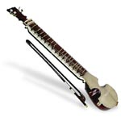
Provisional Outline Programme:
9.30 | Registration & free refreshments – the committee will be there to welcome you!
10.00 – 10.40 | Plenary:  Welcome & Introductions & Official launch of ALL London Branch Community electronic forum.  Narinder Kaur, Head of Community Languages at Cranford Community College and Head of Community Languages Committee, ALL London,  Helen Myers, Chair of ALL London,  ‘Taking Community Languages forward – Opportunities and Challenges.  Dr Jim Anderson, Lecturer in Modern Languages in Education, Goldsmith’s College, University of London & Hilly Day , Asset Languages & NRC representative  Overview of resources/support available: Asset & National Resource Centre & CILT
10. 45-11.35 | Session 1 A choice from 4 talks (see overleaf)
11.35 – 12.00 | Comfort break / refreshments / chance to ‘network’ / view info sent from publishers and supporters, including a CILT, Asset and NRC stand
12.05 -12.55 | Session 2 A choice from 4 talks (see overleaf)
1.00 | Community Lunch (hosted by Cranford Community College) - Meet up together to continue relaxed networking!  A short musical performance

MAP (http://www.multimap.com/maps/?hloc=GB|TW5%209PD)
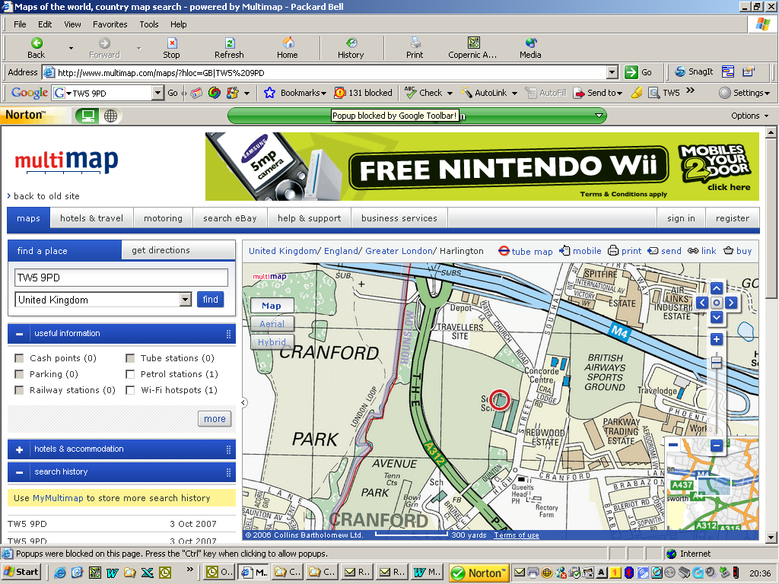

Bus maps: http://www.tfl.gov.uk/tfl/gettingaround/maps/buses/pdf/cranford-13613.pdf
REGISTRATION FORM

As refreshments will be provided throughout the event we need to know how many people are intending to attend.

Preferably, please send in the application form by post or by email below to the college along with payment by Thursday 22nd November to secure you a definite place.

PLEASE NOTE: To cut down costs and administration time, we won’t send confirmation unless you particularly ask for it... assume you have a place if you have paid unless you hear otherwise!

If you need any more information, or if you’ve missed the deadline, please ask. Thanks.

Application Form
To: Rakhvinder Gill, Cranford Community Language Community College, Hounslow
OR, if no time to send form, email info to her: RGI@cranford.hounslow.sch.uk & send cheque separately
London All & Cranford - Community Languages Event ; Saturday 1st December, 9.30 – 1 pm followed by lunch, Cranford Community Language College
Name
Establishment
Work Telephone Number
Home Address

Home Telephone Number
E-mail
Languages taught

I enclose cheque (payable to ALL LRB) to the value of £__________ as payment for (No.)_________ persons as listed below (BLOCK CAPITALS please):

Name ___________________________________

Name ____________________________________

Name ___________________________________

Please attach details of any issues which you would like us to raise on the day.

