

ASSOCIATION FOR LANGUAGE LEARNING
LONDON REGION BRANCH
www.all-london.org.uk

- Would you like to find out about how the Association for Language Learning can help YOU?
- Would you like to spread your circle of friends in the Languages World, meeting other students from other colleagues & meeting a bunch of keen enthusiastic teachers?
You are invited to
The ALL Reception Evening
for PGCE + GTP Language Students
in the London Area
on
Monday 9th October 2006 1730-1900
to be held at
Nunn Hall, Institute of London.
20, Bedford Way, London WC1H OAL
Telephone 020 7612 6000
Nearest tube: Russell Square. For map, visit site: www.ioe.ac.uk
Free!
Outline Programme:
1700 | Registration & wine and nibbles – the committee will be there to welcome you!
1730 | Intro to the London Branch of ALL + Top Tips from our Committee members - Committee members will introduce themselves and give their ‘top tips’ for survival of your training year and beyond!
1810 | Support for languages from Institutes, Embassies and CILT – we will advise you about support in London, including information from the Goethe-Institut
1840 | David Wilson, President of ALL,will share some thoughts and ideas with us and invite you to be Associate members – free of charge!
1855 | Round-up –ALL events / issue of INSET certificates
1900 - 1930 | Networking over refreshments
& next? | Why not take advantage of this venue to spend the evening in town?

Looking forward to seeing you –
bring a fellow language student from another training institution

If you would like any more information about the evening, you can contact Sharon Mangion: smcmangion@yahoo.co.uk

☺ dates for your diary – please turn over! ☺

FUTURE EVENTS .... Please pencil these into your diary!
Please check our website for up-dates and fuller information! www.all-london.org.uk

Saturday 7th October 06 | Austrian Day
Friday 20th October 06 | Ashcombe ICT workshop | Dorking
Fri 3rd – Sun 5th November 06 | London Language Show – visit our stand! | Olympia
Sat 4th November | Spanish ICT day | JAGS
Wednesday 15th November 06 | Ashcombe ICT workshop | Dorking
Thursday 11th – Sun 14th December 06 | BETT Show – an ALL speaker will be represented – visit our stand! | Olympia
Saturday 27th January 2007 | The January Event – Rachel Hawkes: use of song + Joe Dale : ICT tricks | TBC
Monday 5th February 07 | Ashcombe ICT workshop | Dorking
Fri 30th & Sat 31st March 07 | Language World | Oxford
Thursday 7th June 07 | Ashcombe ICT workshop | Dorking
Saturday 16th June 07 | The June Event | TBC
Friday 29th June 07 | Ashcombe ICT workshop | Dorking

WAYS TO KEEP IN TOUCH AND SHARE IDEAS AND RESOURCES:

ALL
For members of ALL ...
Join ALLNet

simply send an email to sharonc@all-languages.org.uk and type in the text your name, ALL membership number and the word ‘subscribe’.

CILT
Join Linguanet:
http://www.mailbase.org.uk/lists/linguanet-forum/
then click on ‘join’

PRIVATE FORA

Join mflresources, mflresources2 and mflresources3:

http://groups.yahoo.com/group/mflresources/
http://groups.yahoo.com/group/mflresources2/
http://groups.yahoo.com/group/mflresources3

TES FORUM:
www.tes.co.uk

As refreshments will be provided, it would be very helpful to know how many people are intending to attend. Please send or email the application form below to Alison Owen, by Weds October 4th; otherwise send an email with the information to her,
PLEASE NOTE: To cut down costs and administration time, we won’t send confirmation unless you particularly ask for it... assume you have a place unless you hear otherwise!
If you need any more information please ask. Thanks.

Application Form
To: Mrs Alison Owen, The Ashcombe School, Ashcombe Road, Dorking RH4 1LY
OR, if no time to send form, email info to her: ao@ashcombe.surrey.sch.uk or phone 01306 886312
London ALL Student Reception Event ; Monday 9th October 2006 Institute of Education
Name
Establishment
Work Telephone Number
Home Address

Home Telephone Number
E-mail

Name ________________________________________

Travel directions web link – click on map on this page: http://ioewebserver.ioe.ac.uk/ioe/index.html

If you forget to contact us, DON’T WORRY! Just turn up and we’ll be pleased to see you!
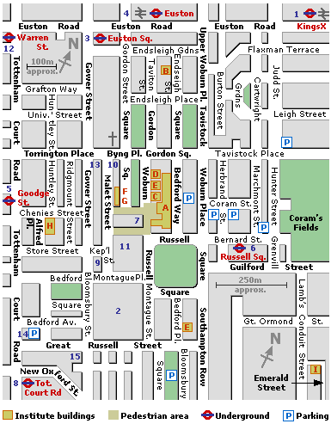
Nunn Hall, Institute of Education,
20, Bedford Way
Russell Square
(Piccadilly Line)

