

ASSOCIATION FOR LANGUAGE LEARNING
LONDON REGION BRANCH
www.all-london.org.uk
To download this invitation: http://www.all-london.org.uk/pgce_2008.htm
- Would you like to find out about how the Association for Language Learning can help YOU?
- Would you like to spread your circle of friends in the Languages World, meeting other students from other colleagues & meeting a bunch of keen enthusiastic teachers?
You are invited to
The ALL Reception Evening
for PGCE + GTP Language Students
in the London Area
on
Monday 6th October 2008 1730-1900
to be held at
Nunn Hall, Institute of Education, London.
20, Bedford Way, London WC1H OAL
Telephone 020 7612 6000
Room will be indicated in the main foyer.
Nearest tube: Russell Square. For map, visit site: www.ioe.ac.uk
Free!
Outline Programme:
1700 | Registration & wine and nibbles – the committee will be there to welcome you!
1730 | Intro to the London Branch of ALL + Top Tips from our Committee members - Committee members will introduce themselves and give their ‘top tips’ for survival of your training year and beyond!
 | Support for languages from Institutes, Embassies and CILT – we will advise you about support in London - The Goethe Institut will be there 'in person'!
1840 | Helen Myers, Past President of ALL, will share some thoughts and ideas with us and invite you to be members – free membership for students & NQTs!
1855 | Round-up –ALL events / issue of INSET certificates
1900 - 1930 | Networking over refreshments
& next? | Why not take advantage of this venue to spend the evening in town?

Looking forward to seeing you – please encourage others to come!

If you would like any more information about the evening, you can contact : Leanne Simmonds: leannesimmonds@yahoo.co.uk

Anyone will be welcome to 'turn up on the door', but as refreshments will be provided, it would be very helpful to know how many people are intending to attend. Please send or email the application form below to Alison Owen, by Thursday October 2nd, otherwise send an email with the information to her,
PLEASE NOTE: To cut down costs and administration time, we won’t send confirmation unless you particularly ask for it... assume you have a place unless you hear otherwise!
If you need any more information please ask. Thanks.

Application Form
To: Mrs Alison Owen, The Ashcombe School, Ashcombe Road, Dorking RH4 1LY
OR, if no time to send form, email info to her: ao@ashcombe.surrey.sch.uk or phone 01306 886312
London ALL Student Reception Event ; Monday 6th October 2008 Institute of Education
Name
Establishment
Work Telephone Number
Home Address

Home Telephone Number
E-mail

Travel directions web link – click on map on this page: http://ioewebserver.ioe.ac.uk/ioe/index.html

If you forget to contact us, DON’T WORRY! Just turn up and we’ll be pleased to see you!
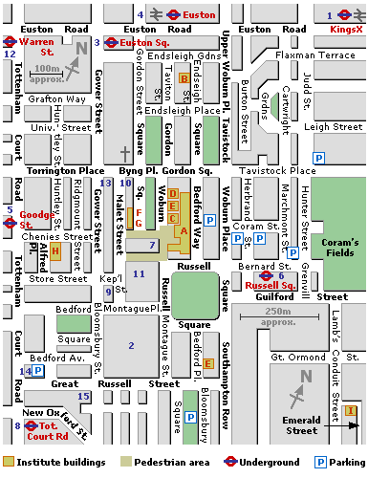
Institute of Education,
20, Bedford Way
Russell Square
(Piccadilly Line)

