

ASSOCIATION FOR LANGUAGE LEARNING
LONDON REGION BRANCH
www.all-london.org.uk

- Would you like to find out about how the Association for Language Learning can help YOU?
- Would you like to spread your circle of friends in the Languages World, meeting other students from other colleagues & meeting a bunch of keen enthusiastic teachers?
You are invited to
The ALL Reception Evening
for PGCE + GTP Language Students
in the London Area
on
Monday 5th October 2009 1730-1930
to be held at
Nunn Hall, Institute of Education, London.
20, Bedford Way, London WC1H OAL
Telephone 020 7612 6000
Nearest tube: Russell Square. For map, visit site: www.ioe.ac.uk
Free!
Outline Programme:
1730 | Registration & wine and nibbles – the committee will be there to welcome you!
1800 | Intro to the London Branch of ALL + Top Tips from our Committee members - Committee members will introduce themselves and give their ‘top tips’ for survival of your training year and beyond!
 | Support for languages from Institutes, Embassies and CILT – we will advise you about available support in London.
1855 | Helen Myers, Chair of ALL London will share some thoughts and ideas with us and invite you to be members – free membership for students & NQTs!
1910 | Round-up –ALL events / issue of INSET certificates
1910 - 1930 | Networking over refreshments
& next? | Why not take advantage of this venue to spend the evening in town or see what’s on at one of London’s best arthouse cinemas and friend of foreign film, The Renoir, www.curzoncinemas.com/venues/renoir_cinema.
Looking forward to seeing you – please encourage others to come!

If you would like any more information about the evening, you can contact Leanne Simmonds: leannesimmonds@yahoo.co.uk
☺ dates for your diary – please turn over! ☺

FUTURE EVENTS ...Please pencil these into your diary!
Please check our website www.all-london.org.uk and the national website www.all-languages.org.uk for updates and full information!

Mon 5th October 09 5.30pm -7 pm | Student Reception, Institute of Education WC1H 0AL
Sat 10th October 09 | ALL Italian Day, Italian Cultural Institute, Knightsbridge SW1X 8NX
Weds 14th October 09 | Ashcombe ICT workshop RH4 1LY
Sat 17th October 09 | ALL French Day, Institut français, London, SW7 2JR  Austrian Day, Goethe Institut,
Oct 30th - 1st November 09 | London Language Show, Olympia2, Kensington W14 8UX
Sat 31st October 09 | Show and Tell/Social, The Albion Function Room, Hammersmith W14 0QL (6 pm onwards)
Friday 13th November 09 | Ashcombe China Day, Ashcombe School RH4 1LY
Saturday 21st November 09 | ALL London Spanish Event, Davenant School, Chester Road, Loughton, Essex IG10 2LD
Tue 1st December 09 | ALL London Committee meeting (CILT) SE1 7HR
Thu 3rd December 09 | CILT 14-19 conference, Birmingham
Weds 13th - Sat 16th 10 | BETT exhibition (ALL stand), Olympia
Sat 23rd January 10 | The January Event! University of Westminster W1W 6UW
Sat 6th February | ISMLA annual conference
Mon 8th Feb 10 | Ashcombe ICT Workshop, Ashcombe School, Dorking
Tue 2nd March 10 | LRB Committee Meeting CILT SE1 7HR  1730-1900
Mon 12th & Tue 13th April | CILT Primary Show (Liverpool)
Fri 26 & Sat 27th March 10 | ALL Language World, York
Thu 27th May 10 | LRB Committee Meeting CILT SE1 7HR  1730-1900
Mon 7th & Tue 8th June 2009 | International Boys School Conference, Dulwich College
Thu 10th June 10 | Ashcombe ICT Workshop, Ashcombe School RH4 1LY
Sat 19th June 10 | ALL London June Event - Institut français, London, SW7 2JR

WAYS TO KEEP IN TOUCH AND SHARE IDEAS AND RESOURCES:

ALL
For members of ALL ...
Join ALLNet

Simply send an email to info@all-languages.org.uk and type in the text your name, ALL membership number and the word ‘subscribe’.

CILT
Join Linguanet:
http://www.mailbase.org.uk/lists/linguanet-forum/
then click on ‘join’

PRIVATE FORA:

Join mflresources, mflresources2 and mflresources3:

http://groups.yahoo.com/group/mflresources/
http://groups.yahoo.com/group/mflresources2/
http://groups.yahoo.com/group/mflresources3

TES FORUM:
www.tes.co.uk

Anyone will be welcome to 'turn up on the door', but as refreshments will be provided, it would be very helpful to know how many people are intending to attend. Please send or email the application form below to Sarah Bowley or, otherwise, send an email with the information to her,
PLEASE NOTE: To cut down costs and administration time, we won’t send confirmation unless you particularly ask for it; please do assume you have a place unless you hear otherwise!
If you need any more information, please ask. Thanks.

Application Form
To: Mrs Sarah Bowley, The Ashcombe School, Ashcombe Road, Dorking RH4 1LY
OR, if no time to send form, email info to her: bowley.sarah@ashcombe.surrey.sch.uk
or phone 01306 886312
London ALL Student Reception Event ; Monday 5th October 2009 Institute of Education
Name
Establishment
Work Telephone Number
Home Address

Home Telephone Number
E-mail

Name ________________________________________

Travel directions web link – click on map on this page: http://ioewebserver.ioe.ac.uk/ioe/index.html

If you forget to contact us, DON’T WORRY! Just turn up and we’ll be pleased to see you!
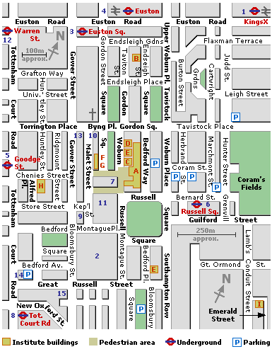
Institute of Education,
20, Bedford Way
London WC1H 0AL
Russell Square
(Piccadilly Line)

