

ASSOCIATION FOR LANGUAGE LEARNING
LONDON REGION BRANCH
www.all-london.org.uk

- Would you like to find out about how the Association for Language Learning can help YOU?
- Would you like to spread your circle of friends in the Languages World, meeting other students from other colleagues & meeting a bunch of keen enthusiastic teachers?
You are invited to
The ALL Reception Evening
for PGCE + GTP Language Students
in the London Area
on
Monday 1st October 2012 5.30 pm – 6.40 pm
to be held at
The Drama Studio (level 1), Institute of Education, London.
20, Bedford Way, London WC1H OAL
Telephone 020 7612 6000
Nearest tube: Russell Square. For map, visit site: www.ioe.ac.uk
Free!
Outline Programme:
5.00 pm onwards- arrive any time! | Registration – the committee will be there to welcome you! Please join our email list to receive information about the great events we hold during the year.  Networking over refreshments -free wine and nibbles
5.00– 5.30 | Carousel activities as you wait for the main sessions, to including ‘How to write your CV’ (please bring 2 copies of your CV and managers will take a look and advise); Games in the classroom; Look at LINGUASCOPE resources ..
5.30 | (1) Short introduction to the London Branch of ALL Helen Myers, Chair of ALL London will share some thoughts and ideas with us and invite you to be members- special package for student teachers. Including introduction to Webinar room which will be open. (If you cannot make this meeting, please join us there: http://lancelot.adobeconnect.com/all-london  (2) Top Tips from our Committee: a series of short talks covering teaching and managing behaviour
6.40 | Round-up –ALL events / issue of INSET certificates
& next? | Why not take advantage of this venue to spend the evening in town or see what’s on at one of London’s best arthouse cinemas and friend of foreign film, The Renoir, www.curzoncinemas.com/venues/renoir_cinema.
Looking forward to seeing you – please encourage others to come!
If you would like any more information about the evening, you can contact Cat Fox:
☺ dates for your diary – please turn over! ☺

FUTURE EVENTS ...Please pencil these into your diary!
Please check our website www.all-london.org.uk and the national website www.all-languages.org.uk for updates and full information!

Mon 1st October 12 | Student Reception, Institute of Education WC1H 0AL
Weds 14th October 12 | Ashcombe ICT workshop RH4 1LY
Fri Oct 19th – Sun 21stOctober 12 | London Language Show, Olympia W14 8UX
Sat Oct 20th | Language Show Live 2012, National Hall, Olympia London W14 8UX  16:45 - 17:45 Language teachers together: Show and Tell! FOLLOWED BY A SOCIAL at a pub opposite the venue … Down The Albion … 6 pm onwards
Sat 20th October 12 | Social get together, The Albion Function Room, Hammersmith W14 0QL (6 pm onwards)
Thu 6th December 12 | ALL London Committee meeting Linguascope E2 7PR Followed by meal (Tell us if you’d like to join the committee!)
Sat 19th January 13 | The January Event! Venue TBC
Thu 30th Jan- Sat 2nd Feb 2013 | BETT exhibition
Sat 2nd February | ISMLA annual conference. York
Weds 23rd January 13 | Ashcombe ICT Workshop, Ashcombe School, Dorking
Tue 5th March 13 | LRB Committee Meeting  1730-1900 Linguascope E2 7PR
Fri 22nd – Sat 23rd March 2013 | ALL Language World, Nottingham
Thu 23rd May 13 | LRB Committee Meeting, Linguascope E2 7PR
Weds 26th June 13 | Ashcombe ICT Workshop, Ashcombe School RH4 1LY
Sat 15th June 13 | ALL London June Event  Westminster University  http://www.linguascope.com/junevent/

WAYS TO KEEP IN TOUCH AND SHARE IDEAS AND RESOURCES:

ALL
For members of ALL ...
Join ALLNet

Simply send an email to info@all-languages.org.uk and type in the text your name, ALL membership number and the word ‘subscribe’.

NETWORK LANGUAGES
Join Linguanet:
http://www.mailbase.org.uk/lists/linguanet-forum/
then click on ‘join’

PRIVATE FORA:

Join mflresources, mflresources2 and mflresources3:

http://groups.yahoo.com/group/mflresources/
http://groups.yahoo.com/group/mflresources2/
http://groups.yahoo.com/group/mflresources3

TES FORUM:
www.tes.co.uk

Anyone will be welcome to 'turn up on the door', but as refreshments will be provided, it would be very helpful to know how many people are intending to attend. Please send or email the application form below to Sarah Bowley or, otherwise, send an email with the information to her,
PLEASE NOTE: To cut down costs and administration time, we won’t send confirmation unless you particularly ask for it; please do assume you have a place unless you hear otherwise!
If you need any more information, please ask. Thanks.

Application Form
To: Mrs Sarah Bowley, The Ashcombe School, Ashcombe Road, Dorking RH4 1LY
OR, if no time to send form, email info to her: bowley.sarah@ashcombe.surrey.sch.uk
or phone 01306 886312
London ALL Student Reception Event ; Monday 1st October 2012 Institute of Education
Name
Establishment
Work Telephone Number
Home Address

Home Telephone Number
E-mail

Name ________________________________________

Travel directions web link – click on map on this page: http://ioewebserver.ioe.ac.uk/ioe/index.html

If you forget to contact us, DON’T WORRY! Just turn up and we’ll be pleased to see you!
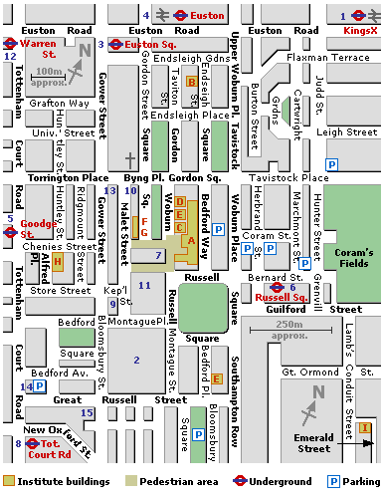
Institute of Education,
20, Bedford Way
London WC1H 0AL
Russell Square
(Piccadilly Line)

