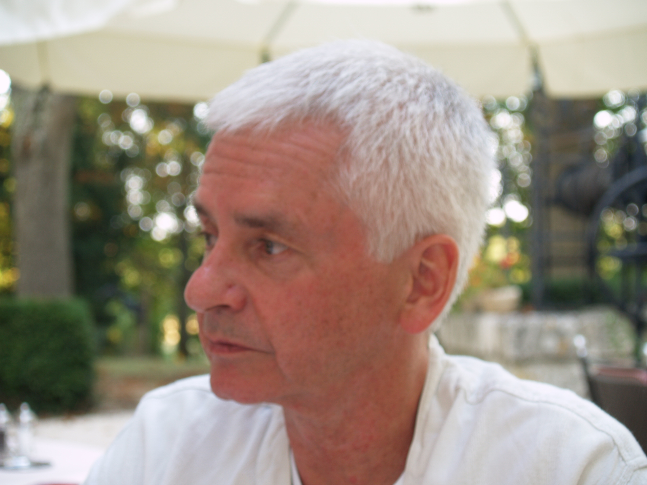

ARRANGEMENTS FOR March 4th 2009

11.00am Service of Remembrance
St. Luke’s Church
Phipps Hatch Lane
Enfield
EN2 0HG

12.45pm Private cremation

1.00pm Celebration of the life of David at
Royal Chace Hotel
162 The Ridgeway
Enfield,
EN2 8AR

Both the service and the celebration are open to anyone who would like to join us at these occasions, to meet with old friends, share reminiscences and remember David.

Family flowers only but donations to the Loquax Foundation via Loquax Languages. Cheques made payable to ‘Loquax Languages’ – Marked Foundation on reverse.

