draft as at 4-Apr-06

Additions to Statement from CEM report

Methodology to be inserted after “Historical context”
When comparing the grades gained by pupils in different subjects, you can either do the comparisons on the basis of
- prior attainment - i.e look at pupils with the same results at an earlier stage (typically Key Stage 3 test results) and then compare the grades gained by those pupils in the different subjects (at GCSE). This is the basis of value-added analysis e.g. as used by DfES
- concurrent attainment - i.e. look at the grades gained by individual pupils in the different subjects, and then compare the accumulation of outcomes. There are two ways of doing this:
i) PANDA Relative Performance Index (RPI) - for each pupil, compare the difference between the grade (score) in the particular subject, and the average grade (score) of that pupil in all their other subjects.
ii) Durham CEM Rasch model (publ. Mar 06) - This looks at the probabilities (odds) of a pupil who gets a certain grade in one subject getting a certain grade in another. The model then calculates “difficulties” for subjects and grades that best match all the combinations of pupils, subjects and grades. “The grade difficulty depends on the relative probabilities of that grade being achieved by candidates of different ability, as determined by their performance in all their subjects and taking into account the different difficulties of all the grades they have gained.” These “difficulties” can then be converted back into “grade” units for comparison and dicussion. Note that the higher the number the more “difficult” the subject, which is the opposite way round to the prior attainment analysis (where comparable pupils will be gaining lower numbers in the more “difficult” subjects).

Outcomes to be inserted in 1. GCSE after “DfES value-added”
In practice, all three methods give similar outcomes. In particular, for MFL at GCSE, the CEM Rasch model gives a very similar outcome to the other two methods. For grade C, French, Spanish and German are half a grade more “difficult” than subjects such as Science (dual), Geography, History, Maths, and a grade more “difficult” than English, PE, Drama, DT and Art.

Commentary to be inserted before “Summary”
The research from CEM was reported on in the TES on 31 Mar 2006. Some extracts from the TES article and the CEM website follow:
- Dr Coe analysed a national dataset of over 600,000 students to compare the grades achieved in each subject with the grades achieved by the same student in their other subjects. Some subjects do come out as apparently 'harder' than others, though it makes a difference which grade you look at. (CEM)
- The figures will alarm the exam regulator, however. It has argued that all GCSEs are equally difficult to do well in. (TES)
- They concluded that, students, whatever their ability, would be more likely to achieve good grades in subjects such as drama and PE, than in science and languages. (TES)
- Robert Coe, director of secondary projects at Durham university’s Curriculum, Evaluation and Management Centre, who led the research, said: “It’s hard to deny that there are differences in the difficulty levels of particular subjects.” (TES)
- Dr Coe said it was unlikely that this [better teaching, motivation, time allocation] explained all of the differences. The analysis is powerful in that it offers more information than can be gleaned by analysing “raw” results in GCSE subjects each year. (TES)

Data and graphs for CEM Rasch model to be inserted in Appendix 1. GCSE as 8. CEM Rasch model

Further explanation of methodology
This looks at the probabilities (odds) of a pupil who gets a certain grade in one subject getting a certain grade in another. The model then calculates “difficulties” for subjects and grades that best match all the combinations of pupils, subjects and grades.

So for the 600,000 pupils, the model counts the number of pupils doing say French and English, and getting a grade B in French and a grade E in English, and converts these to probabilities. This is repeated for all combinations of subjects and grades. If all subjects were equally difficult, then there would be a equivalence between the probability of getting a grade B in French and a grade E in English, and vice versa. If one subject is “harder” than the other, then there will be a mismatch in these probabilities.

Table 2: Rasch coefficients for main full subjects, and conversion to grade units (subjects sorted by the grade C values)

Rasch coefficients
 | Spanish | German | French | History | Science Dbl | IT | DT Graphic | Geography | RS | Bus Studs | Maths | Eng. Lit | English | Sport PE | DT Food T | Drama | DT Res Mat | Art
G | -0.4 | -0.41 | -0.45 | -0.45 | -0.65 | -0.43 | -0.45 | -0.51 | -0.45 | -0.48 | -0.69 | -0.62 | -0.78 | -0.68 | -0.59 | -0.58 | -0.61 | -0.62
F | -0.28 | -0.27 | -0.3 | -0.33 | -0.44 | -0.31 | -0.35 | -0.38 | -0.33 | -0.37 | -0.46 | -0.45 | -0.53 | -0.49 | -0.45 | -0.45 | -0.45 | -0.45
E | -0.13 | -0.15 | -0.17 | -0.2 | -0.3 | -0.2 | -0.24 | -0.26 | -0.22 | -0.25 | -0.3 | -0.33 | -0.38 | -0.35 | -0.34 | -0.33 | -0.33 | -0.33
D | 0.01 | -0.01 | -0.03 | -0.07 | -0.14 | -0.08 | -0.09 | -0.11 | -0.1 | -0.1 | -0.14 | -0.18 | -0.22 | -0.2 | -0.2 | -0.2 | -0.2 | -0.21
C | 0.17 | 0.16 | 0.14 | 0.08 | 0.06 | 0.05 | 0.05 | 0.05 | 0.04 | 0.04 | 0.04 | 0.01 | -0.01 | -0.04 | -0.04 | -0.05 | -0.05 | -0.07
B | 0.35 | 0.35 | 0.34 | 0.27 | 0.27 | 0.25 | 0.23 | 0.27 | 0.22 | 0.26 | 0.26 | 0.24 | 0.24 | 0.11 | 0.17 | 0.14 | 0.17 | 0.12
A | 0.53 | 0.55 | 0.53 | 0.48 | 0.46 | 0.44 | 0.42 | 0.47 | 0.42 | 0.43 | 0.49 | 0.47 | 0.48 | 0.3 | 0.37 | 0.34 | 0.37 | 0.33
A* | 0.78 | 0.84 | 0.83 | 0.8 | 0.75 | 0.73 | 0.68 | 0.78 | 0.71 | 0.65 | 0.78 | 0.77 | 0.79 | 0.52 | 0.65 | 0.59 | 0.64 | 0.56

Converted to “grade” units
Note that the higher the number the more “difficult” the subject, which is the opposite way round to the prior attainment analysis (where comparable pupils will be gaining lower numbers in the more “difficult” subjects)

 | Spanish | German | French | History | Science Dbl | IT | DT Graphic | Geography | RS | Bus Studs | Maths | Eng. Lit | English | Sport PE | DT Food T | Drama | DT Res Mat | Art
A* | 9.0 | 9.3 | 9.3 | 9.1 | 8.8 | 8.7 | 8.4 | 9.0 | 8.6 | 8.3 | 9.0 | 8.9 | 9.0 | 7.6 | 8.3 | 7.9 | 8.2 | 7.8
A | 7.6 | 7.7 | 7.6 | 7.3 | 7.2 | 7.1 | 7.0 | 7.3 | 7.0 | 7.1 | 7.4 | 7.3 | 7.3 | 6.4 | 6.7 | 6.6 | 6.7 | 6.5
B | 6.6 | 6.6 | 6.6 | 6.2 | 6.2 | 6.1 | 6.0 | 6.2 | 5.9 | 6.1 | 6.1 | 6.0 | 6.0 | 5.3 | 5.6 | 5.5 | 5.6 | 5.4
C | 5.6 | 5.6 | 5.5 | 5.1 | 5.0 | 5.0 | 5.0 | 5.0 | 4.9 | 4.9 | 4.9 | 4.8 | 4.6 | 4.5 | 4.5 | 4.4 | 4.4 | 4.3
D | 4.8 | 4.6 | 4.5 | 4.3 | 3.9 | 4.3 | 4.2 | 4.1 | 4.2 | 4.2 | 3.9 | 3.7 | 3.5 | 3.6 | 3.6 | 3.6 | 3.6 | 3.5
E | 4.0 | 3.9 | 3.8 | 3.6 | 3.1 | 3.6 | 3.4 | 3.3 | 3.5 | 3.3 | 3.1 | 2.9 | 2.6 | 2.8 | 2.8 | 2.9 | 2.9 | 2.9
F | 3.2 | 3.2 | 3.1 | 2.9 | 2.3 | 3.0 | 2.8 | 2.6 | 2.9 | 2.7 | 2.2 | 2.2 | 1.8 | 2.0 | 2.2 | 2.2 | 2.2 | 2.2
G | 2.5 | 2.4 | 2.2 | 2.2 | 1.1 | 2.3 | 2.2 | 1.9 | 2.2 | 2.1 | 0.9 | 1.3 | 0.4 | 1.0 | 1.5 | 1.5 | 1.3 | 1.3

Table plotted as graphs

1. subjects sorted by the grade C values

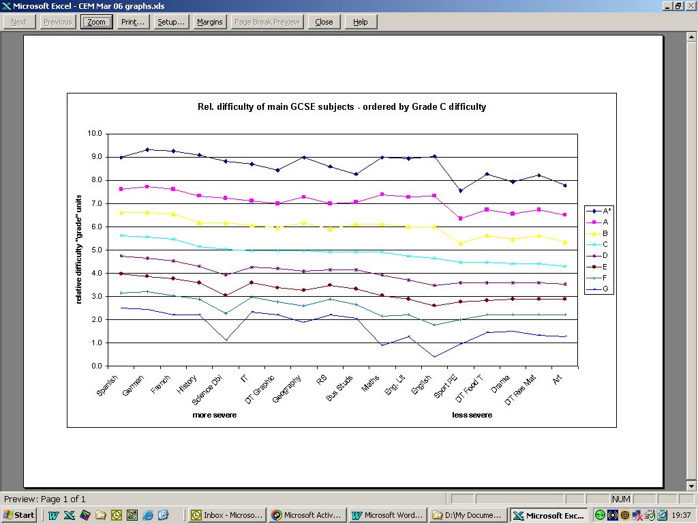

2. subjects sorted by the grade B values
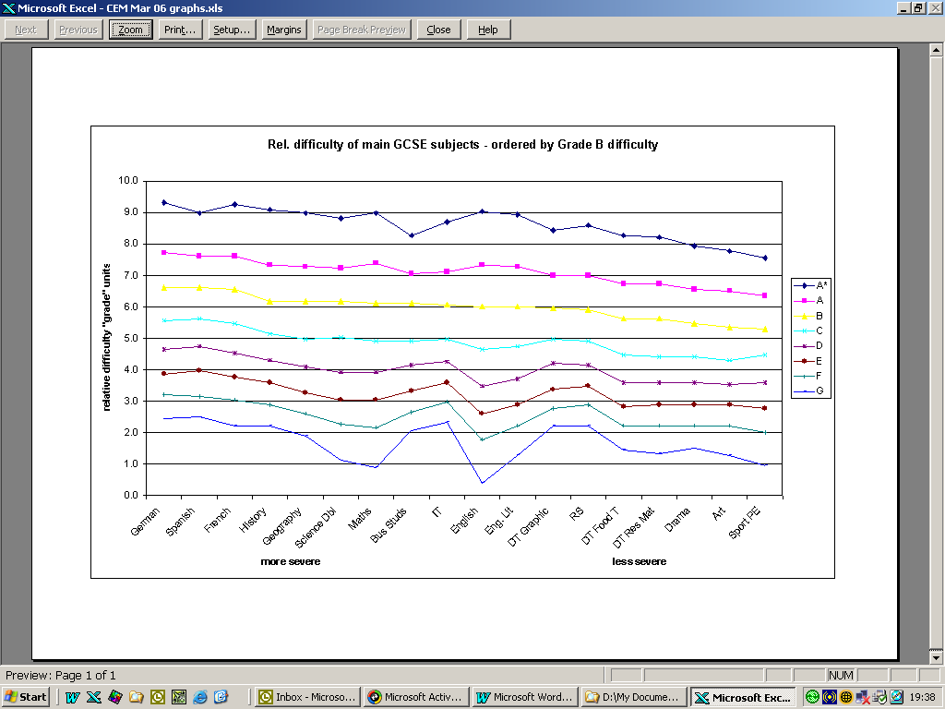

Interpretation of graphs

Note that the higher the number the more “difficult” the subject, which is the opposite way round to the prior attainment analysis (where comparable pupils will be gaining lower numbers in the more “difficult” subjects)

By reference to the original CEM paper, there is a detailed discussion of the technical issues regarding the analysis, such as which subjects out of all those studied fitted the model etc. From this, 34 subjects were selected (excluding music, and fine art, and many short courses). This has been reduced further to those studied by a substantial number (approx. greater than 50,000). The paper also includes a discussion about the differences between each of the grades, and how the Rasch coefficients were converted to “grade” units.

The “difficulties” do vary according to the grades (as do the other measures such as value-added). But by looking at the middle grades, a consistent pattern emerges:

Modern Languages (Spanish, French and German)
are half a grade more “difficult” than
main cluster of subjects (Science (dual), IT, Geography, RS, Busi. St., Maths, Eng. Lit) which
are half a grade more “difficult” than
“practical” subjects (Sport/PE, DT Food Techn., Drama, DT Resistant Materials, Art)

History is on the “more difficult” side of the middle cluster; English is one the “less difficult” side.

This is consistent with the findings from the other forms of analysis such as value-added, and tend to support the theory that there is systematic “severe grading”.

