LA CULTURE FRANCOPHONE
Que sais-je?

As well as learning the language, it is important (and hopefully interesting) to learn about the cultural / political / historical / social / geographical background of the people who speak the language.

You will be doig some tasks relating to the Cannes Film Festival. Here is some background in English!

References:
http://www.festival-cannes.fr/ | Official site
http://en.wikipedia.org/wiki/Cannes_film_festival | Overview in English
http://www.linternaute.com/sortir/cinema/festival-de-cannes/ | Popular electronic magazine which gives info via photos + text about the festival.
http://www.cannesguide.com/ | A Festival Virgin's Guide

FESTIVAL BASICS
For 12 days in May the city of Cannes is transformed from a quiet seaside resort into the entire focus of the international film industry. Over 200,000 people – filmmakers, film fans, and star-gazers alike – descend on the Croisette to take part in the Cannes Film Festival (or more correctly, the Festival de Cannes). During these two weeks thousands of films are screened, careers are made (and ruined), and stars from all over the world gather to bask in the limelight.
Ever since the early 1950s, when a bikini-clad Brigitte Bardot frolicked on the beach for the cameras, Cannes has grown to embody two of the world's favourite pastimes: sex and cinema. Now easily the most famous film festival of them all, the mere mention of Cannes conjures up images of red carpets, palm trees, scantily-clad starlets, the blinding flashes of a million paparazzi cameras, and of course, celebrity parties.

WHAT IS THE CANNES FILM FESTIVAL?
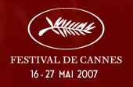
Extracts from WIKIPEDIA entry:
The Cannes Film Festival (French: le Festival international du film de Cannes or simply le Festival de Cannes), founded in 1939, is widely considered to be among the world's most prestigious film festivals.

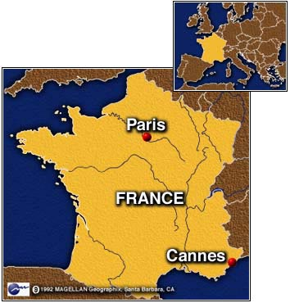
In May 2006, Hollywood Reporter acknowledged that Cannes is the "granddaddy of all film festivals" (although the oldest film festival in the World, beginning in 1932, is the Venice Film Festival).

The private festival is held annually, once a year, (usually in the month of May) in the resort town of Cannes, in the south of France.

The 60th Annual Cannes Film Festival will be held May 16 to 27, 2007.
The 61st will be held May 14 to 25, 2008.

The Festival takes place in the Palais des Festivals et des Congrès (Festival and Congress Palace)

HISTORY

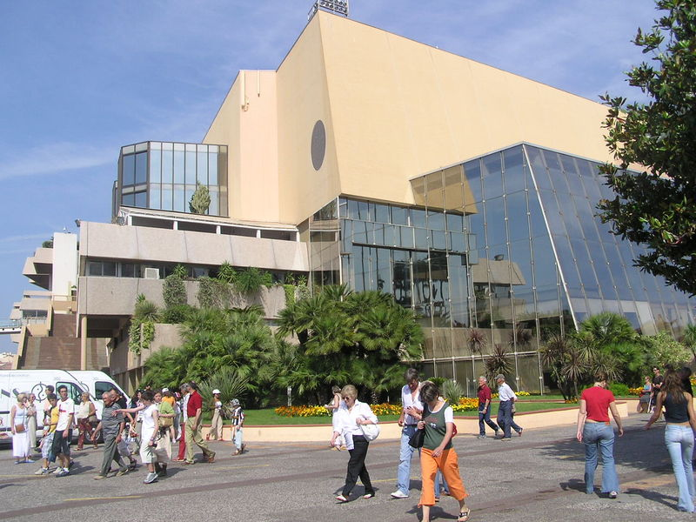
At the end of the year 1938, shocked by the interference of the fascist governments of Germany and Italy in the selection of films for the Mostra de Venise, Jean Zay, the French Minister of National Education, decided, on the proposal of Philippe Erlanger, to create an international cinematographic festival in Cannes. In June 1939, Louis Lumière agreed to be the president of the first festival, set to begin on September 1, 1939. The declaration of war against Germany by France and the United Kingdom on September 3, 1939, however, postponed the festival's premiere.

AWARDS

The most prestigious award given out at Cannes is the Palme d'Or ("Golden Palm") for the best film. The jury of the festival, made of a small international selection of movie professionals, grants other awards, including the Grand Prix ("Grand Prize") — the second most prestigious award.

Feature films
- Palme d'Or - Golden Palm
- Grand Prix du Festival International du Film - Grand Prize of the Festival (1946-1954)
- Prix de la mise en scène - Best Director
- Prix du Jury - Jury Prize
- La Caméra d'Or - Best first film
- Prix du meilleur scénario - Best Screenplay
- Prix d'interprétation féminine du Festival de Cannes - Best Actress
- Prix d'interprétation masculine du Festival de Cannes - Best Actor
- Prix un certain regard - Un Certain Regard Award
- Prix de la FIPRESCI - International Federation of Film Critics Prize

Short films
- Palme d'Or du Festival de Cannes - court métrage
- Prix du Jury - court métrage

JURIES

Prior to the beginning of each event, the Festival de Cannes board of directors appoints four juries who will hold sole responsibility for selecting films from the festival crop which will receive the blessing of a Cannes award. Jurors are chosen from all walks of the international film industry, based on their body of work and respect from their peers. In many cases, jury membership (especially the presidency) is bestowed on a kind of 'lifetime achievement award' basis.

FESTIVAL STRUCTURE

There are actually four organisations several major sections that comprise what is commonly referred to as the "Cannes Film Festival".

1. Compétition | The competition is the festival's main event and this is where you'll find all the glamour and glory. Films screening in this section are referred to as being "in competition" and vie for an assortment of awards. The Holy Grail is of course the Palme d'Or (Golden Palm) for best picture, one of the most prestigious film awards on the planet. Winning the Palme d'Or generally gives the film a massive lift: for art-house films, it can bring in millions of extra dollars at the international box-office, for foreign films it means worldwide distribution. Historically, the competition has only been open to narrative films, although occasionally a documentary is slipped in (such as Michael Moore's "Fahrenheit 9/11" which won the top prize in 2004). The competition welcomes both features and shorts, and there are different awards in each category.
2. Hors Compétition"Out of Competition". | special events or films which did not necessarily meet the criteria for entering the competition.
3. Un Certain Regard | the main showcase section of the festival and is intended to be a "survey of current world cinema". Now has a prize: the Prix Un Certain Regard
4. Cinéfondation | competition for short and medium-length films made at film schools around the world – 3 awards
5. Cannes Classics | a selection of new or restored prints of classic films, tributes to foreign cinema, documentaries on filmmaking, and occasionally rare or rediscovered footage of from days gone by.
6. Tous les Cinémas du Monde"All Cinemas of the World" | a programme of films from selected countries which have historically had a low cinema output.
7. Semaine Internationale de la Critique (SIC)  "International Critics' Week" | a competition for around 14 features and shorts from first and second-time filmmakers - cash prizes are awarded for the best film in each category.
8. Quinzaine des Réalisateurs  "The Directors' Fortnight" | Created in 1968 by a group of French filmmakers to present films in a forum which was free from politics, censorship and elitism,
9. Marché du Film"The Film Market" or simply, the "Cannes Market", | tradeshow open to anyone who is looking to buy or has something to sell - and it's attended by around 10,000 film industry professional each year.

