

THE ASHCOMBE SCHOOL
Headteacher: D.J. Blow M.A.
Ashcombe Road, Dorking, Surrey RH4 1LY
Tel: 01306 886312 Fax: 01306 742537
e-mail: Info@ashcombe.surrey.sch.uk

Chinese Day

Friday, 13th November 2009

9.45am – 3pm
for Managers and Teachers involved in developing Chinese language and culture in their curriculum with an an opportunity to look at and order teaching materials from Heath Books, the leading supplier of Chinese educational books.

9.45 Registration and refreshments

10.00 Welcome
David Blow, Headteacher, The Ashcombe School

  - If this has happened to us, then it could happen for you
Reflections on successes with Chinese link schools during the last year
Sue Bullen, Jane Hamer, Danny Moloney

10.50 Questions / discussion (coffee / tea available)

11.00 English at KS3 and how we use our China links in English lessons
Rooney Hall, Head of English, The Ashcombe School

11.20 Open Forum
An opportunity for delegates to talk about other recent developments in any aspect of Chinese within their own institution, raising issues that are of benefit to others present

11.45 Opportunities for links with China
Richard French, British Council

12.20 Lunch and book display

1.10 Enhancing Mandarin learning with ICT
An opportunity to research resources in the Multi-media room

  - So there’s no such thing as a Primary Exchange to China?
Jennie Clarke, Outreach Teacher, The Ashcombe School

2.00 Chinese in the Primary Curriculum
Jane Gorecka, Headteacher, St. Martin’s Primary School

  - Options for Assessment
GSCE and Asset Languages: A view from teachers and pupils
Theresa Munford, teacher of Mandarin, The Ashcombe School

2.40 Chinese tea and plenary: questions, discussion and end of session

If you would like to attend our Chinese Day and/or contribute a session please email our Language College Secretary at the School on bowley.sarah@ashcombe.surrey.sch.uk. We are more than happy to amend the programme if anyone would like to input into the day. Please contact us.

I look forward to meeting you.
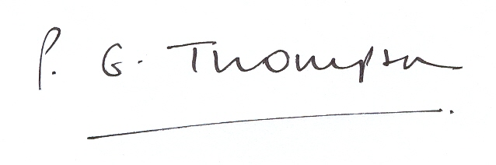
Peter Thompson
Deputy Head

