Cuirassés A  Pupils say sentence. Teacher highlights grid reference + changes font colour from white to black to reveal any points scored.  GCSE TOPICS  1D Daily Routine & 3B Healthy living |  | 6 | 6.15 | 6.30 | 6.45 | 6.20 | 6.40
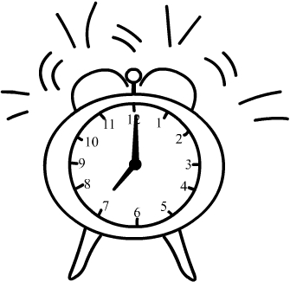 |  | 1 |  |  | 11 |  |  | 5
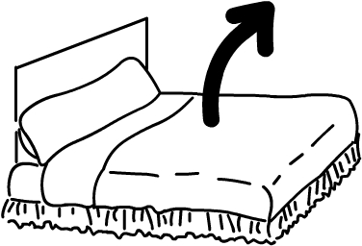 |  |  | 2 |  |  |  |  |  |  | 13
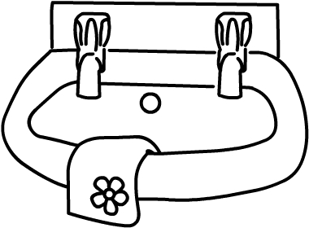 |  |  |  |  |  |  | 3 |  | 15
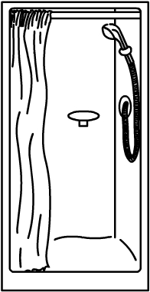 |  | 12 |  |  | 14
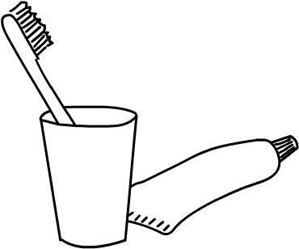 |  |  |  | 4 |  |  |  |  | 6
 |  |  |  |  |  |  |  |  |  | 10
 |  | 9 |  |  |  | 7 | 8

Cuirassés B
GCSE TOPICS
1D Daily Routine & 3B Healthy living
 |  | 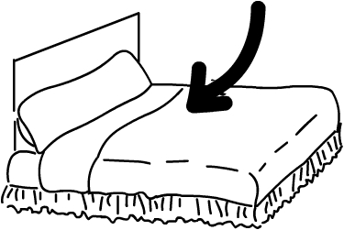 |  |  |  |  | 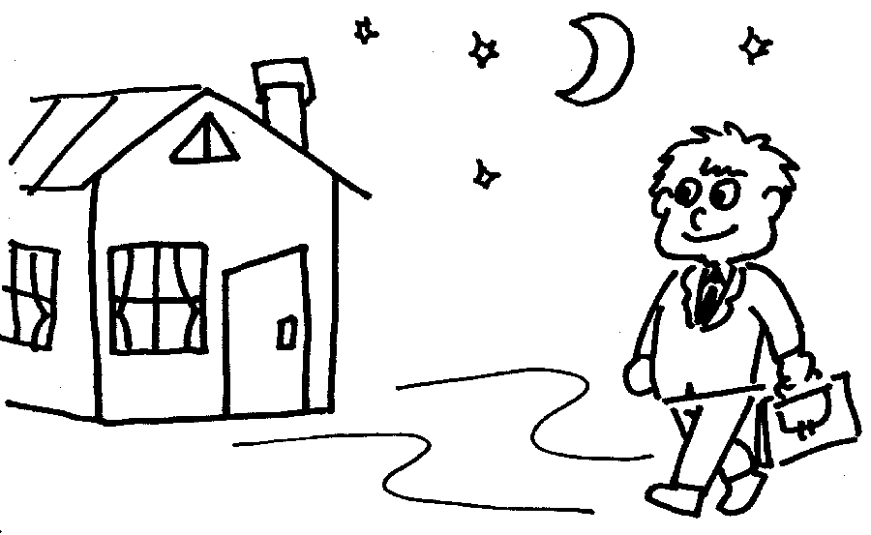
 |  |  |  |  |  |  |  | 5 | 7
 |  |  |  |  |  |  |  | 6 |  |  | 9
 |  | 4 |  |  | 3
 |  |  |  | 10 |  |  |  |  | 8
 |  |  |  | 2 |  |  |  |  |  |  | 1

