Cuirassés A  GCSE TOPICS  1D Daily Routine & 3B Healthy living |  | 6 | 6.15 | 6.30 | 6.45 | 6.20 | 6.40
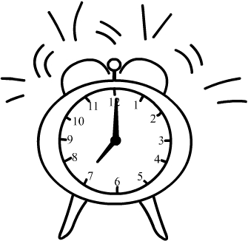
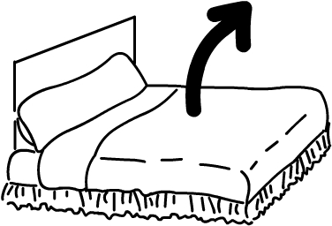
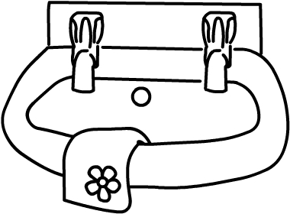
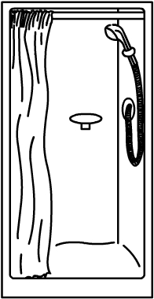


Cuirassés B
GCSE TOPICS
1D Daily Routine & 3B Healthy living
 |  | 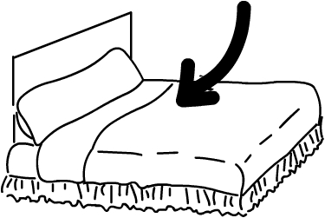 |  |  |  |  | 