Exploiting the World Cup for teaching MFL

Rationale:
Pupils engaged by topic which interests them – which gives then information they want to know.
Topic of World Cup ahould interests all through the nature of the topic and current relevance.

KNOWLEDGE UNDERSTANDING AND SKILLS which could be addressed:

Knowledge / understanding  (a) relating to country of target language  (b) relating to other countries if appropriate | People: Famous footballers / coaches in France (current and past)  Geography: Where the main French clubs are situated  Media: How public can find out about football (TV radio website press)  Football: colours worn, anthem sung, mascots, rules, equipment  Gestures: common gestures used!!  Language: chants, technical vocabulary
Specific language content | TOPICS  Chants  Clothing (kit)  Colours (kit, flags)  Dates (of matches / years – match year to venue)  Local environment (description of towns,facilities)  numbers (shorts)  Personal Identification  Technical core vocabulary relating to football  Towns + Countries (in Germany / home / target language country)  FUNCTIONS  Compare & Contrast  Opinions  GRAMMAR  comparatives, superlatives
Specific language skills | LISTENING: to  radio/TV commentary, new items  READING  web, magazines, emails, newspaper  WRITING  diary / results / profiles / reports ... display on wall / website  SPEAKING  opinions / recorded commentary in Powerpoints etc

LINKS TO LINKS!

http://www.elliott-school.org.uk/LangCol/Langcol/Langcolsport.html

http://www.sunderlandschools.org/international/resources-worldcup.htm
scroll to the pink section for links to language activities

http://www.ltscotland.org.uk/mfle/creativeteaching/worldcup/index.asp
Links to exercises and resources

2) READY-PREPARED ACTIVITIES
http://www.languagesonline.org.uk/
Activities in French, German and Spanish
http://www.the-voyage.com/e/infopoint/sport/deutschland06.html
Info from a German perspective

linguashare – go to ‘sports’ – Neil Jines has uploaded many of his resources there

Sources for all languages:

Ideas for exploiting world cup  Sunderland site ... general  PDF with ideas for all subject areas | http://www.sunderlandschools.org/international/resources-worldcup.htm  http://www.sunderlandschools.org/international/resources/WorldCup2006Sudoku.pdf
Sudoku .. could be translated into other languages | http://www.sunderlandschools.org/international/resources/WorldCup2006Sudoku.pdf
Document with useful links for all areas
Flags | http://www.sunderlandschools.org/international/resources/worldcupflags.pdf
World Cup History – interesting site in English – probable souce of penalty shoot out questions | http://www.worldcup.isn.pl/
Details about venues: city info, profile, tourist info, stadium profile (links to fifa site) | http://www.britishembassyworldcup.com/en/venues.htm
British Embassy World Cup site | http://www.britishembassyworldcup.com
World cup site – available in Gn En Sp French Portunguese | http://wm2006.deutschland.de/
World cup images used by Andrew Balaam for languageslinline (aso great for other images!!) |  | http://www.sevenoaksart.co.uk/worldcup1.htm
Football database acknowledged by A Balaam as source for languagesonline exercises |  | http://www.footballdatabase.com/site/home/index.php
What languages do they speak?  Grid to complete for Tunisia, Germany, Brazil, Paraguay, Switzerland, Australia, Italy, Netherlands |  | http://www.sunderlandschools.org/international/resources/WorldCup2006whatlangs.pdf
All news – teams, stadia etc in En Fr Gn Sp It and Portuguese | http://fifaworldcup.yahoo.com/06/en/index.html
Soccerlingua poster – gives key vocab in En Sp It Gn – not French! | http://soccerlingua.net/soccerlingua/index.php?id=114
CILT’s support of Starwatch  The resource pack contains a series of fifteen 'football, nutrition and fitness' worksheets and a starwatch competition poster as well as links to the international Starwatch website with competition details, key vocabulary, a language quiz and information about the featured football stars. Resource packs have been sent to all secondary schools in the UK, CILT has a very limited number of replacement packs but all files can be downloaded, see the resources area of the Starwatch website or click here.  (Mainly WEnglish ... language games not really that engaging .. but perhaps could use th edictionary)  Statements of players from worksheets translated into English, German, Italina, Dutch, Czech in resource area | http://www.cilt.org.uk/sport/starwatch.htm  Resources here:  http://www.starwatch2006.de/eng/resources
Starwatch dictionary English, German, Italina, Dutch, Czech | onl ine + HEM has made word document stored in folder
Summary of where and when matches take place incl info on Groups.  (Use to practise countries, dates, times) | pdf 1_schedule_football_wc downloaded from starwatch resource site  Stored in folder

Sources for French:
French team details + adssociated reading comprehension (could be a source for many more games e.g. pelmansim, TaskMagic etc) | equipe de france – full version includes reading comp, answers + source – Helen Myers (on school network + mflresources2 + ALL site)
Grid with links to football team sites in France | http://absoluteff.free.fr/football_championnat_france.php?id_division=1&id_pays=1  (Helen intends to do a sheet on this!)
Website in English on French football teams | http://sports123.com/teams/foo-fra.html
Vocab for French football – HEM made copy form French gov sitre – no longer on line | football vocab list on the network
Linguascope – DIVERS – has vocab list
Fifa site in French – has overviews etc – good for R/C and revision of culture / geographie etc | http://fifaworldcup.yahoo.com/06/fr/t/team/overview.html?team=fra
From MFLE:
Thanks to Jeff Marsh of Stewart’s Melville College, Edinburgh. for contributing these documents and advising on suitable levels. | Download word docs from web site
R/C – gap-fill on personal identification about Ronaldo | Word file: ‘Ronaldo’ exercise in filling gaps (suitable for S1) – 36KB
R/C – matching statements to numbers | Word file: ‘Ça fait combien?’ exercise in matching numbers to statements (suitable for S2) – 22KB
R/C – match countries to descriptions (c’est un pays qui ....) | Word file: ‘La Coupe Du Monde’ exercise in matching countries with their descriptions (suitable for S3) – 35KB
Vocab acquistion – fond meaning of faux amis | Word file: ‘A Vos Dictionnaires’ exercise in working out the meaning of the ‘faux ami’ (suitable for S3) – 45KB
S/W – frame for giving opinions | Word file: ‘A mon avis’ exercise in expressing opinions about all things World Cup (suitable for S3) – 39KB
Grammar – après avoir/être exercise | Word file: ‘After...’ exercise in the use of ‘Après’ and the perfect tense (suitable for S4) – 21KB
French puzzles T hanks to Nan McGhee for providing these entertaining puzzles.
English clues given to French technical words | Word file: World Cup crossword in French (39KB)
French words given for finding French words in grid | Word file: World Cup wordsearch in French (26KB)
French anagrams to find French words for the countries above | Word file: World Cup anagram puzzle in French (40KB)
From Neil Jones – The Elliott School (includes Sunderland resources)
Dowloaded from
http://www.elliott-school.org.uk/LangCol/Langcol/Langcolsport.html
Worksheet to present + practise the words for positions and roles (3 errors to correct) | http://www.elliott-school.org.uk/LangCol/Langcol/lang/FRENCH%20Le%20football%20en%20.pdf
Wordsearch with all 32 countries | http://www.elliott-school.org.uk/LangCol/Langcol/lang/FRwordsearch%20COUNTRIES.pdf
Photos giving nationalities, positions, shirt numbers of Chelsea team, coach and owner | http://www.elliott-school.org.uk/LangCol/Langcol/lang/FRENCHequipechelsea.pdf
World cup flags to colour in and label (countries not given) (from Sunderland site) | http://www.elliott-school.org.uk/LangCol/Langcol/lang/FRENCH%20World%20cup%20flags%20in%20French.pdf
Team names - fill in the vowel | http://www.elliott-school.org.uk/LangCol/Langcol/lang/FRENCH%20teams%20in%20French.pdf
R/C match start to end of phrases describing Michael Essien
Followed by
Writing: write paragraph based on info given
Footballeurs  R/C – secton A to match En to French categories in a personal fiche. (Thierry Henry); Section B to answer questions about the answers on the form; Section C: Writing: Give details about Zinedine Zidane following same model  (Spanish headings to be changed!) | http://www.elliott-school.org.uk/LangCol/Langcol/lang/FRENCH%20les%20footballeurs.pdf
resources also in linguashare – see the topic ‘sport’ to download the following from Neil Jones, The Elliott school
Listening comprehension on les footballeurs
Chelsea
Les footballeurs - profiles

From Sunderland site:
Les drapeaux du monde  R/C – description of colour and shapes on flags ... pupils have to match description to flag, then place on map  (Need to sort this .. some pages meant ot be on A3, but page not set up to print this way – also not sure what the number mean) | workshop
Powerpoint slide showing different time zones on French world map  (tp [ractise times, countries) | Time Zones en français
Wordsnake of countries involved in World Cup  (Sunderland resource) | Find the countries
World cup schedule- dates and fixtures written in words  Pupils could keep in book and fill in. | http://www.sunderlandschools.org/international/resources/worldcupschedulefr.pdf
From TES resources:
TES resource submitted by slick – A4 sheet to present/practise Countries, flags, key vocabulary, opinions | http://www.tes.co.uk/resources/Resource.aspx?resourceId=960
TES resource submitted by slick – world map to show participating countries – worksheet tpo fill in countries | http://www.tes.co.uk/resources/Resource.aspx?resourceId=1143
TES resource submitted by slick – A4 poster per country with flag, French name and German name | http://www.tes.co.uk/resources/Resource.aspx?resourceId=1144

From mflresources2
Several documents for a project submitted by lady_skier (Sharon Foley) – cover, matches. ideal team, flags, match En to Fr country, match stadia pictures + name to dot on German map, writing frame for writing a profile on a football player – join mflresources2 to access these then go to files / French / World Cup 2006 | http://groups.yahoo.com/group/mflresources2/
L’équipe en chiffres – reading comp – submitted by Helen Blow – French / reading seciton | as above
Sources for German:
YJC.org.uk has been created by Yvonne Clerehugh, who is an advanced skills teacher for MFL at Notre Dame High School in Norwich. | http://www.yjc.org.uk/
Resources from Notre Dame High Svhool Norwich  Die Stadien – powerpoint with info and pictures about each staduium | http://www.yjc.org.uk/weltmeisterschaft.htm
“ Spielplan – info on dates, groups etc
Welches Land?  Multichoice – select country which matches flag (Hot Potatoes) | http://www.yjc.org.uk/wmfiles/1_which_country.htm
Welche Manschaft ist das?  Multichoice – select nationality which matches team photo (Hot Potatoes) | http://www.yjc.org.uk/wmfiles/3_which_team.htm
In welchen Gruppen spielen die Mannschaften?
Select group for each country named (32)
Fill gaps in paragraph about WM Stadt Hamburg ... followed by other stadia | http://www.yjc.org.uk/wmfiles/hamburg.htm
Match info about players: one exrcise each for 6 players
Weltmeisterscheft – penalty shoot out – 10 questins in German about the history of the games (who won .. how many times etc) | http://www.yjc.org.uk/wmfiles/weltmeisterschaft_quiz.html
GCSE Reading & Matching Activity - excel print version  World cup novelties – match picture, title + text describing | http://www.yjc.org.uk/wmfiles/worldcup_oddities.xls
Reading passage on Drugtesting + qestions in English | http://www.yjc.org.uk/weltmeisterschaft.htm
Reading passage on Theo Walcott + questions in german

Websites
Engish chants with German translations  (Could do fun with texts exercise on this? or TaskMagic reordering | http://www.britishembassyworldcup.com/en/crazy/songs.htm
Fpotball glossay – 24 sides on a pdf file – for 6th form? | http://www.britishembassyworldcup.com/en/glossary.htm
Football chants – flash show gives phrase / translation / sound on a click  mp3 download | http://www.bbc.co.uk/languages/german/cool/football_flash.shtml
Reading headlines – multichoice of 3 for 5 headlines (2 mins) | http://www.bbc.co.uk/languages/german/headline/
Interactive game on football positions and officials (5 mins) | http://www.the-voyage.com/e/language/learn_german06_game.html
Info in English on the football grounds, their home teams and snippets of info. (Click on location for info)  Then do 10 question quiz based on this (can be printed out) | http://www.the-voyage.com/e/infopoint/sport/deutschland06map.html
Soccerlingua poster – gives key vocab | http://soccerlingua.net/soccerlingua/index.php?id=114
MFLE
Word document with Webquest (from MFLE Scotland):  With this German internet challenge, students can check out the home team and book train tickets to the towns in which they might play. | http://www.ltscotland.org.uk/mfle/creativeteaching/worldcup/index.asp  Internet challenge
Overview of activities offered by Goethe Institut | http://www.goethe.de/ins/gb/lon/lhr/akt/ftb/enindex.htm
World cup poster from Goethe Institut
Overviewfrom the youth portal promoting cooperation between En/Gn young people (the voyage) | http://www.the-voyage.com/e/infopoint/sport/deutschland06.html
From Elliott (some from Sunderland)
Wordsnake of countries involved in World Cup  (Sunderland resource) | http://www.elliott-school.org.uk/LangCol/Langcol/lang/GERMAN%20countries%20german.pdf
Team names - fill in the vowel | http://www.elliott-school.org.uk/LangCol/Langcol/lang/teams%20german.pdf
Atantot website - IWB
A variety of games for use with IWB  Wordsearch – 6 German words (no translation)  Die Flagge – select groups, click on flag which represents country name given (no feedback – teacher will scor – or could be practice stage before team game)  Penalty Shoot out - series of queston – mulitcjoice answer then chance to score the goal (I can’t work out how to et the question – must ask Esther.!) NB great tool for creating games – must buy this!!!  NC – noughts and crosses to test positions (linguamate)  Quiz – questions (pupil write answers?) then 10 answers  Lied – words for a German chant (no translation, no sound) | http://www.atantot.com/ks3football2006.swf

Sources for Spanish:
Soccerlingua poster – gives key vocab | http://soccerlingua.net/soccerlingua/index.php?id=114

Elliott (some form Sunderland)
Team names - fill in the vowel | http://www.elliott-school.org.uk/LangCol/Langcol/lang/teams%20spanish.pdf
Crossword to translate categories of personal form into Spanish from English | http://www.elliott-school.org.uk/LangCol/Langcol/lang/SPANISH%20Mi%20jugador%20favorito.pdf
Los Futbolistas  R/C – section A to match En to French categories in a personal fiche. (Thierry Henry); Section B to answer questions about the answers on the form; Section C: Writing: Give details about Zinedine Zidane following same model | http://www.elliott-school.org.uk/LangCol/Langcol/lang/SPANISH%20Los%20futbolistas%20Reyes%20+%20Guti.pdf
Wordsnake of countries involved in World Cup  (Sunderland resource) | http://www.elliott-school.org.uk/LangCol/Langcol/lang/SPANISH%20countries%20spanish.pdf

Sources for Italian
Soccerlingua poster – gives key vocab | http://soccerlingua.net/soccerlingua/index.php?id=114
Word document with Webquest (from MFLE Scotland):  Your students can find out more about the Serie A in Italy, and about visiting Pisa, with this Italian internet challenge. Thanks to Maura Carr of East Renfrewshire for providing it. | http://www.ltscotland.org.uk/mfle/creativeteaching/worldcup/index.asp  Internet challenge

Langaugesonline – exercises for French Spanish and German using the same sources. The French is given below to aid with planning and follow-up (e.g. we could do a wordlist and set a homeowrk to create ‘fiches’ for othe rplayers using the vocabulary they have learnt.

Languages online – French

This unit is designed and written by Andrew Balaam.

The materials in this unit should be accessible to all abilities, from beginners onwards. To help with more difficult vocabulary, any word in blue type can be clicked for a translation into English.
- Thierry Henry (Match up)
- Zinédine Zidane (Gap fill)
- Wayne Rooney (Match up)
- Michael Ballack (Multi-choice
- Robinho (Gap fill)
- Michael Essien (Gap fill)
- David Beckham (Gap fill Q/A)
- Angleterre (Match up)
- Allemagne (Match up)
- France (Match up)
- Japon (Gap fill)
- Argentine (Gap fill)
- Espagne (Multi-choice)
- Côte d'Ivoire (Gap fill)
- Les Pays et les Drapeaux (Match up)
- Les Pays et les Drapeaux 2 (Match up)

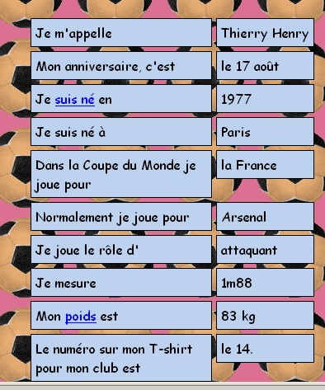

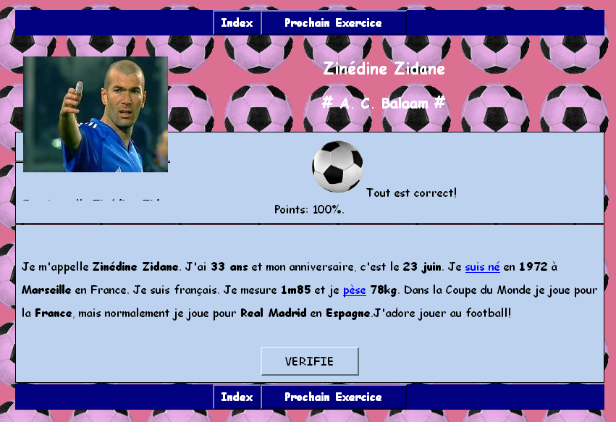

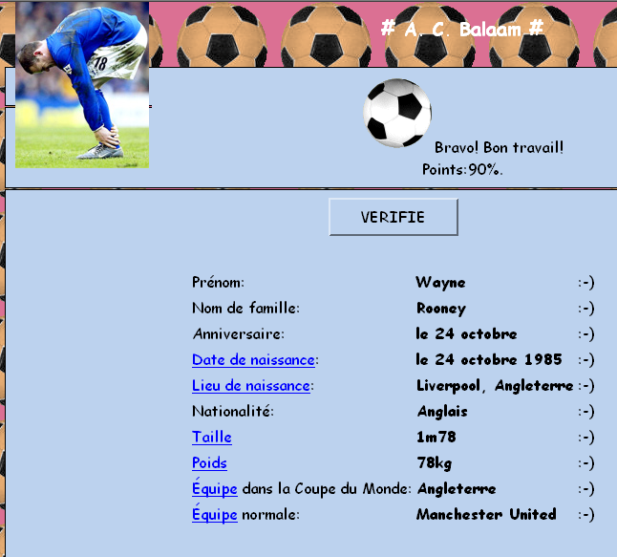

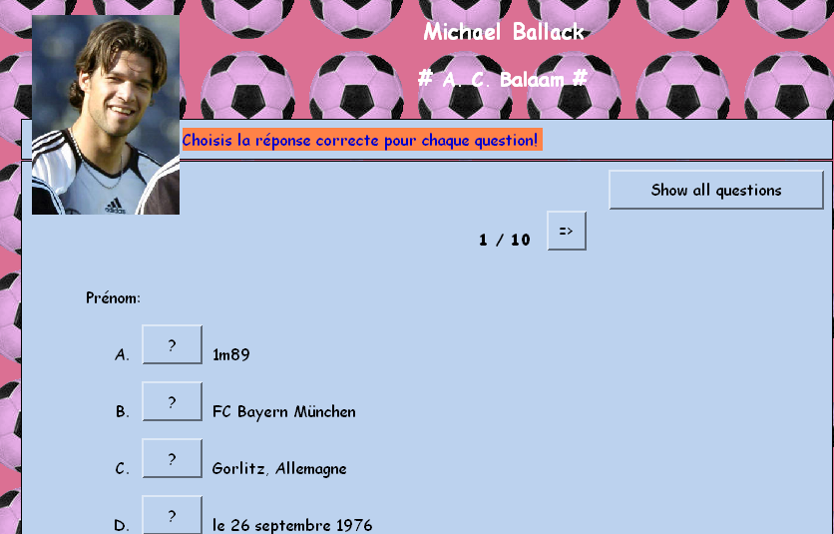

Prénom:
- ? Allemand
- ? le 26 septembre
- ? Gorlitz, Allemagne
- ? 1m89
- ? FC Bayern München
- ? Allemagne
- :-) Michael
- ? Ballack
- ? le 26 septembre 1976
- ? 80kg
Nom de famille:
- ? le 26 septembre 1976
- ? FC Bayern München
- :-) Ballack
- ? Gorlitz, Allemagne
- ? Michael
- ? 80kg
- ? 1m89
- ? Allemand
- ? le 26 septembre
- ? Allemagne
Anniversaire:
- :-) le 26 septembre
- ? Ballack
- ? Allemand
- ? Michael
- ? le 26 septembre 1976
- ? 80kg
- ? Gorlitz, Allemagne
- ? FC Bayern München
- ? Allemagne
- ? 1m89
Date de naissance:
- ? Allemand
- ? 1m89
- ? Ballack
- ? Gorlitz, Allemagne
- ? Michael
- :-) le 26 septembre 1976
- ? 80kg
- ? le 26 septembre
- ? Allemagne
- ? FC Bayern München
Lieu de naissance:
- ? Michael
- ? le 26 septembre 1976
- ? 1m89
- ? Allemagne
- ? Ballack
- ? le 26 septembre
- ? FC Bayern München
- ? Allemand
- :-) Gorlitz, Allemagne
- ? 80kg
Nationalité:
- ? FC Bayern München
- :-) Allemand
- ? 1m89
- ? Gorlitz, Allemagne
- ? 80kg
- ? le 26 septembre 1976
- ? Ballack
- ? Michael
- ? Allemagne
- ? le 26 septembre
Taille:
- ? le 26 septembre
- ? Ballack
- ? Michael
- ? FC Bayern München
- ? Gorlitz, Allemagne
- :-) 1m89
- ? Allemagne
- ? le 26 septembre 1976
- ? Allemand
- ? 80kg
Poids:
- ? FC Bayern München
- ? le 26 septembre 1976
- ? Allemagne
- ? le 26 septembre
- ? Michael
- ? Allemand
- ? Gorlitz, Allemagne
- :-) 80kg
- ? 1m89
- ? Ballack
Équipe dans la Coupe du Monde 2006:
- ? Ballack
- ? le 26 septembre 1976
- ? 80kg
- ? Michael
- ? Gorlitz, Allemagne
- :-) Allemagne
- ? le 26 septembre
- ? 1m89
- ? FC Bayern München
- ? Allemand
Équipe normale:
- ? 80kg
- ? 1m89
- ? le 26 septembre
- ? Michael
- ? le 26 septembre 1976
- ? Gorlitz, Allemagne
- ? Allemagne
- :-) FC Bayern München
- ? Ballack
- ? Allemand

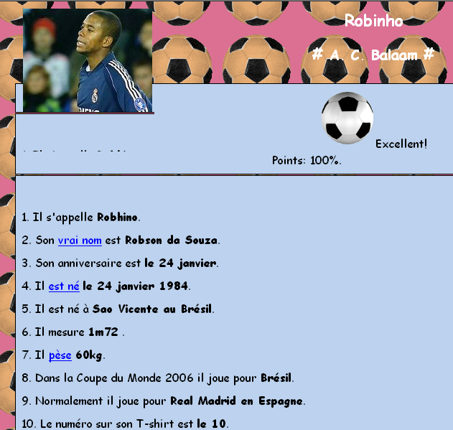

Select phrase which precedes single word (more advanced)
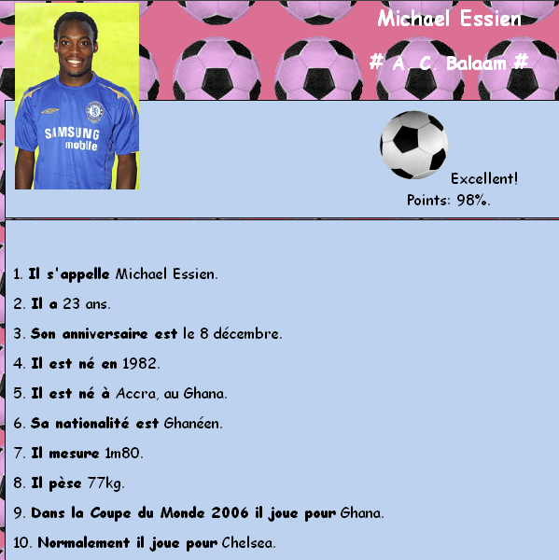

Select full sentence answer to question

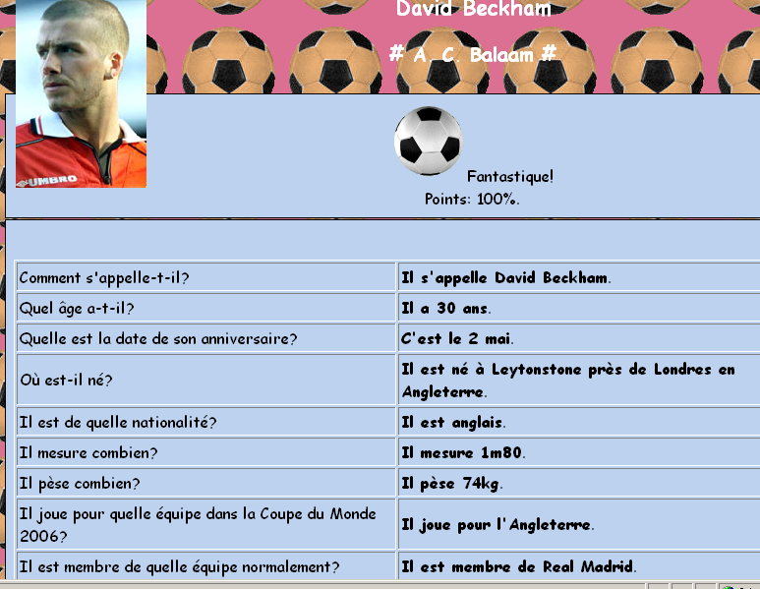

Match info to category about the country
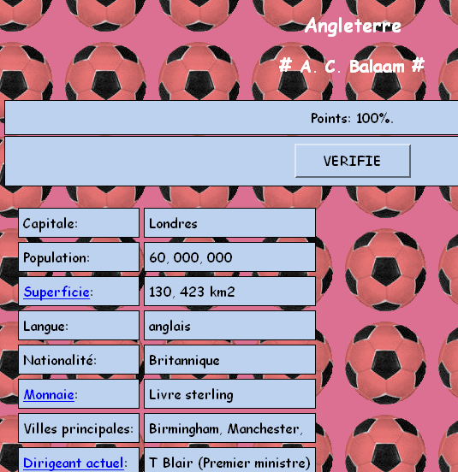

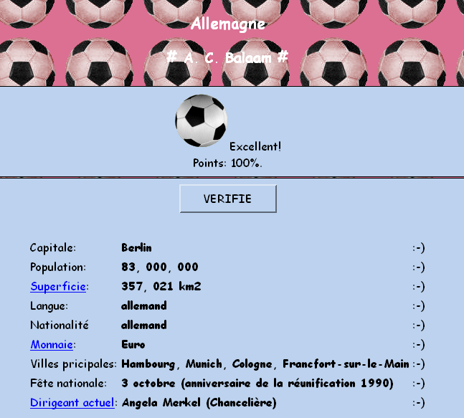

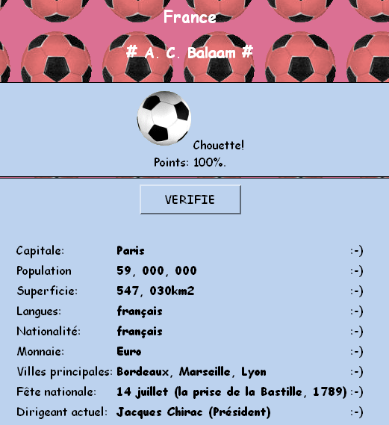

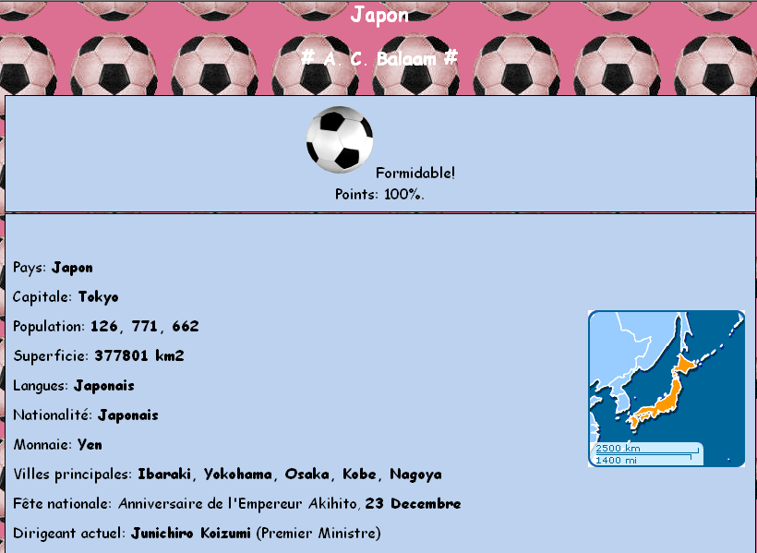

Select category to match to answer
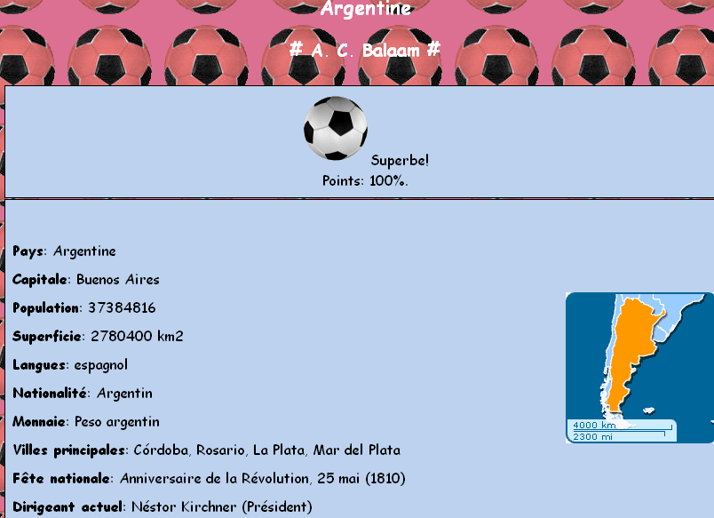

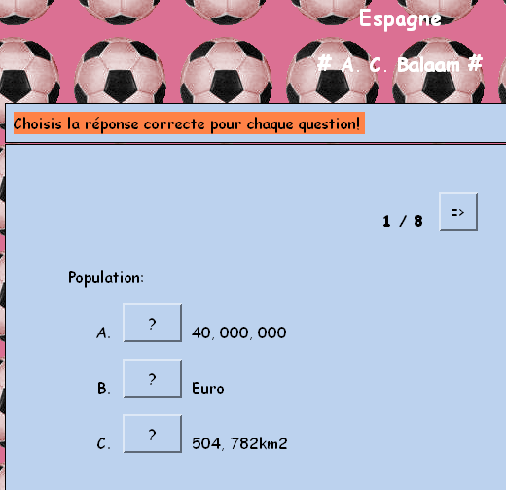

Population:
- :-) 40, 000, 000
- ? Euro
- ? 504, 782km2
Fête nationale:
- :-) 12 octobre
- ? Espagne
- ? Euro
Monnaie:
- ? Espagne
- ? espagnol
- :-) Euro
Langues:
- ? Espagne
- ? 40, 000, 000
- :-) espagnol
Superficie:
- ? espagnol
- :-) 504782 km2
- ? 40, 000, 000
Nationalité:
- :-) espagnol
- ? castillan
- ? Madrid
Capitale:
- ? Castillan, Catalan
- :-) Madrid
- ? Espagnol
Dirigeant actuel:
- ? Espagne
- ? 12 octobre
- :-) Juan Carlos I (Roi) / Rodriguez Zapatero (Premier Ministre)

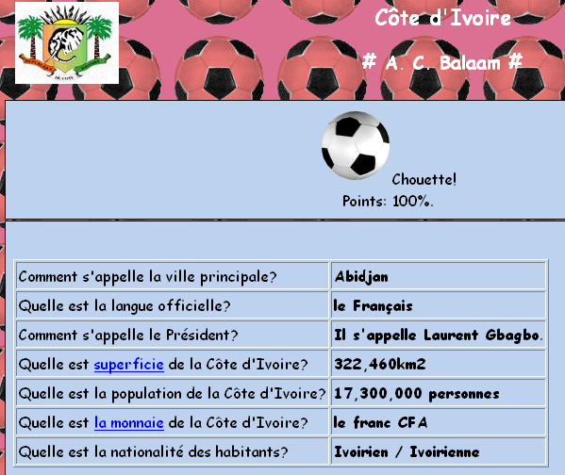

Les Pays et les drapeaux

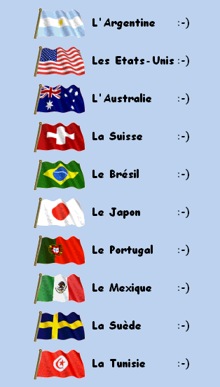

Les Pays et les drapeaux 2

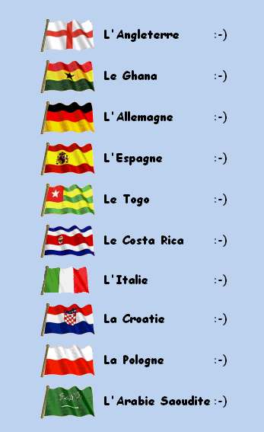

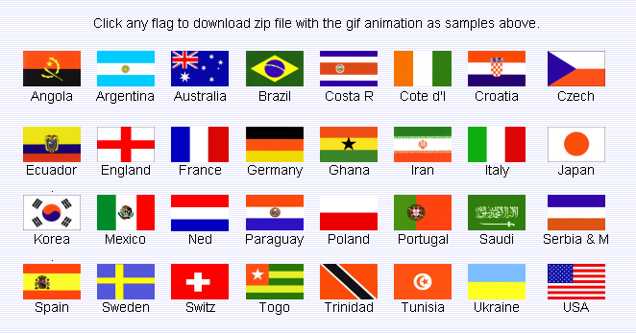Flag images from sevenoaks art site (wish I’d seen this before tackiling the exrecises!!!!)

Ideas from Sunderland Geekie – AST teacher Clare Seccombe ...

With ref to my post 5, I've been putting together a list of activities for said event which will take place on Feb 27th.
Exclusive preview for you guys:
-Calculate the number of spectators at each match.
-Work out the average age of each team.
-Time zones. E.g. Germany play Costa Rica at 6 pm on the opening day of the tournament. What time will it be in Costa Rica when the match begins ?
-Angles - use an elastic band stretched over two nails to show how the goalkeeper can narrow the angle for players shooting from different positions
-Recalculate the league table, giving two points for a win instead of three. Does it change much?
-Find out the heights and weights of the players in each team. Which team is the tallest / smallest / heaviest / lightest, what are the averages ?
-Write match reports (ICT or handwriting)
-Direct and indirect speech – comments by players, coaches, commentators…
-Grammar using football terminology
-Imagine being at the opening ceremony/England’s first game/the final and write about your feelings
-Pick a player or a manager. Follow stories about them in the papers or on TV and prepare to be interviewed by classmates as that person.
-Imagine you are the only child reporter allowed to interview one of the World Cup personalities.
-Prepare questions and find out as much about the person in advance as you can. How does the interview go? How do you react when you are given a signed football?
-Discuss the vocabulary used in football commentary, such as "sick as a parrot" and "over the moon". Think about how to use language more creatively, then write an article or prepare to speak about a match without using expressions like these.
-Imagine) You've won a Category A ticket to the Rugby World Cup Final. Write a cheer for your favourite team; design a banner and an appropriate outfit for the day.
-Write a travel itinerary to get your family to the nearest Rugby World Cup match.
-Write 2 poems capturing the emotions of the winners and losers of the World Cup Final.
-There are many football heroes and legends. Who is yours? Write a brief half page biography.
-World Cup songs (get inspired at www.everyhit.com/worldcup.html !)
-Traditional music of the participating countries
-National Anthems (www.national-anthems.net)
-Draw people in football poses
-Traditional arts and crafts of the participating countries
-National costumes
-Mascots
-Flags and strips – find out why they are the colours they are and what the colours symbolise
-How have football boots and strips changed since the first World Cup ?
-Design a poster for the tournament (view the posters for all tournaments up to 1998 at 2002.fifaworldcup.yahoo.com/02/en/pf/h/pwc/index.html )
-Compare the climates of each participating country. How comfortable will they feel in Germany in June ? What clothes should teams take with them? Will they need special training to help them prepare for a change in climate?
-Research the venues
-Research the lifestyles of the people in each participating country
-Prepare fact sheets about each participating country
-Locate each country on a map of the world
-Adopt a country playing in the World Cup (work in pairs or groups) and prepare a pack to tell other groups about your country.
-Research local foods of each team
-Work out the route each national team has to take to get to Germany. How many countries will they cross? How far will they travel? What is the time difference between the two countries?
-Compare and contrast two venues / participating countries
-Have a mini-World Cup. Select teams of three or four players (or pupils can form "squads" and take turns to play for their team). Each team takes the name of one of the 32 countries in the World Cup. Play short games (three or four minutes each way) on small pitches. Keep the results up to date and displayed on a notice-board, or on computers. Make league tables (three points for a win, one for a draw, and show the numbers of goals for and against). Histograms can be used to show how many goals each team scored. You can calculate the average number per match. Pupils can referee and run the line. Write match reports for a newsletter, website, or sports video.
-Research the languages spoken by each team.
-Find out how to say “football” in all the languages spoken in all the participating countries. This could stimulate some interesting discussion about language families.
-Many of the above activities, in the foreign language !

