D Candidates Notes Proforma
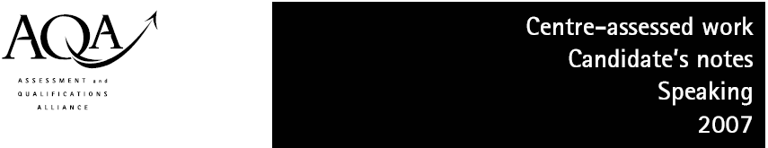
Language  (please tick) |  | GCSE French B (Modular) | Module 1: My world
Language  (please tick) |  | GCSE German B (Modular) | Module 1: My world
Language  (please tick) |  | GCSE Spanish B (Modular) | Module 1: My world

Centre name: The Ashcombe School Centre no: 64050

Candidate name: ..................... Candidate no: .........................

- If you want to make notes for your Module 1 Speaking Assignment you must use this sheet.
- Don’t write more than 60 words in total, and these must not contain conjugated verbs or complete sentences.
- Remember to try to refer to past, present and future events in your presentation.
- You must sign this sheet and hand it to your teacher together with your tape whether you have used it or not.

1 Myself and my family | 2 Where I live
3 My school | 4 My free time
5 Routine | 6 Future plans
 | Number of words used:

Candidate’s signature: ....................... Date: .............

