version as at 9/4/06/ including references to CEM information highlighted in TES article 31/3/06

The “severe grading” of MFL grades at GCSE and A level.

Background

Who has put together this paper and why?
This paper has been put together by Helen Myers, with reference to members of the ALL National Executive Committee, and in response to members’ concerns expressed over a long period of time about the apparent severe grading of MFL external examinations. This has included more recently a significant number of expressions of concern from managers in Language Colleges (in response to a presentation of the data at the Annual Language Conference organised by SST), and from contributors to the ALL net, CILT hosted Linguanet forum and teacher-run mflresources forum.

At a time when professionals are judged by the performance of their pupils in external examinations, the committee believes that it is very important that managers who judge professionals are crystal clear about the nature of this data, as misunderstanding / false conclusions can lead to unfair criticism of professional standards in teaching and learning, and to wasted time and energy in the wrong area.

The paper was presented at the SST Language Conference and made available through Linguanet and ALL net. There was a significantly high level of positive response to the presentation.

Principle
Pupils from similar prior attainments should gain similar grades in subjects at GCSE and A level, but if this is not the case (and it is not) then there needs to be widespread awareness of the differences in order to avoid misleading judgements.

We use the phrase “severe grading” to put the emphasis onto the grading issue. Terminology is important. Words like “hard”and “standards” carry multiple connotations. Our principle is that pupils of comparable prior attainment should attain comparable grades across a range of subjects whether Business Studies (which will be only started at GCSE), Maths, Drama, etc all of which have very varying situations for different pupils.

Historical context
This imbalance goes back a long time including for example the issue of comparability of grading of the old O level maths and O level English; readers of the Cockcroft report in 1982 will remember the stark statistic that 33% gained an O level English, 25% gained an O level maths. The relative gap between those subjects has been pretty consistently maintained over the last 20 years - perhaps as a consequence of the relentless media focus on 'standards' versus 'dumbing down'.

Peter Downes raised MFL issue when he was President of ALL.

Methodology
When comparing the grades gained by pupils in different subjects, you can either do the comparisons on the basis of
- prior attainment - i.e look at pupils with the same results at an earlier stage (typically Key Stage 3 test results) and then compare the grades gained by those pupils in the different subjects (at GCSE). This is the basis of value-added analysis e.g. as used by DfES
- concurrent attainment - i.e. look at the grades gained by individual pupils in the different subjects, and then compare the accumulation of outcomes. There are two ways of doing this:
i) PANDA Relative Performance Index (RPI) - for each pupil, compare the difference between the grade (score) in the particular subject, and the average grade (score) of that pupil in all their other subjects.
ii) Durham CEM Rasch model (publ. Mar 06) - This looks at the probabilities (odds) of a pupil who gets a certain grade in one subject getting a certain grade in another. The model then calculates “difficulties” for subjects and grades that best match all the combinations of pupils, subjects and grades. “The grade difficulty depends on the relative probabilities of that grade being achieved by candidates of different ability, as determined by their performance in all their subjects and taking into account the different difficulties of all the grades they have gained.” These “difficulties” can then be converted back into “grade” units for comparison and dicussion. Note that the higher the number the more “difficult” the subject, which is the opposite way round to the prior attainment analysis (where comparable pupils will be gaining lower numbers in the more “difficult” subjects).

Data supporting the position statement

GCSE
The data presented in Appendix 1from DfES data and Ofsted / PANDA data shows that:

By the principle which we have suggested above (that pupils of similar prior ability should expect to get similar grades in all subjects) you would expect the differences to be negligible. They are not.

PANDA: These figures show that French and German are both about half a grade BELOW the average of other subjects whereas Art, Drama, English and PE and about half a grade above, thus confirming that between Art/Drama/English/PE and French/German there is a difference of one full grade for pupils looking at their grades in different subjects

DfES value-added: these figures compare the average grade obtained by students with the same KS3 score in a range of different subjects. French and German are consistently amongst the lowest, especially in the mid-range of candidates generally gaining C and B grades

Outcomes
In practice, all three methods give similar outcomes. In particular, for MFL at GCSE, the CEM Rasch model gives a very similar outcome to the other two methods. For grade C, French, Spanish and German are half a grade more “difficult” than subjects such as Science (dual), Geography, History, Maths, and a grade more “difficult” than English, PE, Drama, DT and Art.

Decline in numbers: the data shows that over the last three years:
- the overall number taking any modern language has declined significantly
- the overall numbers getting A*-C grades has remained constant
- the percentage of candidates getting A*-C grades has increased significantly
Issues of grading, grade boundaries etc become very complex during such a transitional period

 | % of ALL 15 year old pupils taking any modern language | % of ALL 15 year old pupils gaining grade A*-C in any modern language | % of CANDIDATES in any modern language gaining grade A*-C
2003 | 73% | 36% | 49%
2004 | 68% | 36% | 53%
2005 | 59% | 35% | 60%

This discrepancy in grades in likely to lead pupils to regard French and German as less successful subjects and therefore they are less likely to choose them at post 16.

A level (including AS)
The data presented in Appendix 2 from DfES data and Ofsted / PANDA data shows that:

at the end of 2 years of study, there is nearly half a grade ON AVERAGE between grading in MFL and the other subjects taken by those pupils, and nearly a whole grade between MFL and some other common subjects

Note that ...because by and large the most able are getting A grades in each of their subjects .... so the disparity will be much greater for the lower grades - Cs in one subject, E in French for example will be a typical result.

Note that French & German have high “severe grading factor” at A/L.
Candidates for French & German have the highest average grades in OTHER subjects
so will suffer in comparison with other subjects. French & German are only left with the most able.

Decline in numbers and consequent issues for grading : From 2004 to 2005 there has been a drop in numbers taking French and German.

The question is,
has the ability profile stayed the same in the 2004 and 2005 cohorts
OR
have the more able continued

The German output profile tends to indicate that the less able have given up
The French output profile indicates that the ability profile has remained the same

In German, the numbers of those achieving A grades has stayed the same
In French, the percentage of those achieving A grades has remained the same.

When numbers in subjects are declining, this puts great pressure on the examiners and grade-awarding bodies because however sophisticated the statement-related criteria may be, inevitably the actual questions will vary in difficulty from year to year, so it becomes very difficult for examiners to make an accurate consistent judgement from one year to the next.

Two different approaches to this are highlighted above.

French appears to have adopted a policy of keeping the grade profile constant, whereas in German the absolute numbers of candidates getting A grades has remained constant and the profile has been adjusted, with more getting higher grades and fewer getting lower grades.

Outside the severe grading issue, this different approach can therefore cause great problems even when comparing results within a department, let alone for SMT and governors in individual schools who will be judging professionals by the results obtained by their students.

Commentary
The research from CEM was reported on in the TES on 31 Mar 2006. Some extracts from the TES article and the CEM website follow:
- Dr Coe analysed a national dataset of over 600,000 students to compare the grades achieved in each subject with the grades achieved by the same student in their other subjects. Some subjects do come out as apparently 'harder' than others, though it makes a difference which grade you look at. (CEM)
- The figures will alarm the exam regulator, however. It has argued that all GCSEs are equally difficult to do well in. (TES)
- They concluded that, students, whatever their ability, would be more likely to achieve good grades in subjects such as drama and PE, than in science and languages. (TES)
- Robert Coe, director of secondary projects at Durham university’s Curriculum, Evaluation and Management Centre, who led the research, said: “It’s hard to deny that there are differences in the difficulty levels of particular subjects.” (TES)
- Dr Coe said it was unlikely that this [better teaching, motivation, time allocation] explained all of the differences. The analysis is powerful in that it offers more information than can be gleaned by analysing “raw” results in GCSE subjects each year. (TES)

Summary
In the context of MFL, it is vital that people know about the national pictures so that they do not leap to false conclusions which could severely affect the feeling of success and the desire to go on….whether for pupils or teachers!!

Simplistic, poor use of data will lead to depressing the sense of achievement .. or even actual achievement

Our ideal would be that “Language grading is fair, so...pupils choose MFL at KS4, feel good after their exams and get grades in line with other subjects so...more choose at AS and get grades in line with other subjects so...more continue to A2 and so...”

Recommendations
- The issue of “severe grading” in French and German at both GCSE and A-level is recognised as fact, and is not confused or obfuscated by issues such as “standards”, etc.
- Publicity is given to this so that school managers and others automatically accept that there is an issue when judging the results of teachers of French and German, and make due allowance for “severe grading”
- At a time of substantial decline in numbers taking French and German at GCSE and A-level, that grading issues are examined carefully and a more level playing field is established, and certainly that a steeper one is not created!

Appendices

These appendices are drawn from presentations given to staff in order to explain the position statement.

In an area which can be ‘off-putting’ for many staff, the informal register of the language has been left as such in an attempt to make the explanations more accessible.

Appendix 1: data and analysis relating to GCSE
- There is a correlation between KS3 and GCSE performance, and this is used by institutions to ‘set’ targets, and by DfES to judge ‘value-added’.
- Performance in individual subjects by pupils of the same prior attainment can be calculated.
- Tabulate the Average score at GCSE for all the pupils with the same KS3 prior attainment
- Compare results for different subjects
- Look at GCSE Grade distribution in different subjects for pupils of the same KS3 prior attainment
- PANDA & Relative performance indicator (RPI)
- Overall numbers and percentages taking GCSE Modern Languages 2003-05
- CEM Rasch model

Appendix 2: data and analysis relating to A-level (and AS)
- PANDA & Relative performance indicator (RPI)
- A-level numbers and percentages incl. by grade - male + female - 2004 & 2005
- Commentary

Appendix 1 - GCSE comparisons (using DfES and PANDA data)

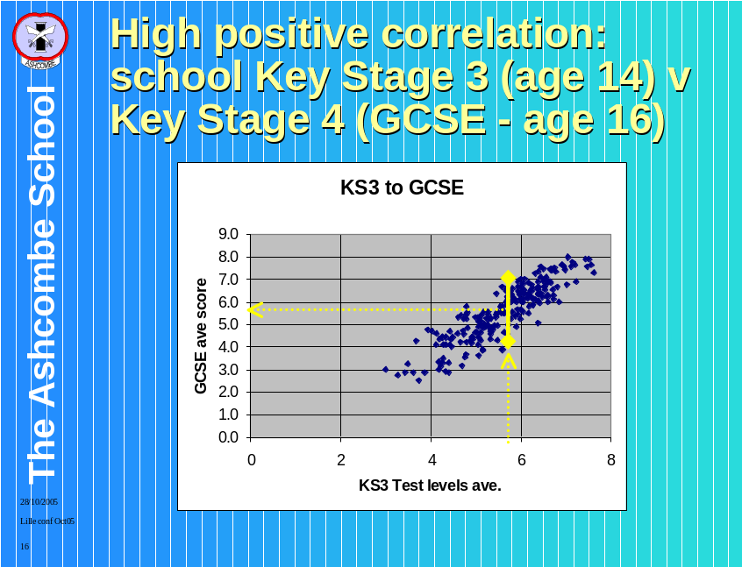 1. There is a correlation between KS3 and GCSE performance, and this is used by institutions to ‘set’ targets, and by DfES to judge ‘value-added’.

This graph illustrates how we can take the KS3 scores as the input (the yellow dotted line) and how this converts to an output in GCSE scores (yellow dotted line)

This shows that there is a clear connection between KS3 scores and GCSE output in overall terms.

Although there is a very good correlation in overall terms, there is still plenty of variation, as demonstrated by the solid double headed yellow line, showing that there is plenty of scope for individual pupils to move up or move down.

How can you meaningfully compare performance in individual subjects?

2. Performance in individual subjects by pupils of the same prior attainment can be calculated.
In order to calculate the average score in each subject for the puils of the same prior attainment, INSERT TABLE AND GRAPH OK let’s take all the pupils of the same prior attainment (as the previous graph - we took the KS3 score - went up and across for the output)

Here, we’re breaking this down a bit.

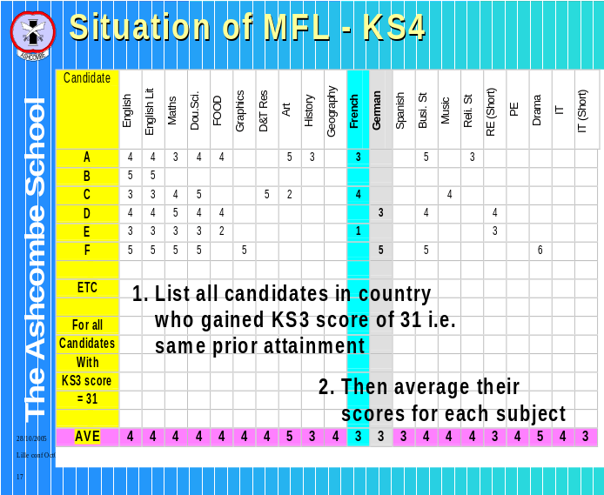Step 1, you list all the people with KS3 score of 31 average .. This will be a long list -tens of thousands (600,000 GCSE candidates)

Step 2 - you then take each subject in turn - so that’s each column - and do the average of all the numbers in that column for that subject. So for example I've highlighted the French in blue.

The purple line at the bottom is the average for each subject of all the scores in the column for that subject, rounded to the nearest whole grade.

3. Tabulate the Average score at GCSE for all the pupils with the same KS3 prior attainment:
Data is given for a range of subjects (see table below for 2004) showing the average grade obtained nationally for each subject for all the students of a given KS3 prior attainment score. This therefore shows directly for pupils of equal prior attainment whether or not the grades awarded in different subjects are comparable.

KS3 Ave Pts Score | English | English Literature | Maths | Double Science | D&T FOOD | D&T Graphics | D&T RMT | Art & Design | History | Geography | French | German | Spanish | Business Studies | Music | Religious Studies | RE (Short) | PE | Drama | IT | IT (Short)
17 | 1 | 1 | 1 | 1 | 2 | 1 | 2 | 3 | 1 | 0 | 1 | 1 |  | 0 | 1 | 1 | 1 | 2 | 2 | 0 | 1
19 | 2 | 2 | 1 | 1 | 2 | 2 | 2 | 3 | 1 | 1 | 1 | 1 |  | 1 | 1 | 1 | 1 | 2 | 3 | 1 | 1
21 | 2 | 2 | 1 | 1 | 2 | 2 | 2 | 3 | 1 | 1 | 1 | 1 | 1 | 1 | 2 | 2 | 1 | 3 | 3 | 1 | 1
23 | 2 | 2 | 2 | 2 | 3 | 2 | 3 | 3.5 | 1 | 2 | 2 | 2 | 2 | 2 | 2 | 2 | 2 | 3 | 3 | 2 | 1
25 | 3 | 3 | 2 | 2 | 3 | 3 | 3 | 4 | 2 | 2 | 2 | 2 | 2 | 2 | 3 | 2 | 2 | 3 | 4 | 2 | 2
27 | 3 | 3 | 3 | 3 | 3 | 3 | 4 | 4 | 2 | 2 | 2 | 2 | 2 | 3 | 3 | 3 | 2 | 4 | 4 | 2 | 2
29 | 4 | 4 | 3 | 3 | 4 | 4 | 4 | 4 | 3 | 3 | 3 | 3 | 3 | 3 | 4 | 3 | 3 | 4 | 4 | 3 | 3
31 | 4 | 4 | 4 | 4 | 4 | 4 | 4 | 5 | 3 | 4 | 3 | 3 | 3 | 4 | 4 | 4 | 3 | 4 | 5 | 4 | 3
33 | 5 | 5 | 4 | 4 | 5 | 4 | 4 | 5 | 4 | 4 | 4 | 4 | 4 | 4 | 5 | 4 | 4 | 5 | 5 | 4 | 4
35 | 5 | 5 | 5 | 5 | 5 | 5 | 5 | 5 | 5 | 5 | 4 | 4 | 4 | 5 | 5 | 5 | 5 | 5 | 5 | 5 | 4
37 | 5 | 5 | 5 | 5 | 5 | 5 | 5 | 5 | 5 | 5 | 5 | 5 | 5 | 5 | 5 | 5 | 5 | 5 | 6 | 5 | 4
39 | 6 | 6 | 6 | 5 | 6 | 5 | 5 | 6 | 6 | 6 | 5 | 5 | 5 | 5 | 6 | 6 | 5 | 6 | 6 | 5 | 5
41 | 6 | 6 | 6 | 6 | 6 | 6 | 6 | 6 | 6 | 6 | 5 | 5 | 5 | 6 | 6 | 6 | 6 | 6 | 6 | 6 | 5
43 | 6 | 6 | 6 | 6 | 7 | 6 | 6 | 6 | 7 | 7 | 6 | 6 | 6 | 6 | 6 | 7 | 6 | 7 | 6 | 6 | 6
45 | 7 | 7 | 7 | 7 | 7 | 7 | 7 | 7 | 7 | 7 | 7 | 6 | 7 | 7 | 7 | 7 | 7 | 7 | 7 | 7 | 6
47 | 7 | 7 | 7 | 8 | 7 | 7 | 7 | 7 | 7 | 7 | 7 | 7 | 7 | 7 | 7 | 7 | 7 | 7 | 7 | 7 | 7
49 | 8 | 7 | 8 | 8 | 7 | 7 | 7 | 7 | 8 | 8 | 8 | 7 | 8 | 8 | 8 | 8 | 7 | 7 | 7 | 7 | 7
ave (19-47) | 4.5 | 4.5 | 4.1 | 4.1 | 4.6 | 4.3 | 4.5 | 4.9 | 4.0 | 4.1 | 3.8 | 3.7 | 4.0 | 4.1 | 4.4 | 4.3 | 3.9 | 4.7 | 4.9 | 4.0 | 3.6

Here is a graph showing the same information:
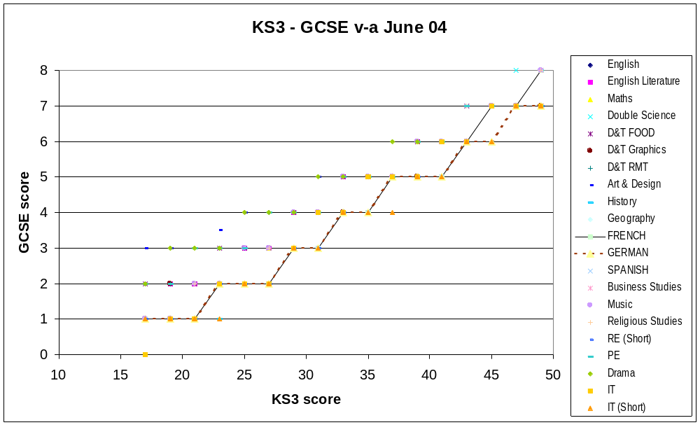
To explain:...

* for all the pupils in the country who gained a KS3 score of 31 (which is pretty much middle of the road) in English Maths and Science, their average GCSE points score was 4 (i.e. grade D), French and German was 3 (i.e. grade E) and Art, and drama was 5 (i.e. grade C).

* for all the pupils in the country who gained a KS3 score of 35, their average GCSE points score was 5 (i.e. grade C) in all subjects except IT short, French and German, , while French and German was 4 (i.e. grade D)3.

* for all the pupils in the country who gained a KS3 score of 41in all subjects their average GCSE points score was 6 (i.e. grade B)except IT short, French and German, while French and German was 5 (i.e. grade C).

KS3 level | 2 | 3 | 4 | 5 | 6 | 7 | 8
KS3 score in DfES points | 15 | 21 | 27 | 33 | 39 | 45 | 51

The bottom row gives the mathematical average score across the KS3 average points score.

The data given below (from the DfES standards website:-
2004
http://www.standards.dfes.gov.uk/performance/excel/KS3-GCSEvacharts04.xls?version=1
2003
http://www.standards.dfes.gov.uk/performance/software/ks4-GCSEvaSummaryv2.doc?version=1
is the latest evidence regarding the lack of comparability of grading for modern language subjects.

4. Compare results for different subjects
The overall situation is summarised by the averages which show that French and German are over half a grade below English and over a full grade below Art and Drama.
The bottom row gives a mathematical average for the GCSE scores obtained. Note that it isn’t the actual average from the country, because you may have more pupils getting say 31 points than 17 points … it just averages that column.

That way you’re getting valuable information which means that one subject can be compared with another, without having to take into consideration the numbers entering the subject.

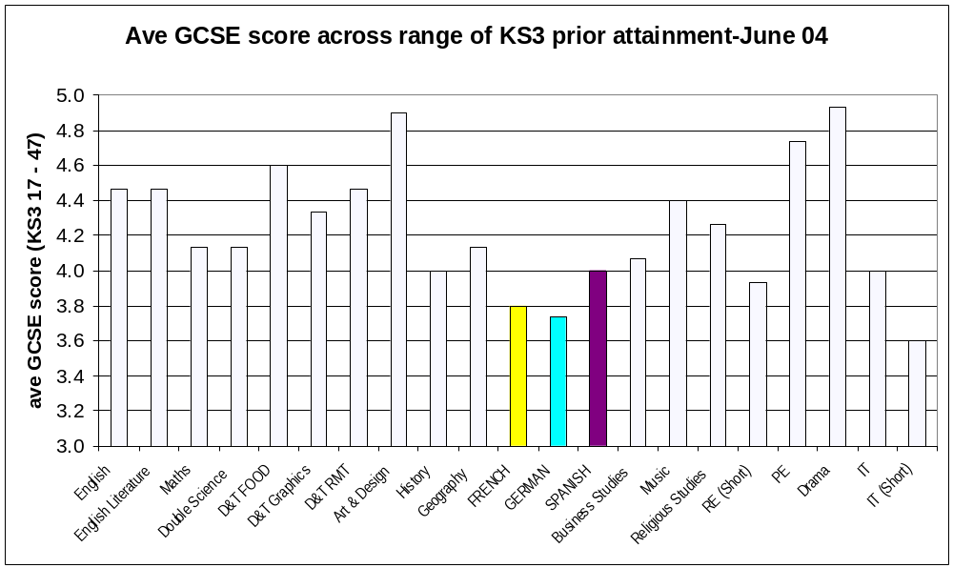
This national data shows beyond doubt that French and German are below all other major subjects in terms of comparable grades. Whether considered point by point (as in the first graph) or as an overall average (as in the second graph), it is clear that Modern Languages (French, German, Spanish) gain lower comparable grades than any other full subject.

5. Look at GCSE Grade distribution in different subjects for pupils of the same KS3 prior attainment
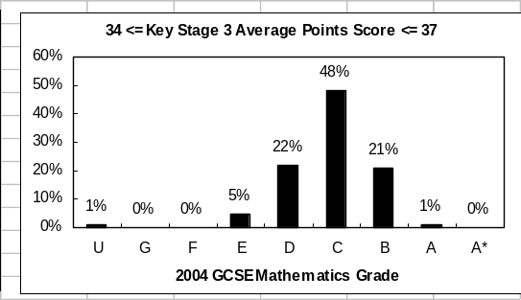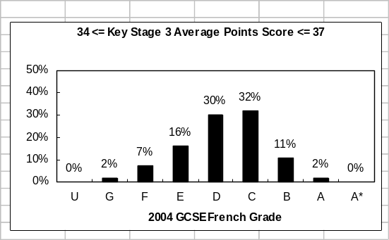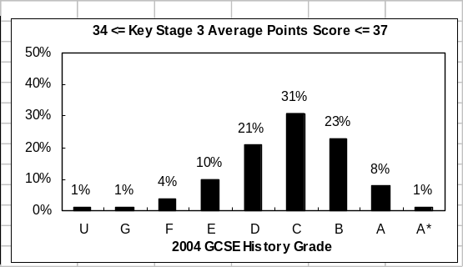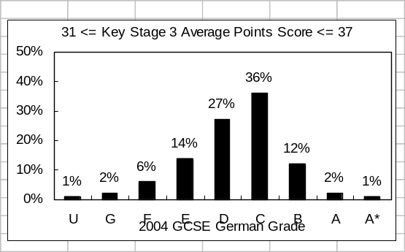

Because the figures in each cell of the table are rounded to the nearest grade, some of the differences can be obscured. The “Progress charts” give a more detailed picture, and in particular help to show just how much lower French and German are than the apparently near subjects of Maths and History

Looking at pupils with KS3 scores of 34 to 37 incl (i.e. between Level 5 and Level 6), the grade distribution is displayed in the graphs above, and summarised in the table below

 | C | A* - C
Maths | 48% | 70%
History | 31% | 63%
French | 32% | 45%
German | 36% | 51%

Note that nearly 20% of the pupils in this category would get a GCSE A*-C in History but NOT in French!!

6. PANDA & Relative performance indicator (RPI)
This situation has been confirmed by the PANDA which has recently been available for every school. These figures are calculated by looking at each pupil, working out their average grade and then for each pupil seeing how the grades for each subject compare with the average for that pupil in their other subjects. These differences are then added up and averaged across all the pupils in the country. By the principle which we have suggested above (that pupils of similar prior ability should expect to get similar grades in all subjects) you would expect the differences to be negligible. They are not.

These figures show that French and German are both about half a grade BELOW the national norm whereas Art, Drama, English and PE and about half a grade above, thus confirming that between Art/Drama and French/German there is a difference of one full grade for pupils looking at their grades in different subjects.

PANDA - - Page A-5 SUBJECT PERFORMANCE INDICATOR - BOYS +GIRLS

National Difference

Subject Area | June 2003  old pts/ grades | June 2004 converted back to old pts / grades | June 2004 new QCA pts as publ in PANDA
Art and Design | 0.55 | 0.53 | 3.19
Combined Science - Double Award | -0.07 | -0.06 | -0.37
Design and Technology | 0.00 | 0.04 | 0.24
Drama | 0.49 | 0.47 | 2.84
English / English Language | 0.36 | 0.32 | 1.89
English Literature | 0.29 | 0.16 | 0.94
French | -0.54 | -0.55 | -3.30
Geography | -0.12 | -0.14 | -0.81
German | -0.55 | -0.56 | -3.36
History | -0.20 | -0.20 | -1.18
Home Economics | 0.15 | 0.13 | 0.79
Information Technology | -0.26 | -0.34 | -2.06
Mathematics | -0.13 | -0.06 | -0.35
Music | -0.09 | -0.11 | -0.68
Physical Education/ Sports Studies | 0.45 | 0.52 | 3.12

remember that 6 new QCA points = 1 grade (= 1 old point)
Here is the same information in graphic form:

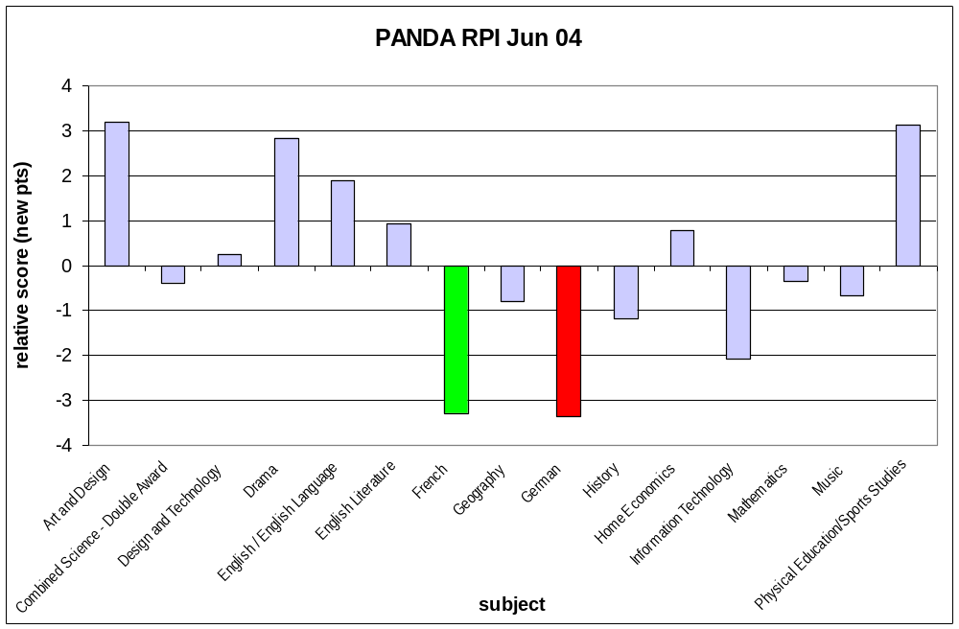

7. Overall numbers and percentages taking GCSE Modern Languages 2003-05
The information is taken from:
Your path: Standards Site Home > Pupil Achievement Tracker > AP 2005 > KS4_2005
http://www.standards.dfes.gov.uk/performance/ap/1386833/?version=1

KS4 National Summary Results
Table 4.1.4: GCSE Results² for All Pupils, Boys and Girls in different subject combinations in England, as a percentage of all 15 year olds

 |  | Percentage of ALL 15 year old pupils for Any Modern language
 |  | Attempted GCSE |  |  | Achieved grade A* - G |  |  | Achieved grade A* - C
Year | total no. of 15 year old pupils | All Pupils | Boys | Girls | All Pupils | Boys | Girls | All Pupils | Boys | Girls
2003 | 622,738 | 73 | 68 | 78 | 71 | 66 | 77 | 36 | 28 | 44
2004 | 644,248 | 68 | 63 | 73 | 66 | 61 | 72 | 36 | 28 | 43
2005 | 633,796 | 59 | 54 | 65 | 59 | 53 | 64 | 35 | 28 | 43

Table 4.1.5: GCSE Results⁸ for All pupils, Boys and Girls in different subjects in England, as a percentage of all 15 year old candidates attempting the subject

 |  |  |  | Percentages of 15 year old candidates
 | Attempted GCSE (in thousands) |  |  | Achieved grades A* - G |  |  | Achieved grades A* - C
2003 | All Pupils | Boys | Girls | All Pupils | Boys | Girls | All Pupils | Boys | Girls
Any Modern Lang. | 454 | 216 | 238 | 98 | 97 | 98 | 49 | 42 | 56
French | 304 | 143 | 161 | 98 | 97 | 98 | 49 | 41 | 56
German | 121 | 58 | 62 | 98 | 98 | 99 | 54 | 47 | 60
Spanish | 51 | 21 | 30 | 97 | 96 | 98 | 55 | 47 | 61
Other M.L. | 18 | 9 | 10 | 98 | 97 | 99 | 76 | 70 | 81
2004
Any Modern Lang. | 437 | 205 | 232 | 98 | 97 | 98 | 53 | 46 | 59
French | 290 | 134 | 155 | 98 | 97 | 98 | 52 | 44 | 58
German | 116 | 56 | 60 | 98 | 98 | 99 | 58 | 52 | 64
Spanish | 54 | 22 | 31 | 98 | 98 | 99 | 58 | 51 | 64
Other M.L. | 18 | 9 | 10 | 98 | 97 | 99 | 77 | 72 | 81
2005
Any Modern Lang. | 376 | 173 | 203 | 99 | 98 | 99 | 60 | 53 | 65
French | 245 | 111 | 134 | 99 | 99 | 99 | 59 | 52 | 65
German | 99 | 48 | 52 | 99 | 99 | 99 | 66 | 60 | 72
Spanish | 52 | 21 | 31 | 99 | 98 | 99 | 63 | 57 | 68
Other M.L. | 19 | 9 | 10 | 98 | 97 | 98 | 79 | 75 | 82

8. Data and graphs for CEM Rasch model

Further explanation of methodology
This looks at the probabilities (odds) of a pupil who gets a certain grade in one subject getting a certain grade in another. The model then calculates “difficulties” for subjects and grades that best match all the combinations of pupils, subjects and grades.

So for the 600,000 pupils, the model counts the number of pupils doing say French and English, and getting a grade B in French and a grade E in English, and converts these to probabilities. This is repeated for all combinations of subjects and grades. If all subjects were equally difficult, then there would be a equivalence between the probability of getting a grade B in French and a grade E in English, and vice versa. If one subject is “harder” than the other, then there will be a mismatch in these probabilities.

Table 2: Rasch coefficients for main full subjects, and conversion to grade units (subjects sorted by the grade C values)

Rasch coefficients
 | Spanish | German | French | History | Science Dbl | IT | DT Graphic | Geography | RS | Bus Studs | Maths | Eng. Lit | English | Sport PE | DT Food T | Drama | DT Res Mat | Art
G | -0.4 | -0.41 | -0.45 | -0.45 | -0.65 | -0.43 | -0.45 | -0.51 | -0.45 | -0.48 | -0.69 | -0.62 | -0.78 | -0.68 | -0.59 | -0.58 | -0.61 | -0.62
F | -0.28 | -0.27 | -0.3 | -0.33 | -0.44 | -0.31 | -0.35 | -0.38 | -0.33 | -0.37 | -0.46 | -0.45 | -0.53 | -0.49 | -0.45 | -0.45 | -0.45 | -0.45
E | -0.13 | -0.15 | -0.17 | -0.2 | -0.3 | -0.2 | -0.24 | -0.26 | -0.22 | -0.25 | -0.3 | -0.33 | -0.38 | -0.35 | -0.34 | -0.33 | -0.33 | -0.33
D | 0.01 | -0.01 | -0.03 | -0.07 | -0.14 | -0.08 | -0.09 | -0.11 | -0.1 | -0.1 | -0.14 | -0.18 | -0.22 | -0.2 | -0.2 | -0.2 | -0.2 | -0.21
C | 0.17 | 0.16 | 0.14 | 0.08 | 0.06 | 0.05 | 0.05 | 0.05 | 0.04 | 0.04 | 0.04 | 0.01 | -0.01 | -0.04 | -0.04 | -0.05 | -0.05 | -0.07
B | 0.35 | 0.35 | 0.34 | 0.27 | 0.27 | 0.25 | 0.23 | 0.27 | 0.22 | 0.26 | 0.26 | 0.24 | 0.24 | 0.11 | 0.17 | 0.14 | 0.17 | 0.12
A | 0.53 | 0.55 | 0.53 | 0.48 | 0.46 | 0.44 | 0.42 | 0.47 | 0.42 | 0.43 | 0.49 | 0.47 | 0.48 | 0.3 | 0.37 | 0.34 | 0.37 | 0.33
A* | 0.78 | 0.84 | 0.83 | 0.8 | 0.75 | 0.73 | 0.68 | 0.78 | 0.71 | 0.65 | 0.78 | 0.77 | 0.79 | 0.52 | 0.65 | 0.59 | 0.64 | 0.56

Converted to “grade” units
Note that the higher the number the more “difficult” the subject, which is the opposite way round to the prior attainment analysis (where comparable pupils will be gaining lower numbers in the more “difficult” subjects)

 | Spanish | German | French | History | Science Dbl | IT | DT Graphic | Geography | RS | Bus Studs | Maths | Eng. Lit | English | Sport PE | DT Food T | Drama | DT Res Mat | Art
A* | 9.0 | 9.3 | 9.3 | 9.1 | 8.8 | 8.7 | 8.4 | 9.0 | 8.6 | 8.3 | 9.0 | 8.9 | 9.0 | 7.6 | 8.3 | 7.9 | 8.2 | 7.8
A | 7.6 | 7.7 | 7.6 | 7.3 | 7.2 | 7.1 | 7.0 | 7.3 | 7.0 | 7.1 | 7.4 | 7.3 | 7.3 | 6.4 | 6.7 | 6.6 | 6.7 | 6.5
B | 6.6 | 6.6 | 6.6 | 6.2 | 6.2 | 6.1 | 6.0 | 6.2 | 5.9 | 6.1 | 6.1 | 6.0 | 6.0 | 5.3 | 5.6 | 5.5 | 5.6 | 5.4
C | 5.6 | 5.6 | 5.5 | 5.1 | 5.0 | 5.0 | 5.0 | 5.0 | 4.9 | 4.9 | 4.9 | 4.8 | 4.6 | 4.5 | 4.5 | 4.4 | 4.4 | 4.3
D | 4.8 | 4.6 | 4.5 | 4.3 | 3.9 | 4.3 | 4.2 | 4.1 | 4.2 | 4.2 | 3.9 | 3.7 | 3.5 | 3.6 | 3.6 | 3.6 | 3.6 | 3.5
E | 4.0 | 3.9 | 3.8 | 3.6 | 3.1 | 3.6 | 3.4 | 3.3 | 3.5 | 3.3 | 3.1 | 2.9 | 2.6 | 2.8 | 2.8 | 2.9 | 2.9 | 2.9
F | 3.2 | 3.2 | 3.1 | 2.9 | 2.3 | 3.0 | 2.8 | 2.6 | 2.9 | 2.7 | 2.2 | 2.2 | 1.8 | 2.0 | 2.2 | 2.2 | 2.2 | 2.2
G | 2.5 | 2.4 | 2.2 | 2.2 | 1.1 | 2.3 | 2.2 | 1.9 | 2.2 | 2.1 | 0.9 | 1.3 | 0.4 | 1.0 | 1.5 | 1.5 | 1.3 | 1.3

Table plotted as graphs

1. subjects sorted by the grade C values

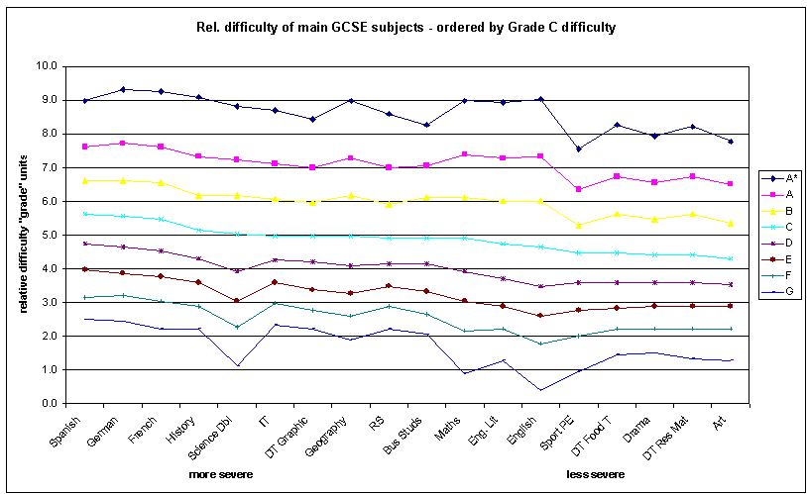

2. subjects sorted by the grade B values
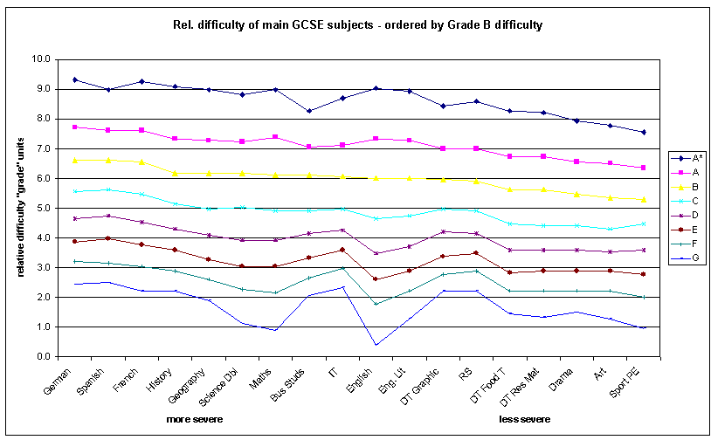

Interpretation of graphs

Note that the higher the number the more “difficult” the subject, which is the opposite way round to the prior attainment analysis (where comparable pupils will be gaining lower numbers in the more “difficult” subjects)

By reference to the original CEM paper, there is a detailed discussion of the technical issues regarding the analysis, such as which subjects out of all those studied fitted the model etc. From this, 34 subjects were selected (excluding music, and fine art, and many short courses). This has been reduced further to those studied by a substantial number (approx. greater than 50,000). The paper also includes a discussion about the differences between each of the grades, and how the Rasch coefficients were converted to “grade” units.

The “difficulties” do vary according to the grades (as do the other measures such as value-added). But by looking at the middle grades, a consistent pattern emerges:

Modern Languages (Spanish, French and German)
are half a grade more “difficult” than
main cluster of subjects (Science (dual), IT, Geography, RS, Busi. St., Maths, Eng. Lit) which
are half a grade more “difficult” than
“practical” subjects (Sport/PE, DT Food Techn., Drama, DT Resistant Materials, Art)

History is on the “more difficult” side of the middle cluster; English is one the “less difficult” side.

This is consistent with the findings from the other forms of analysis such as value-added, and tend to support the theory that there is systematic “severe grading”.

Appendix 2 - A-level incl AS
To asses the relative performance of subjects in the context of uneven grading at a national level, there is a calculation in the PANDA of

1) the average pts score of candidates in the subject

2) the average points score of those candidates in the OTHER subjects they are taken.

The difference between the two figures shows how the grading for the subject compares to other subjects. Because the second figure is calculated ONLY for the candidates doing the first subject, it automatically takes account of the ability profile of the candidates doing the subject

This establishes the national context, and if the same calculation is done for the school, it removes the "severe grading" issue from the consideration of performance
Data is from post-16 PANDA national data for Relative Performance Indicator (RPI) June 2004- note that 20 points = 1 grade

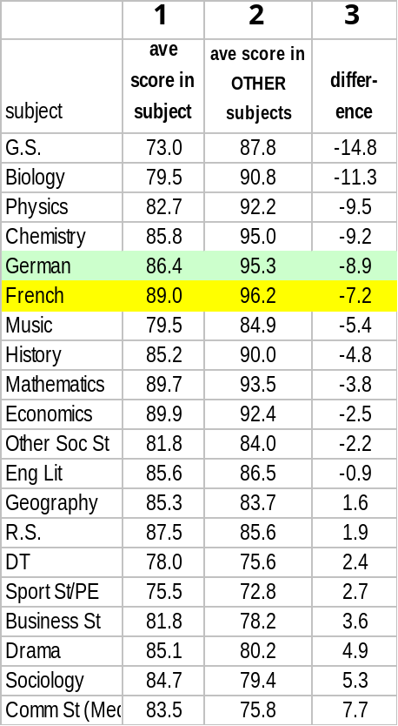

It is a similar situation at A level to GCSE and similar techniques demonstrate the issues.

This grid compare subjects - The RPI - where you take the scores of the students in the particular subject and look at their scores in other subjects.

The first column shows the average score in the subject - the second, the average in the other subjects taken by those same pupils, and the third shows the difference.

This shows that at the end of 2 years of study, there is nearly half a grade ON AVERAGE between attainment in MFL and the other subjects taken by those pupils, and nearly a whole grade between MFL and some other common subjects

Note that ...because by and large the most able are getting A grades in each of their subjects .... so the disparity will be much greater for the lower grades - Cs in one subject, E in French for example will be a typical result.

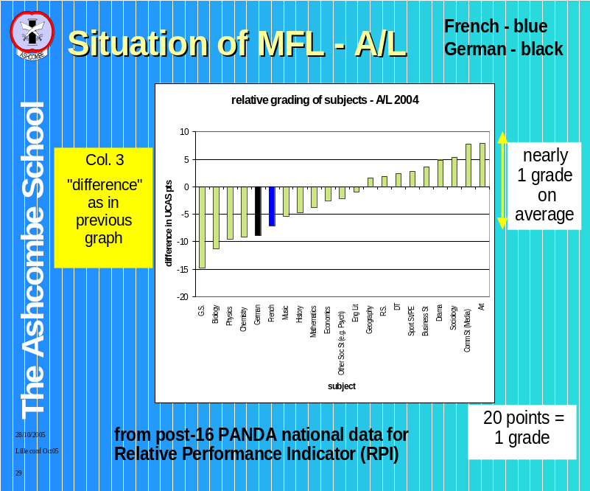Here's the information from the right hand column (column 3 - the difference) in a graph format which makes it easier to see at a glance how MFL compare with other subjects. Look at all the people who did A level French - they averaged 89 points, but this was over 7 points lower than their average in the other subjects they took-- 96.2.

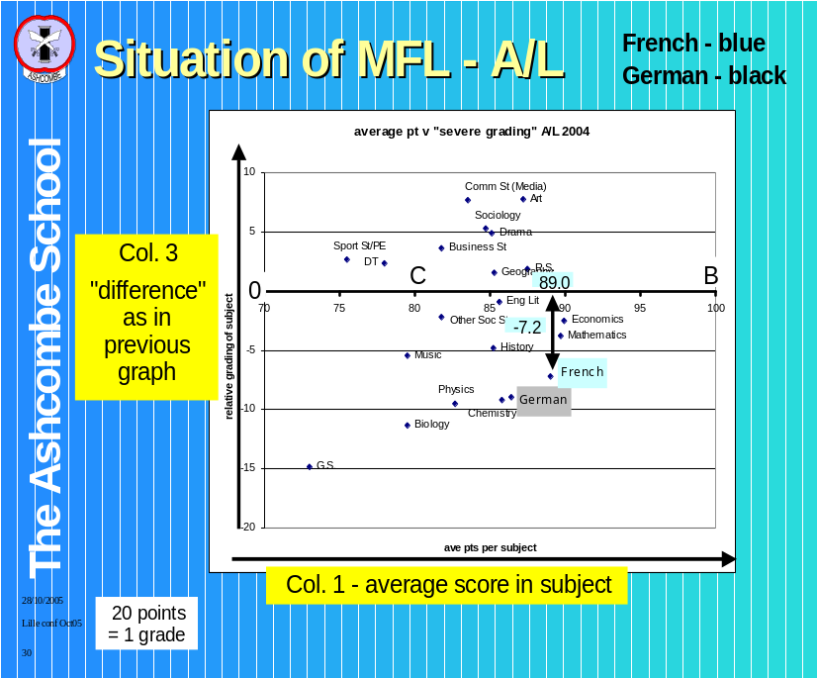The vertical axis here is the same as we had previously showing the difference between the average grade in the named subject and the average of the other subjects taken by the same students. The difference is exactly as on the other graph [see previous, an draw attention to arrows matching bars]

The horizontal shows you the average grades obtained in the subject itself (that first column).

Your instinctive feeling is to say 'oh good, French is getting high grades' - look at how poorly Sports Studies do in comparison - the average is 75.5. - below a C. ‘
But that's the danger of the value-laden vocabulary because let's look at the ability profile of those who've managed to complete the French steeple chase

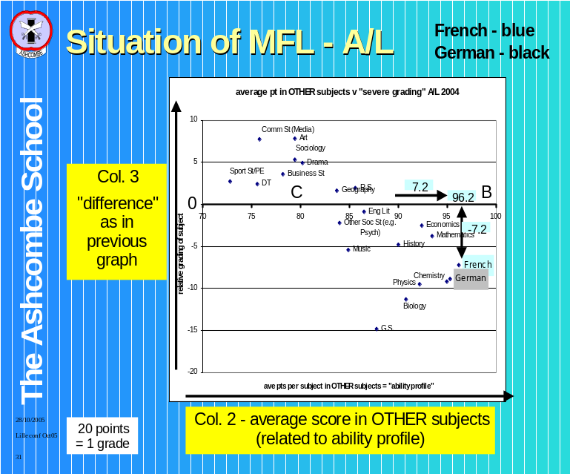As before, the vertical axis if the difference between the subject grade and the average of other subjects taken by the same pupils. But this time, the horizontal shows column 2 - the average score in other subjects.

So for French - it is perhaps no surprise that on average, those who do French get the highest average A level scores .. This is because all except the most able have been weeded out at previous stages either at GCSE or at AS. And even then their French grade still suffers from severe grading!

A-level numbers and percentages incl. by grade - male + female - 2004 & 2005

2005 by percentage
Subject | Number sat | % of total no. sat | % A | % B | % C | % D | % E | %U
French | 14,484 | 1.8 | 32.9 | 27.5 | 20.0 | 12.4 | 5.6 | 1.6
German | 5,901 | 0.8 | 35.6 | 25.1 | 19.2 | 12.5 | 5.7 | 1.9
History | 45,113 | 5.8 | 23.5 | 26.7 | 24.6 | 16 | 7.1 | 2.1
Mathematics | 52,897 | 6.7 | 40.7 | 21.5 | 15.7 | 11.3 | 6.7 | 4.1
Mathematics (Further) | 5,933 | 0.8 | 58.0 | 17.6 | 11.0 | 6.7 | 3.8 | 2.9
Spanish | 6,230 | 0.8 | 36.7 | 27.8 | 19.5 | 10.5 | 4.1 | 1.4
All subjects | 783,878 | 100 | 22.8 | 23.8 | 23.3 | 17.2 | 9.1 | 3.8

2005 by number
Subject | Number sat | change since ‘04 | % change since ‘04 | A | B | C | D | E | U
French | 14,484 | -665 | -4% | 4,765 | 3,983 | 2,897 | 1,796 | 811 | 232
German | 5,901 | -489 | -8% | 2,101 | 1,481 | 1,133 | 738 | 336 | 112
History | 45,113 | 1323 | 3% | 10,602 | 12,045 | 11,098 | 7,218 | 3,203 | 947
Mathematics | 52,897 | 109 | 0% | 21,529 | 11,373 | 8,305 | 5,977 | 3,544 | 2,169
Mathematics (Further) | 5,933 | 213 | 4% | 3,441 | 1,044 | 653 | 398 | 225 | 172
Spanish | 6,230 | 264 | 4% | 2,286 | 1,732 | 1,215 | 654 | 255 | 87
All subjects | 783,878 | 17631 | 2% | 178,724 | 186,563 | 182,644 | 134,827 | 71,333 | 29,787

2004 by percentage
Subject | Number sat | % of total no. sat | % A | % B | % C | % D | % E | %U
French | 15,149 | 2 | 33.4 | 26.8 | 19.8 | 12.6 | 5.8 | 1.6
German | 6,390 | 0.8 | 32.8 | 24.5 | 19.4 | 14.4 | 6.9 | 2
History | 43,790 | 5.7 | 23.9 | 26.5 | 24.3 | 16 | 7.2 | 2.1
Mathematics | 52,788 | 6.9 | 37.9 | 21.3 | 16.5 | 11.7 | 7.8 | 4.8
Mathematics (Further) | 5,720 | 0.7 | 58.9 | 16.8 | 10.8 | 6.9 | 4.4 | 2.2
Spanish | 5,966 | 0.8 | 35.2 | 27.7 | 20 | 10.6 | 4.6 | 1.9
All subjects | 766,247 | 100 | 22.4 | 23.4 | 23.2 | 17.5 | 9.5 | 4

2004 by number
Subject | Number sat | % of total no. sat | A | B | C | D | E | U
French | 15,149 | 2 | 5,060 | 4,060 | 3,000 | 1,909 | 879 | 242
German | 6,390 | 0.8 | 2,096 | 1,566 | 1,240 | 920 | 441 | 128
History | 43,790 | 5.7 | 10,466 | 11,604 | 10,641 | 7,006 | 3,153 | 920
Mathematics | 52,788 | 6.9 | 20,007 | 11,244 | 8,710 | 6,176 | 4,117 | 2,534
Mathematics (Further) | 5,720 | 0.7 | 3,369 | 961 | 618 | 395 | 252 | 126
Spanish | 5,966 | 0.8 | 2,100 | 1,653 | 1,193 | 632 | 274 | 113
 | 766,247 | 100 | 171,639 | 179,302 | 177,769 | 134,093 | 72,793 | 30,650

Commentary
The figures above confirm the well-publicised decline in numbers taking French and German A-level, with French declining by 4% and German by 8% from 2004 to 2005, whilst there was an overall increase in numbers, even in subjects such as Maths, Further Maths and History.

It is interesting that German now has the same numbers studying it as Further Maths, which would normally be classed as an “elite” subject.

Maths and Further Maths are a very helpful benchmark when highlighting the % of A and B grades in French and German.

Maths has also suffered from “severe grading”; Further Maths is a subject which pupils only take if they are likely to do well / those who are not top-flight at Maths will have been filtered out on the way, including at AS-level

Note the difference between French and German from 2004 to 2005 in the numbers and percentages of A grades in the context of declining numbers taking the exam. In French, the percentage has been maintained whilst the overall numbers have declined; in German the numbers have been maintained whilst the percentage has been increased.

Summary for A_level

Note that French & German have high “severe grading factor” at A/L.
French & German have the highest average grades in OTHER subjects
So they will suffer in comparison with other subjects, and they are only left with the most able.

(And as an aside, it’s more noticeable in MFL than in science subjects .. Usually those doing a science are doing another science, or maths, and will not notice the difference as much.)

This situation is compounded by the AS statistics:
for these 2004 A/L grades, in 2003 at AS French had:
subject ave 22.9
OTHER subject ave 29.9 (diff = - 7.7)

Is there any wonder people drop out?

