How to reach the Italian Cultural Institute

Details:
Istituto Italiano di Cultura, 39 Belgrave Square, London SW1X 8NX
tel. 020 7396 4409
www.icilondon.esteri.it

From Hyde Park Corner Tube Station (Piccadilly Line):
- Turn right into Grosvenor Place
- Turn right down Grosvenor Crescent
- Turn left into Belgrave Square, and you should see the Italian flag flying straight ahead of you, to the left, on the corner by Chapel Street.

OR
From Victoria:
10 minutes walk probably the easiest, but if it's pouring with rain (which it won't be ...!) there are loads of buses you can get to take you to Wilton Street / Chester Street (opposite where it says 'The Royal Mews on the map), then you can walk through to Belgrave Square to the corner of Chapel Street (where the flag flies!)

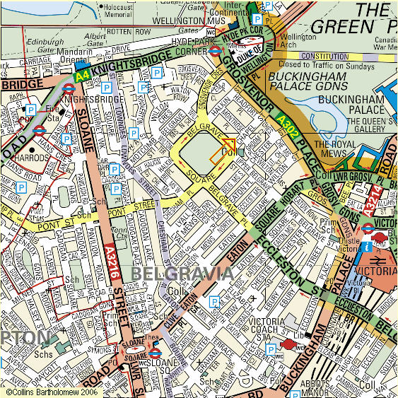
Buses from Victoria (to save approx 5 mins walk from total 10 min walk)

All of the following can take you one stop up Grosvenor Gardens / Road -
Get off at Wilton Street / Chester Street, then walk to Belgrave Square, to the crossing with Chapel Street.

Victoria Bus Station Stop: C
Take the Route Bus 73 from Stop: D
towards Tottenham T.Hall/Seven Sisters
or Route Bus 38 towards Lea Bridge Roundabout
or Route Bus 52 from Stop: A
towards Willesden Bus Garage

Victoria Station Stop: H
Take the Route Bus 82 towards North Finchley/Tally Ho Co
or Route Bus 16 towards Cricklewood Bus Garage
or Route Bus 148 from Stop: G
towards Shepherds Bush / Central Line
or Route Bus 36 towards Queens Park Station/The Falcon
or Route Bus 8 towards Bow Church
or Route Bus 2 towards Marylebone
Victoria Bus Station Stop: D
Take the Route Bus 73 towards Tottenham T.Hall/Seven Sisters
or Route Bus 38 from Stop: C
towards Lea Bridge Roundabout
or Route Bus 52 from Stop: A
towards Willesden Bus Garage

