

ASSOCIATION FOR LANGUAGE LEARNING: LONDON REGION BRANCH
www.all-london.org.uk

All are invited to come along to:
The ALL London January Event 2014
on
Saturday January 18th 2014 9.30 –1.00

and afterwards to the
Annual General Meeting (free) 1.00 – 1.30
Venue: DLT - Kamran DJAM Lecture Theatre, Russell Square Campus, SOAS
School of African and Oriental Studies, University of London, Thornhaugh Street, Russell Square, London, WC1H 0XG, Tel +44 (0) 2076372388 www.soas.ac.uk
visit tfl.gov.uk for travel directions or http://www.soas.ac.uk/visitors/location/travel/
Tube: Russell Square (Piccadilly Line) – approx 5 minute walk; Buses: 7, 68, 91, 168 and 188 stop on Russell Square; 10, 24, 29, 73 and 134 stop on Tottenham Court Road (north bound) or Gower Street (south bound).

Provisional Outline Programme – Check www.all-london.org.uk for up-dates:
0930 | Registration & tea/coffee and biscuits – the committee will be there to welcome you!
1000-1010 | Plenary– Helen Myers, Chair of ALL London. Welcome & Introductions including committee members, SOAS staff, and sponsors
1010- 1020 | ‘Welcome from SOAS’ Renata Albuquerque, Project Manager, Capital L - Routes into Languages our generous host shares ideas and information about events
1020 – 1120 | ‘Alternative approaches to teaching key language at KS3/KS4’ Rachel Hawkes, Director of Language College at Comberton Village College, ALL President What can we do to increase the level of thinking and active learning in the classroom? How can we ensure that we are really differentiating from the outset with Y7? This session explores approaches for structuring different learning activities for different levels of knowledge at KS3 and KS4 and will offer principles which can be applied to all sectors and all languages. Rachel is one of our all-time favourites! Don’t miss her, especially in her presidential year!
1120 – 1150 | Comfort break / top-up of coffee / chance to ‘network’ / view info sent from corporate members, speakers, and our sponsors.
1150-1250 | ‘Meanings that Matter' : Real Language for Real Purposes John Connor, Independent Consultant MFL John gave us an outstanding Webinar on using music in teaching, he shares superb ideas and encouragement online where he has a wide and devoted following, and we are delighted that he is willing to come to talk to us 'in the flesh'!
1300 1330 | Job Application Clinic for Students. 'What are schools looking for?' with Nick Mair, Director of Languages, Dulwich College, Chair ISML, Vice Chair ALL London A ‘Must’ for trainee teachers preparing CVs, applications and interviews from an experienced and inspiring teacher and manager!
OR
Annual General Meeting - Chaired by Helen Myers 1. Election /confirmation of committee members; 2. Reports from the Chair, Secretary, Treasurer, Languages Committees (Community, French, German, IT, Italian, Spanish); 3. Response to issues raised by Management Board; 4. Issues to be raised with the Management Board (please give advance notice of issues you wish to raise in writing before the event if possible); 5. AOB to be decided!
& next? | Visit the British Museum, explore London and catch the last of the sales!
FREE to students who are members of ALL; £6 – non-member students; £10 – members (incl retired) or people who join on the day, £15 – group members, £28 – non-members

As refreshments will be provided, it would be very helpful to know how many people are intending to attend. Please send or email the application form below to Sarah Bowley, by Friday January 10th; otherwise send an email with the information to her. You can also register and pay online at Eventbrite:
https://www.eventbrite.co.uk/e/the-all-london-january-event-2014-registration-9598903579
PLEASE NOTE: To cut down costs and administration time, we won’t send confirmation unless you particularly ask for it... if you have paid, assume you have a place unless you hear otherwise!
If you need any more information please ask. Thanks.

Application Form

To: Mrs Sarah Bowley, The Ashcombe School, Dorking, RH4 1LY Urgent queries: 01306 886312
OR, if no time to send form, email info to her: langcoll@ashcombe.surrey.sch.uk
London January Event (+ AGM) ; Saturday 18th January '14, 0930 -1300, (+ 1.00-1.30) SOAS
Name
Establishment
Work Telephone Number
Home Address

Home Telephone Number
E-mail
How did you hear about this event?

£28 – non-members, (why not join on the day and get £18 refunded?!) £15 – group members,
£10 – members and students who are not members £6 – students; Free: Student members. Follow this link to join beforehand: http://www.all-languages.org.uk/join/join_us

*Please delete as appropriate.

I enclose cheque (payable to ALL-LRB) to the value of £__________ as payment for (No.)_________ persons as listed below (BLOCK CAPITALS please):

Name _________________________________ Member/Group member / Student Non-Member /Student member *

Name _________________________________ Member/Group member / Student Non-Member /Student member *

Name _________________________________ Member/Group member / Student Non-Member /Student member *

Name _________________________________ Member/Group member / Student Non-Member /Student member *

MEMBERS + GROUP MEMBERS (but observers welcome!): AGM 1.00 – 1.30(free)
* I would like to offer to join the committee. Please contact me to discuss what this involves.
* These are issues which I would like to raise: (continue overleaf if necessary)
Please note that we deliberately keep down the cost of courses by subsidising them from ALL funds: we feel that members ought to receive value for the money paid in subscription fees to the Association. Fees charged do not, in any way, reflect the quality of courses offered!
Travel directions web link:
http://www.soas.ac.uk/visitors/location/travel/

The ALL London January Event
Saturday January 18th 2014 9.30 onwards

Venue: Kamran DJAM Lecture Theatre, Russell Square Campus, SOAS
School of African and Oriental Studies, University of London, Thornhaugh Street, Russell Square, London, WC1H 0XG, Tel +44 (0) 2076372388
www.soas.ac.uk
visit tfl.gov.uk for travel directions or http://www.soas.ac.uk/visitors/location/travel/

Tube: Russell Square (Piccadilly Line) – approx 5 minute walk; Buses: 7, 68, 91, 168 and 188 stop on Russell Square; 10, 24, 29, 73 and 134 stop on Tottenham Court Road (north bound) or Gower Street (south bound)

We would advise you not to come by private car: parking spaces are scarce and expensive in this area of London.
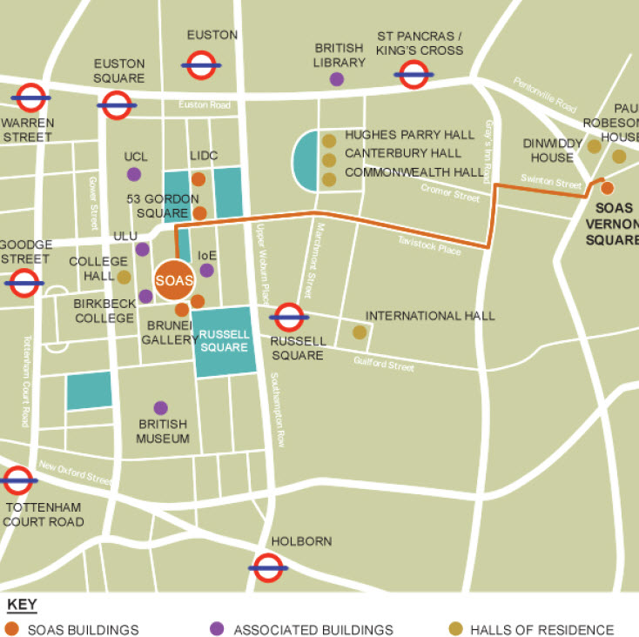
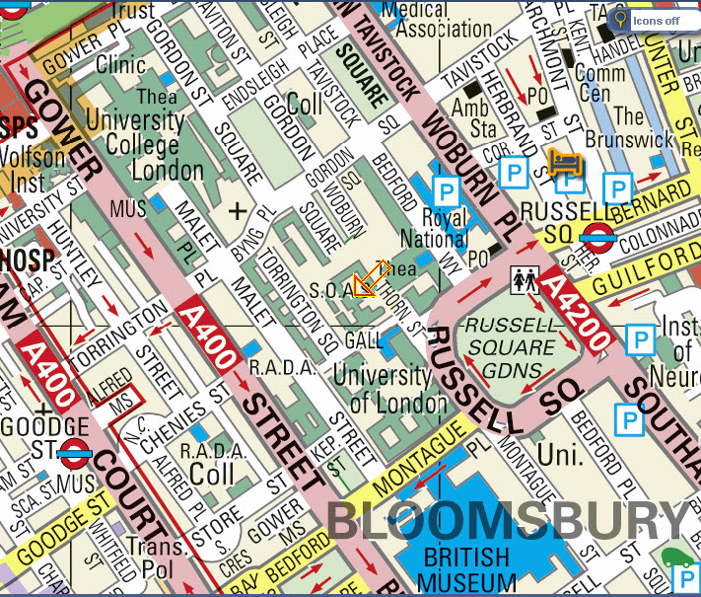
1
5
1
5

