

ASSOCIATION FOR LANGUAGE LEARNING: LONDON REGION BRANCH
www.all-london.org.uk

All are invited to come along to:
The ALL London June Event 2010

on
Saturday June 19th 2010 9.30 –1.30
to be held at
University of Westminster
www.westminster.ac.uk + www.linksintolanguages.ac.uk 309 Regent Street, London W1B 2UW
(2 mins from Oxford Circus, 'Turn right at Top Shop!')
and afterwards to the Subject specific sessions 1.40 onwards
Provisional Outline Programme:
9.30 | Registration & tea/coffee and delicious pastries– the committee will be there to welcome you!
9.55- 10.15 | Plenary– Helen Myers, Chair of ALL London. Welcome & Introductions incl committee members, University / Links staff, and sponsors
10.20- 11.10 | '“What’s my motivation?” ' Rachel Hawkes- Everyone always wants more of Rachel .. so here she is! She will give a wide range of tips / ideas for successful language teaching and learning .. and her resources are always fantastic!
11.15 -11.45 | Comfort break / top-up of coffee / chance to ‘network’ / view info including The European Commission stand with loads of free posters, maps and books (bring a bag!). Thanks to ‘Vocabexpress’, www.vocabexpress.com and 'Sanako' www.sanako.co.uk, sponsors of this event!
11.50 -12.40 | “Reach for the stars” Dr Michael Wardle- His entertaining and fun-packed session inspired us so much at Language World that we invited him all the way down south to share his ideas for making language learning great, rooted in sound pedagogy. There will be something for EVERYONE in this talk! (Especially laughter!)
12.40- 1.30 | Lunch – A chance to mingle with others, and browse the stands.  FREE LUNCH IF YOU BOOK AND PAY BY SAT JUNE 12TH!
 | And if you’re keen for more ….!!!! Have a get-together with people from your subject community .. share ideas and resources!
1.40 – 2.55– | Subject Specific Sessions.  Choose a language (French, German, Spanish, Italian.. and there’s room for others!) .. and share ideas and resources in a session hosted by our friends….  FRENCH – The ALL French Committee will lead this session  SPANISH – Rachel Hawkes leads this ‘Show and Tell’ session.. she’ll kick off with ideas then invite you ..  GERMAN – The ALL German Committee [including: ‘Making German engaging and motivating in KS3’ with Carol Hughes; ‘Literature Techniques’ with Geoff Brammall]  ITALIAN – Sharon Mangion will lead this session  OTHER LANGUAGES – please offer!
& next? | Oxford Street….?? Lots of other London attractions!
£5 – students - £10 – members (incl retired) and associate members (or people who join on the day),
£15 – group members, £25 – non-members; FREE to University of Westminster students. LUNCH: £7 if not registered and paid for before Sat June 12th.
Please send the form overleaf / below ….

As refreshments will be provided, it would be very helpful to know how many people are intending to attend. Please send or email the application form below to Kathleen Merino, by Saturday June 12th; otherwise send an email with the information to her.
PLEASE NOTE: To cut down costs and administration time, we won’t send confirmation unless you particularly ask for it... if you have paid, assume you have a place unless you hear otherwise!
If you need any more information please ask. Thanks.

Application Form

To: Mrs Kathleen Merino, 11 Tavistock Road, Edgware, HA8 6DF
OR, if no time to send form, email info to her: kathleen.merino@btinternet.com
Urgent queries: contact Helen Myers via Ashcombe school, 01306 886312
London June Event ; Saturday 19th June '10, 0930 -1300, (+ 1.00-3) University of Westminster
Name
Establishment
Work Telephone Number
Home Address

Home Telephone Number
E-mail
How did you hear about this event?

£25 – non-members, (why not join on the day and get £15 refunded?!) £15 – group members,
£10 – members and associate members (NB ALL offers Students and NQTs Associate Membership for free! Fill in the online form here:http://www.all-languages.org.uk/associate_membership_form.asp ) £5 - students

*Please delete as appropriate.

I enclose cheque (payable to ALL-LRB) to the value of £__________ as payment for (No.)_________ persons as listed below (BLOCK CAPITALS please):

Name ________________________________________ Member/Group member / Non-Member /Associate member*
Preferred Language Sessions (put in order 1/2/3) :French_ German ______ Spanish _______ Italian ______ Other: _______

Name ________________________________________ Member/Group member / Non-Member /Associate member*
Preferred Language Sessions (put in order 1/2/3) :French_ German ______ Spanish _______ Italian ______ Other: _______

Name ________________________________________ Member/Group member / Non-Member /Associate member*
Preferred Language Sessions (put in order 1/2/3) :French_ German ______ Spanish _______ Italian ______ Other: _______

* I would like to offer to join the committee. Please contact me to discuss what this involves.
* These are issues which I would like to raise: (continue overleaf if necessary)
Please note that we deliberately keep down the cost of courses by subsidising them from ALL funds: we feel that members ought to receive value for the money paid in subscription fees to the Association. Fees charged do not, in any way, reflect the quality of courses offered! NQTs and PGCE students: Consider joining as an Associate Member!
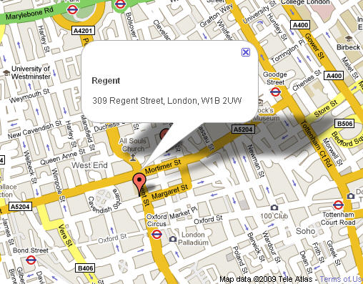
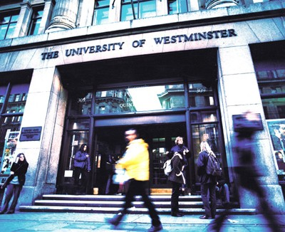
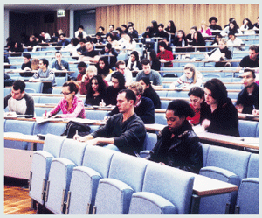
Regent
309 Regent Street, London W1B 2UW
Oxford Circus underground tube station:

From King's Cross/St Pancras,
- Victoria line southbound towards Brixton (Approx 11 minutes)

From Waterloo:
- Bakerloo line northbound towards Harrow.
(Approx 7 minutes)

From Victoria:
- Victoria Line towards Walthamstow /Seven Sisters
- (Approx 5 minutes)

Directions: University of Westminster, 309 Regent Street, London W1B 2UW, UK: www.westminster.ac.uk
Plan your journey by visiting www.tfl.gov.uk/journeyplanner or call 0207 222 1234 for up-to-date travel news

