  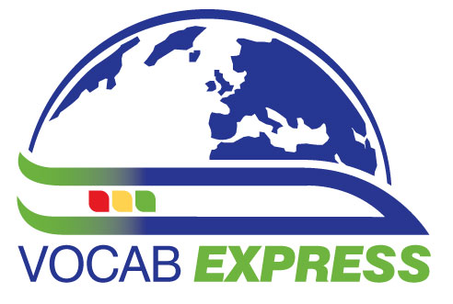   | You are invited to  The London Show & Tell followed by a ‘Social’  -a FREE event-  on
Saturday October 19th 2013,
Show & Tell: 4.45 – 5.45 – The Language Show – Olympia Central, Hammersmith Road, London W14 8UX
Social: 6 p.m. until whenever you like! Hand & Flower, 1 Hammersmith Road, Hammersmith, London, W14 8XJ
Plan your journey by visiting www.tfl.gov.uk/journeyplanner or call 0843 222 1234 for up-to-date travel news
See overleaf for map

The Language Show http://www.languageshowconnect.co.uk/lslive attracts many people from all over the country, including many teachers. It is free and this year it is being held at Olympia Central from Friday 18th October to Sunday 20th October 2013.

It seems a nice opportunity to meet up informally and share ideas, so on behalf of ALL London, Joe Dale and Helen Myers are hosting a Show and Tell during the show (Saturday 4.45 – 5.45 Room 3). During this session, you can offer to come to the front and share a teaching tip for a few minutes. If you need to show anything via the laptop, please bring it on a stick or bring a web address written out so that we can type it in while you start your introduction. We fit everyone in - you write your name and topic on a slip of paper and we divide up the time.

We know that language teachers like to carry on talking and people may just want to have somewhere to go for a quick drink and a chat before they hit the town (or the train home) later, so we have organised a social event straight afterwards, taking place in a function room right opposite the exhibition venue.
We hope you can make it to both events!

Information is also available on the ALL London website: www.all-london.org.uk

Provisional Outline Programme
[1000-1800] | Olympia Central, Hammersmith Road, London W14 8UX. http://www.languageshowconnect.co.uk/lslive
1800 onwards | Gather at Hand & Flower
1800 – whenever you like | Social: Eat, drink and socialise – Quizzes with prizes -  Bar and food available ..thanks to Linguascope for paying the room hire and Justin Sycamore of Vocab Express who is buying you a glass of wine

☺ COME ALONE, OR BRING YOUR ‘TEAM’ ... YOU WILL ALL BE WELCOME! ☺
Hand & Flower, 1 Hammersmith Road, Hammersmith, London, W14 8XJ

