   | You are invited to  The London Show & Tell:  a FREE event  on
Saturday October 31st 2009, 6 p.m. until whenever you like!
to be held at
The Albion, Hammersmith Road
121 Hammersmith Road, W14 0QL, Tel: 020 7603 2826 www.downthealbion.com
Tube: Baron's Court (District & Piccadilly Line) – approx 5 minute walk;
Station: Kensington Olympia (9 mins walk)
Plan your journey by visiting www.tfl.gov.uk/journeyplanner or call 0207 222 1234 for up-to-date travel news
See overleaf for map

The London Language Show attracts many people from all over the country, including many teachers. It is free and it is held at Kensington Olympia 2. This year it runs from Friday 30th October to Sunday 1st November 2009.

It seems a nice opportunity, with so many people likely to be around, to find a Saturday evening venue for people to meet up, socialise and to 'show and tell'. There will be lots of good sessions at the event itself, but we know that language teachers brim with ideas! Equally, people may just want to have somewhere to go for a quick drink and a chat before they hit the town (or the train home) later.

Joe Dale, Alex Blagona and Helen Myers have found a function room close to the exhibition venue which we can use, with facilities such as a data projector / internet access. The likely maximum is 60 seated, 100 standing, but we can always overflow into the pub! Preferably, please could you 'sign up' on the wiki to show your interest .... otherwise, just turn up!
http://mflresources.pbworks.com/London-Show-and-Tell
You don't have to 'commit' to 'showing and telling ' yourself at this stage, but if you have an idea that you'd like to, feel free to offer!

Information is also available on the ALL London website: www.all-london.org.uk

Provisional Outline Programme
[1000-1800] | Optional (but advisable - it's a great show!): The London Language Show, Olympia 2, Hammersmith Road, London W14 8UX http://www.thelanguageshow.co.uk/
 | Gather at The Albion Pub (open 5 pm, so you can get there early!)
1800 - 1915 | The Albion Pub Function Room - The Top Bar (upstairs): Social  Eat, drink and socialise (Bar and food available .. if enough of us turn up, the food may be free!
1915-2030 | Show and Tell 'Core Plenary' (and/or carry on socialising)
2030 onwards | ...anything you like (more show and tell / chat / drink / eat / sing ???!)
Venue costs underwritten by Linguascope: www.linguascope.com

☺ COME ALONE, OR BRING YOUR ‘TEAM’ ... YOU WILL ALL BE WELCOME! ☺

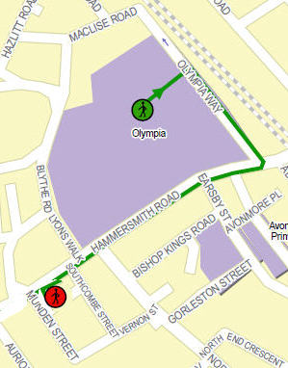
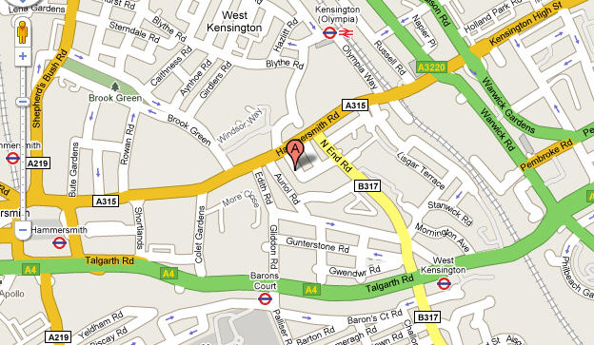
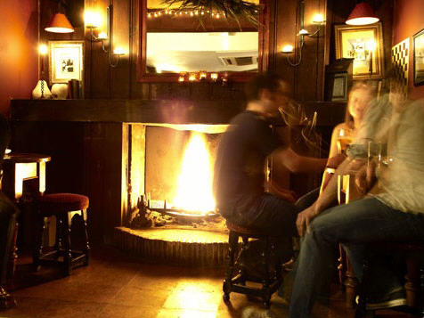
The Albion
121 Hammersmith Road, W14 0QL, Tel: 020 7603 2826 www.downthealbion.com
Tube: Baron's Court (District & Piccadilly Line) – approx 5 minute walk
Station: Kensington Olympia (9 mins walk)

