   | You are invited to  The London Show & Tell followed by a ‘Social’  -a FREE event-  on

Saturday October 16th 2010,
Show & Tell: 4.30 – 5.30 – The Language Show – Earls Court
Social: 6 p.m. until whenever you like! - The Tournament Pub
Pub address: 344, Old Brompton Rd, London, SW5 9JU, Tel: 08721 077 077
West Brompton (0 miles), Earl's Court (0.3 miles), Fulham Broadway (0.5 miles)
Plan your journey by visiting www.tfl.gov.uk/journeyplanner or call 0207 222 1234 for up-to-date travel news
See overleaf for map

The Language Show www.thelanguageshow.co.uk attracts many people from all over the country, including many teachers. It is free and this year it is being held at Earls Court from Friday 15th October to Sunday 17th October 2010.

It seems a nice opportunity to meet up informally, so we are supporting Joe Dale and Helen Myers as they host a Show and Tell during the show (Saturday 4.30 – 5.30, Seminar room 2) and a social event straight afterwards. We know that language teachers like to carry on talking and people may just want to have somewhere to go for a quick drink and a chat before they hit the town (or the train home) later.

The ALL London Committee has found a function room next to the exhibition venue which we can use. The maximum is 150, but we can always overflow into the pub! Preferably, please could you 'sign up' on the wiki to show your interest .... otherwise, just turn up!
http://mflresources.pbworks.com/London-Show-and-Tell
You don't have to 'commit' to 'showing and telling ' yourself at this stage, but if you have an idea that you'd like to, feel free to offer! You don’t have to come to both events, but please try to!

Information is also available on the ALL London website: www.all-london.org.uk

Provisional Outline Programme
[1000-1800] | The London Language Show, Earls Court, Old Brompton Road, London SW5 9TA. http://www.thelanguageshow.co.uk/
1800 onwards | Gather at The Tournament Pub (open 12 – 11pm) 344, Old Brompton Rd, London, SW5 9JU
1800 – whenever you like | The Tournament Function Room - The Top Bar (upstairs): Social  Eat, drink and socialise – Quizzes with prizes -  (Bar and food available ..thanks to Edexcel for sponsoring nibbles and perhaps further sponsors will buy you a drink!)

☺ COME ALONE, OR BRING YOUR ‘TEAM’ ... YOU WILL ALL BE WELCOME! ☺
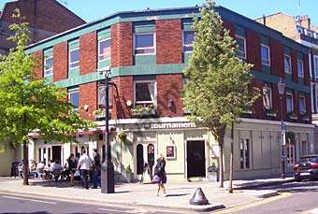
The Tournament
344, Old Brompton Rd, London, SW5 9JU, Tel: 08721 077 077
Tube: West Brompton (0 miles), Earl's Court (0.3 miles), Fulham Broadway (0.5 miles)
(or may be even closer if there is another entrance …!)

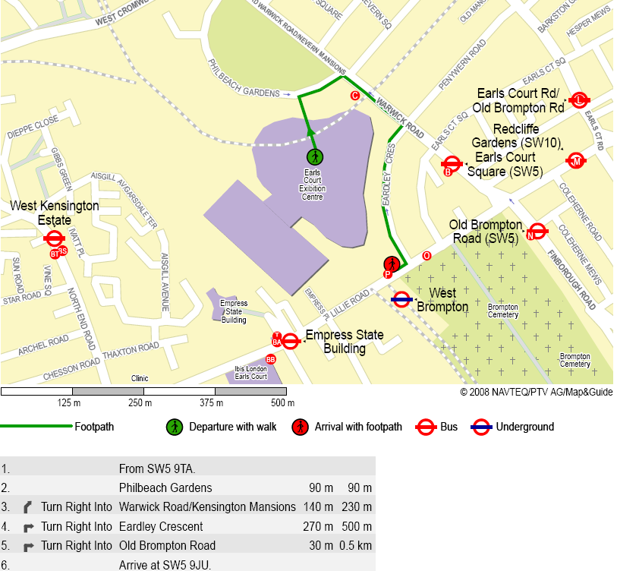
The Tournament

