  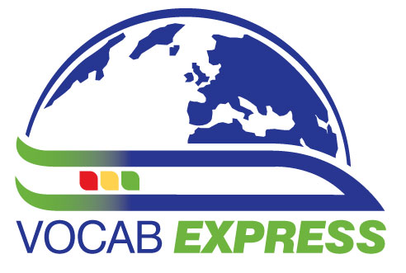   | You are invited to  The London Show & Tell followed by a ‘Social’  -a FREE event-  on
Saturday October 20th 2012,
Show & Tell: 4.45 – 5.45 – The Language Show – National Hall, Olympia, Kensington
Social: 6 p.m. until whenever you like! -
Pub address: Down the Albion, 121 Hammersmith Road, W14 0QL, Tel: 020 7603 2826 www.downthealbion.com
Tube: Baron's Court (District & Piccadilly Line) – approx 5 minute walk;
Station: Kensington Olympia (9 mins walk)
Plan your journey by visiting www.tfl.gov.uk/journeyplanner or call 0843 222 1234 for up-to-date travel news
See overleaf for map

The Language Show http://www.languageshowconnect.co.uk/lslive attracts many people from all over the country, including many teachers. It is free and this year it is being held at National Hall, Olympia from Friday 19th October to Sunday 21st October 2012.

It seems a nice opportunity to meet up informally, so we are supporting Joe Dale and Helen Myers as they host a Show and Tell during the show (Saturday 4.45 – 5.45). During this session, you can offer to come to the front and share a teaching tip for a few minutes. If you need to show anything via the laptop, please bring it on a stick or bring a web address, preferably uploaded beforehand on the wiki:
http://mflresources.pbworks.com/London-Show-and-Tell

We know that language teachers like to carry on talking and people may just want to have somewhere to go for a quick drink and a chat before they hit the town (or the train home) later, so we have organised a social event straight afterwards, taking place in a pub very near to the exhibition venue.
You don’t have to come to both events, but please try to!

Information is also available on the ALL London website: www.all-london.org.uk

Provisional Outline Programme
[1000-1800] | The London Language Show, Olympia 2, Hammersmith Road, London W14 8UX. http://www.languageshowconnect.co.uk/lslive
1800 onwards | Gather at Pub
1800 – whenever you like | Social, Eat, drink and socialise – Quizzes with prizes -  Bar and food available ..thanks to Edexcel for sponsoring food and Vocab Express who is paying for your first drinkl!

☺ COME ALONE, OR BRING YOUR ‘TEAM’ ... YOU WILL ALL BE WELCOME! ☺
Down the Albion, 121 Hammersmith Road, W14 0QL, Tel: 020 7603 2826 www.downthealbion.com
Tube: Baron's Court (District & Piccadilly Line) – approx 5 minute walk
Station: Kensington Olympia (9 mins walk)

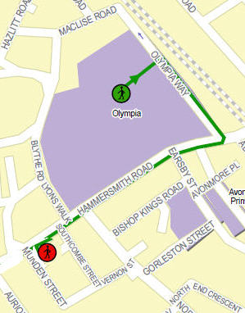
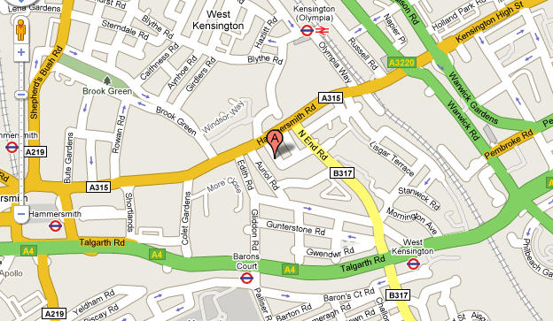
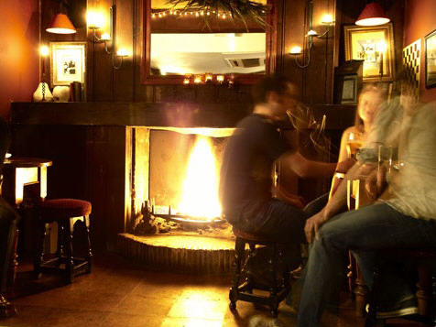
The Albion

