ALL Spanish Committee in collaboration with the
Consejería de Educación, Embajada de España

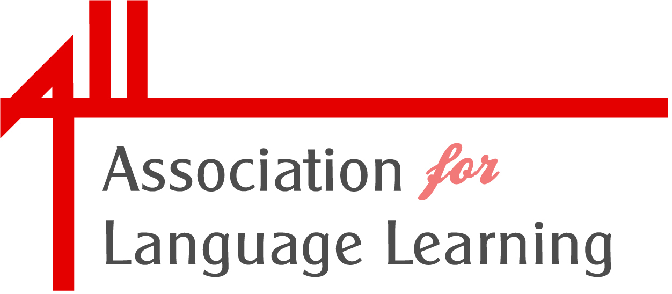
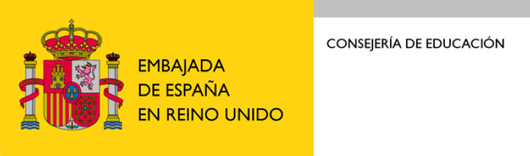
PRESENTS

SPANISH ONLINE QUIZ 2009
A language and cultural quiz about Spain and Latin America

Prizes donated by:
Consejería De Educación, Embajada De España, BBC Active Languages, AQA, Taylor & Francis

- The quiz will be open for 24 hours from 17.00 on Thursday 3 December

- To enter go to the ALL or Consejería de Educación website:

www.all-languages.org.uk
www.educacion.es/exterior/uk

- Individuals may enter at one level only, either;
KS4 – GCSE
Or
KS5 – AS/A2

- Deadline for entries is 17.00 on Friday 4 December.

Please see Conditions of Entry on websites for full entry details

PRIZES:
Individual prizes and whole school prizes for best participating schools.

