 | ASSOCIATION FOR LANGUAGE LEARNING  LONDON REGION BRANCH  www.all-london.org.uk

INFORMATION

What is a Webinar Room?

This is ‘virtual meeting’ room (see the screenshot below – kindly taken by our very own Joe Dale!!) which could be used for a variety of purposes e.g. networking, discussion, sharing good practice.
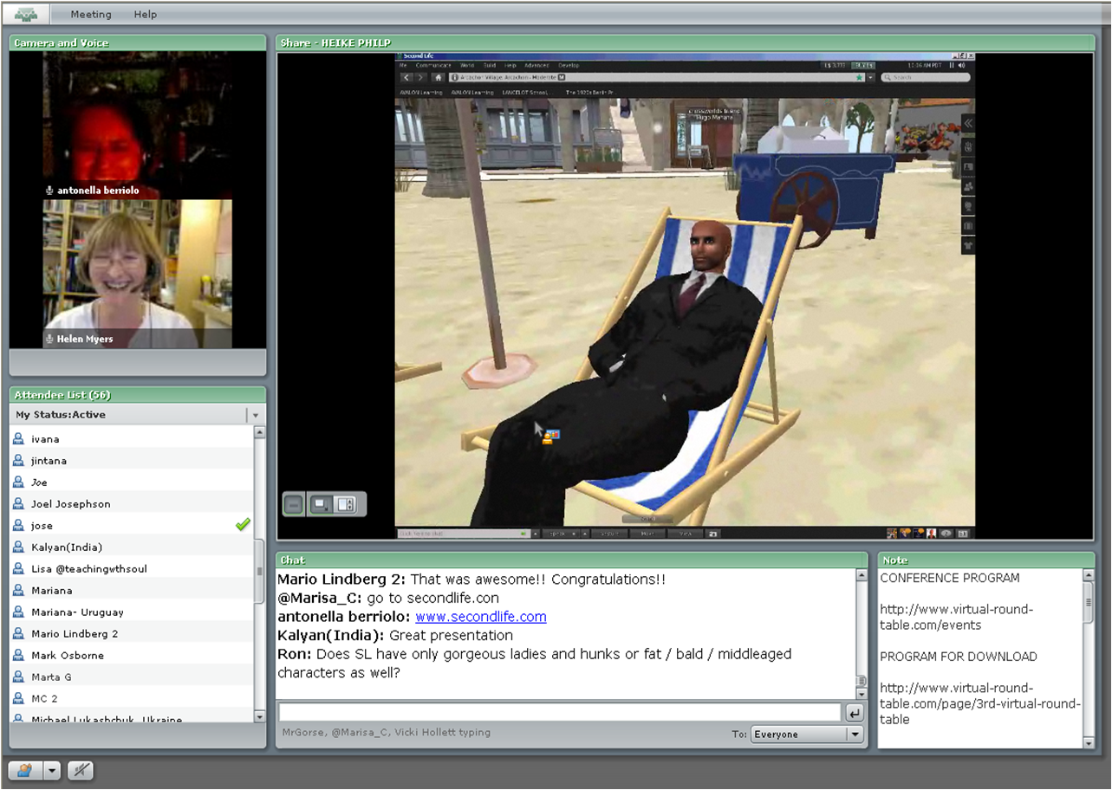
All YOU need to take part is
- a computer,
- an Internet Browser, (any type e.g. Internet Explorer, Google Chrome)
- Adobe Flash version 8 installed on your computer. (This is free to install).

This will enable you to see and hear the presenter, ‘text chat’ to others and use ‘emoticons’ to show your status (agree / disagree / laugh / applaud etc).

(ALL London has acquired an Adobe subscription .. YOU do not need the program)

EXTRA
We want to stress that you can be totally passive in this session .. you can just sit back and ‘watch’ with no pressure at all!

However .. after the presentation, you may wish to get more involved … and then the presenter can “allow” you to speak using your microphone or your webcam .. you choose!

- If you want to speak, you ideally need an integrated headset (a microphone attached to the headset) as this is the most reliable way of ensuring that there is no ‘feedback’ to other participants.
- If you want to show us your face, you need a webcam

PREPARATION AND TESTING IN ADVANCE

We strongly advise that you make sure that you can access the room in advance of the meeting, and times are given when we will be ‘on hand’ to help you.

Please accept our apologies in advance that we may not be able to help you out during the meeting itself.

There is a series of downloads and videos to tell you more about ‘Adobe Connect’ .. links below:

Jumpstart for participants
http://tv.adobe.com/watch/learn-adobe-connect-8/adobe-connect-8-jumpstart-for-participants/

Attending a meeting
http://tv.adobe.com/watch/learn-adobe-connect-8/attending-a-meeting/
(1 minute 30 seconds)

OUR ETIQUETTE
The overall ethos of this group is very similar to that of the Yahoo mflresources forum.
PURPOSE
The purpose of this group is for language professionals to share ideas and resources relating to teaching languages in a relaxed, friendly and supportive environment.
See separate document for a slightly adapted version of the alphabetically ordered ‘guidelines’ given for that forum, drawn from an example given on another Yahoo forum. On the whole the main difference is to use the word ‘contributions’ rather than ‘messages’.
We would draw your attention to the specific points arising from the very nature of a Webinar room. The most important relates to the use of ‘chat’.

Etiquette for use of the chat pod during ‘Presentations’
When people are presenting, please feel free to make relevant comments e.g. encouraging / agreeing / confirming / providing extra information.

If you have questions, please write them in the Q/A ‘pod’ .. this is an efficient way of collecting them so that the presenter can look at them after the presentation, and avoids the need to repeat.

Wherever possible please try not to start a separate conversation / strand, as this can be distracting for the presenter and the other participants. You can use ‘private chat’ to address comments to individuals or ‘park’ your question in the Q/A pod.

Please do not assume that the presenter will be looking at the chat and please do not be offended if you seem to be ignored ‘during’ the chat. In order to help them keep their ‘flow’ and keep to time, presenters will often choose to carry on the presentation and answer questions afterwards, especially if they are new to this format of presentation. Thanks for your understanding and please feel free to make further suggestions to us! This is a new venture!

