

Did you know that there is a friendly and lively Association that has been set up specifically for teachers of languages?

With around 6,000 members across the country, through ALL you can meet others teaching your language, get involved with local branches or national language committees, and attend the brilliant annual Language World Conference ~ a weekend packed with practical and inspirational workshops from the best in the profession.

ALL is the one national teachers' association for all ages, sectors and languages. Come and join us!

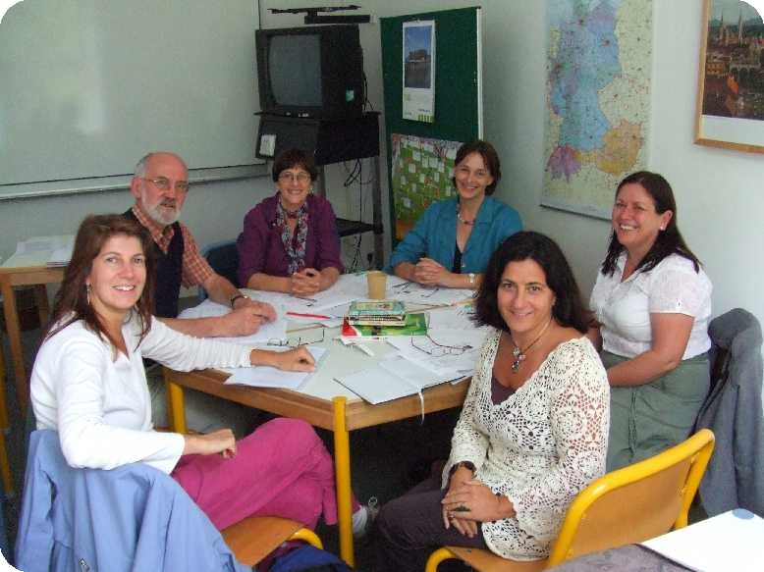
Find out more on
www.all-languages.org.uk or email SheilaJ@ALL-languages.org.uk
for an application form.

Like to chat to a current member before deciding? Phone 01788 546 443 and we will arrange for someone to phone you back.

Association for Langage Learning
University of Leicester
University Road
LEICESTER LE1 7RH
 0116 229 7453

 info@ALL-languages.org.uk

Associate membership for 2007-2008
Free

The Association for Language Learning is very pleased to offer once more FREE Associate Membership to trainee MFL teachers on PGCE, GTP or equivalent courses (as well as to NQTs).

The offer last year proved extremely popular, connecting hundreds of young teachers with their community, especially through the weekly ALLnet e-mail update.

Associates also get special rates at local and national events and offers from the ALL corporate members (e.g. the publishers).

To register, use the simple form on the home page of the ALL website:
www.ALL-languages.org.uk

or complete the form available this evening and hand it in to us.

Note: If you wish also to receive ALL journals and to be eligible for the ALL committees you should take out individual membership instead at a special rate, through the website Membership area.

Many thanks

Steven Fawkes
Membership Officer, ALL
stevenf@ALL-languages.org.uk

