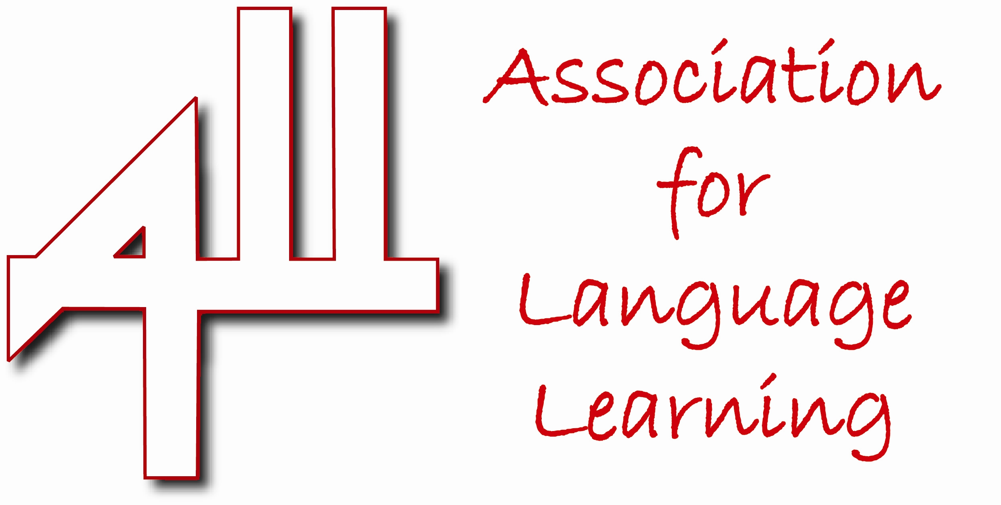

Five good reasons to join us in the Association for Language Learning:
- Keep up to date: high quality publications, a specialist website, an e-mail update, local, regional and national events, and personal contacts.
- Evidence professional standards: updating your subject knowledge helps you to evidence the TDA professional standards and enhance your threshold application.
- Get high quality professional development & networking opportunities: including regional events and the much acclaimed annual Language World conference. Meet like-minded professionals at Branch or Network events and benefit from targeted professional development.
- Make your voice heard in policy making: have your say! Take part in government consultations and contribute to advice and discussion on proposed changes.
- Save money: benefit as a member from discounts on conference rates and publications, and special offers from publisher members of ALL. Your ALL individual membership fee is tax deductible!

