This was the first year of the new GCSE specifications and especially the new arrangements for the speaking exam reflecting the recommendations of the Dearing Review in 2006.

The new speaking exams were designed to enable candidates to show better what they could achieve. The hope had been that these changes would increase both the numbers entering, and the numbers gaining higher grades as they had had more opportunity to meet the criteria.

Sadly, this has not been the case either in terms of numbers or of the grades obtained.

The numbers entered for modern languages has shown a further decline, with French declining from 177860 entries in 2010 to 154,221 in 2011 – a drop of 13% (German 70,174 to 60,887, 13%; Spanish 67,778 to 66,021, 3%). The pattern is the same in England as in the UK as a whole. French and German are now under half of the numbers entered in 2002

An unexpected factor in the figures released by JCQ is the drop in A* grades in French, German and Spanish in both percentages and actual numbers. This drop is deeply concerning.

 | % A* grades 2010 | % A* grades 2011 | number A* grades 2010 | number A* grades 2011
French | 10.8 | 10.1 | 17,635 | 14,289
German | 9.4 | 8.9 | 6,306 | 5,196
Spanish | 16.3 | 14.8 | 10,201 | 8,994

The year-on-year increase in the percentage of candidates gaining A*-C has steadied (French 71.6% to 72.1%, German 75.0% to 75.7%, Spanish 74.6 to 74.2%). There had been a steady rise as a consequence of the dramatic drop in the number of lower-attaining pupils being entered, but the cohort profile would now appear to be similar in 2010 and 2011 (but we will not get the figures to confirm this until late in the Autumn Term)

Colleagues may be interested in the subject matrices available on the Ofsted website in the Library which give the numbers of pupils attaining each GCSE grade from a given KS2 level, which is very helpful in taking account of the different cohort ability profile in individual schools
https://www.raiseonline.org/documentlibrary/ViewDocumentLibrary.aspx > Target-setting>Transition matrices for KS2 to 4
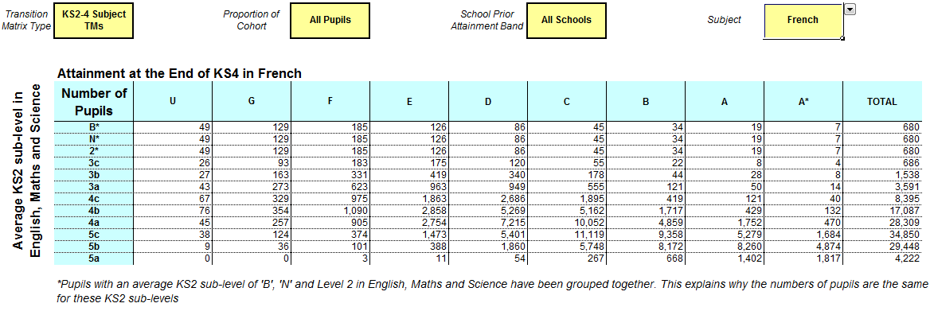

These subject matrices also confirm the significant extent of severe grading in modern languages, reported in the QCA report in February 2008. The changes recommended by Dearing have now been implemented with the exception of bringing the grading for modern languages into line with other traditional academic subjects; these figures show that the Government must now act to create a level playing field for modern language pupils and teachers.

