29-Sep-13

GCSE ML numbers and grades - Sept 2013
Documents and spreadsheets relating to “severe grading” are at the ALL London website: www.all-london.org.uk/severe_grading.htm ASCL, ALL (Association for Language Learning) and ISMLA (Independent Schools Modern Language Association) have worked closely together on these matters which affect state and independent sectors
Notes: Statistics in this paper are based on the JCQ tables for 'England' issued each August.
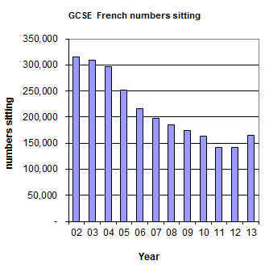

GCSE numbers
- The English Baccalaureate (EBacc) was announced in Jan '11 so its first main effect was on those pupils choosing options in Year 9 in Spring 2011, with the GCSE course starting in Sept ’11 and taking exam in Jun '13.
The combined Hi+Ge numbers jumped by 19%
from 372,598 in 2012 to 443,425 in 2013
(above the 396,723 on 2007), and
the combined Fr+Gn+Sp numbers jumped by 18% from 263,918 in 2012 to 311,730 in 2013,
(but still below 334,566 in 2007)

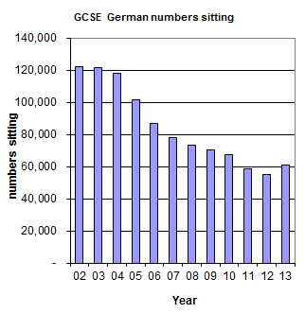
- From 2002-12, there was a steady decline in the total numbers taking GCSE Modern Languages, with sharp declines for the exams taken in June 2004 - 06; as a result, the numbers are around half of those in 2002

- The overall pattern of decline is similar for French and German (just different starting levels) up to and including 2010, but in 2011 and 2012 French stabilised whilst German continued to decline.

- Numbers in French increased by 17% from 2012 to 2013 and are now roughly the same as they were in 2010. German in 2013 saw an increase of 10% on 2012. Although the 2013 numbers are slightly up from 2011, they have not recovered the levels of 2010.

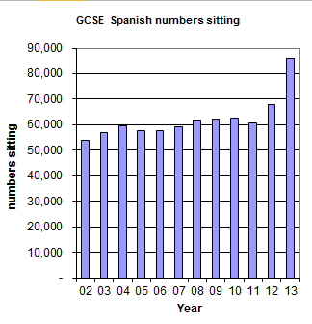
- There was a dramatic increase of 27% in entries in Spanish in 2013 compared with 2012. In 2011, both Spanish and German had approx 60,000 entries, but Spanish has jumped to 86,000 by 2013. The numbers taking Spanish and some other languages (with many native speakers) increased since 2002 (increase in Spanish = 32,000), but are far outweighed by the decline in French and German.

- There will be many theories about this variation amongst languages in response to the EBacc announcement, and it will be of interest to get more detailed analysis whether through "Language Trends" or when the full Performance Tables are published by the DfE in January 2014 .

GCSE grading and numbers including A*-C and D-U
- The decline in numbers over the years has been particularly marked in lower-attaining pupils at GCSE
e.g. in 2002 165,412 gained A*-C and 149,659 gained D-U, (nearly equal split)
but in 2011 102,001 gained A*-C (i.e. 62% of ’02), 39,471 gained D-U (i.e. 26% of ’02))
(over twice as many A*-C as D-U) [nos. in French – similar Gn]

- The change in the intake profile for GCSE from 2002 to 2010 has led to an increased percentage of entries getting higher grades, but there is an unresolved question as to whether the increase was great enough to match the increased ability profile of the students.

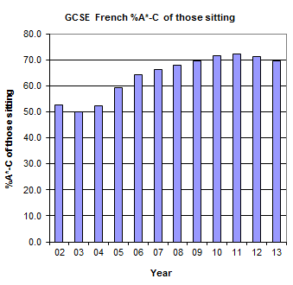
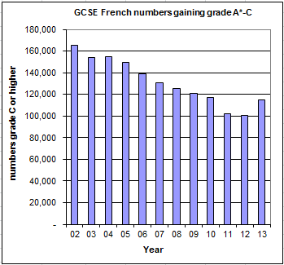
French
In 2013 the percentage of A*-C has dropped, and is lower than in 2010, BUT the number getting A*-C has increased.

There are noticeably more D-Us, even when compared against 2010
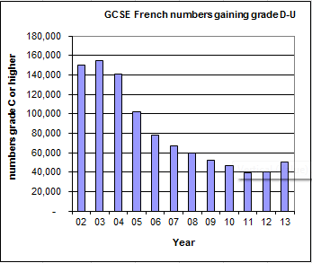
The existence of Severe Grading in Modern Languages is now well-established but we want to be confident that the situation has not worsened. We will need to wait until the prior attainment information is published in early December to see how these apparently conflicting statistics can be reconciled. There is naturally a variation every year at a school-to-school level, and it is always difficult to establish a general picture from individual cases, so we must wait for the national picture.

More detail in French
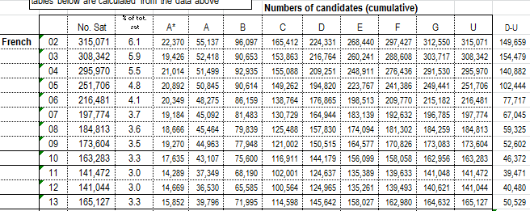
The complex pattern within grades between 2010 and 2013 is clear in the A-Cs in French. Look at the cumulative numbers getting each grade. (e.g. A* 2010: 17,635 2013: 15,852, whereas cumulative A*-C is virtually the same)

Note that border lines are decided for A/B, C/D and F/G and other grades are extrapolated from these. As a result, if a C/D borderline is changed, this will have an inverse effect on the number of A*s. This was highlighted when the Welsh government said in August 2012 that the C/D borderline in GCSE English had to be changed in order to allow more candidates to gain a C grade. This led to an automatic drop in A* (requiring exceptional action for affected candidates)!!!

Across the board, the cumulative percentage getting each individual grade above C is approximately down 2% between 2010 and 2013

Note that in 2012, numbers stabilised in French and increased in Spanish. .

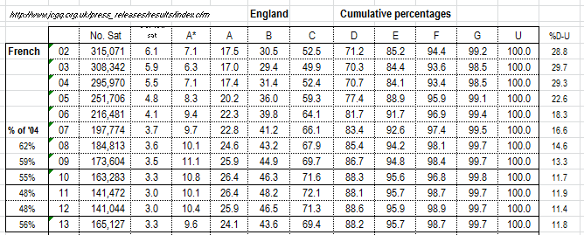
The rise of 2% in the cumulative % at grade F, shows that even fewer candidates were being entered and gaining grades F & G.

In 2010 and before, candidates who could have gained a C grade had been allowed to drop the subject, but with EBacc measure, schools and parents encouraged more pupils who could get a C grade to take the subject. By and large, the increased number represents the number who had dropped the subject since 2008 (those who could gain a C grade). The EBacc did not give an incentive to candidates unlikely to reach a C grade to take the subject.

Within the broad picture, we have a certain concern that not quite enough candidates have been awarded the A* to C grades. The figure should probably be at least 1% higher. This is on top of the already-acknowledged severe grading in 2010 and before.

German
There was a sharp drop in overall numbers from 2010 to 2011, small drop to 2012 and then a rise in 2013 to around the level of 2011, but well below the level of 2010 and before.

Interestingly, between 2010 and 2013, the cumulative percentage for A*-C remained constant at around 75%, although within that there are fluctuations of nearly 2% up and down at grades A and B.

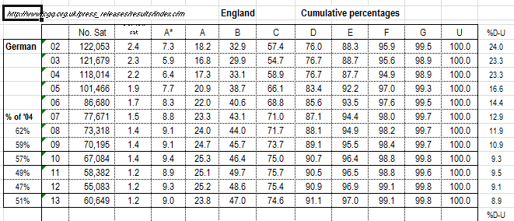
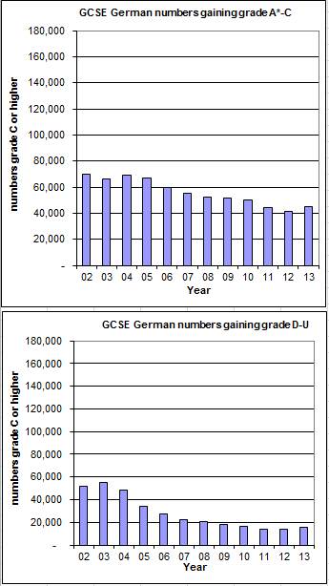
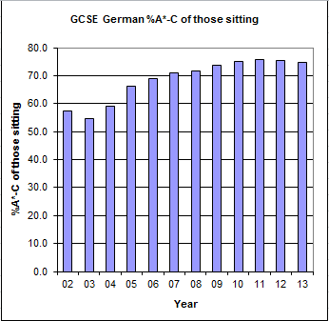

Because the %A*-C has remained reasonably constant between 2010 and 2013, the numbers getting A*-C and D-U have fallen and risen in line with the fall and rise in the overall numbers sitting German

However, the difference in pattern between German and French needs to be investigated, and we need to be confident as to why there was not an increase in the %A*-C and higher grades as the numbers sitting fell.

Note that the graphs of numbers gaining A*-C and D-U in French, German and Spanish all have the same vertical scale (up to 180,000) to enable valid comparison to be drawn.

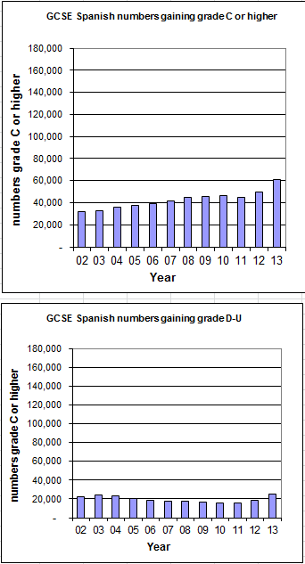
Spanish

There was a dramatic increase in entries in Spanish in 2013 compared with 2012. In 2011, both Spanish and German had approx 60,000 entries, but Spanish has jumped to 86,000 by 2013.
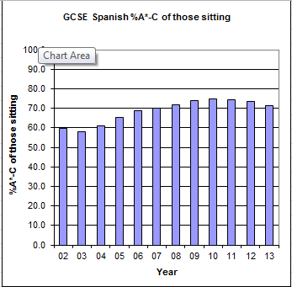
However, the %A*-C dropped from 75% in 2010 to 71% in 2013. Even so, the total numbers gaining A*-C in Spanish rose from 46,685 to 61,199. The changing percentages appear to be reasonably evenly spread across the grades.

