# *with other board boundaries added + feedback from MM - v4b - 22-Aug-14*

# ML AL grade boundaries for June 2014 and impact on A*

This is written further to the JCQ report on ML AL and A* (July 2014)

*http://www.jcq.org.uk/media-centre/news-releases*

* [A review of Modern Foreign Languages at A level: A* grade and low take up](http://www.jcq.org.uk/media-centre/news-releases/mfl-review-press-notice)

which included analysis of the 2013 (and previous) results for several Awarding Organisations (referred to here as "exam boards"). The JCQ Report is extremely thorough and detailed and repays careful study. This paper looks at the ML AL grade boundaries for 2014 and compares them with 2013. It also explains the way grade boundaries and A* grades are defined and allocated, and how that affects ML in particular.

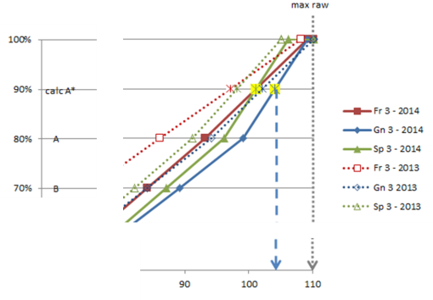

**AQA**

## Summary regarding 2014 boundaries

* 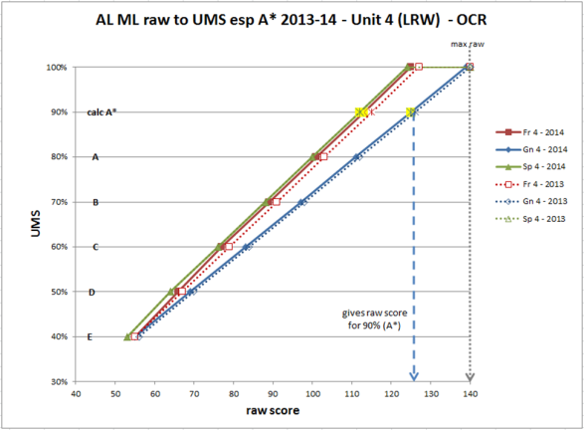The AQA boundaries in Unit 3 (Listening, Reading & Writing, worth 140 UMS of 200) have seen a significant movement in all three ML with higher raw marks required (e.g. 105/110 for German for A*), which is likely to exacerbate the issues raised in the JCQ report. There is also variation between the three ML.
* OCR boundaries have remained very similar, but the raw marks required for German are higher than those for French and Spanish.
* Edexcel has a different pattern of assessment (note JCQ report comments of the differences); the boundaries have changed slightly. There is quite a variation between the three ML which differs for Unit 3 (Understanding and Spoken - 70/200) and Unit4 (Written - 130/200)

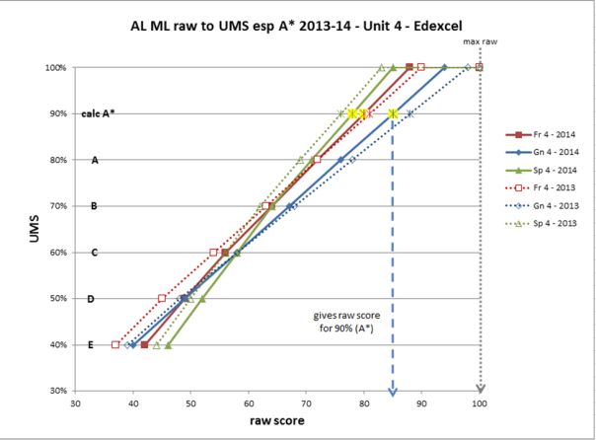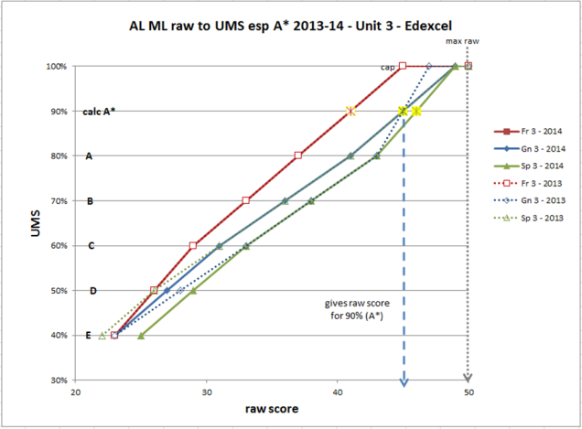

## Definition of A*

In A-level, grade A* is awarded to students achieving grade A overall and 90 per cent or more of the maximum uniform mark on the aggregate of the A2 units. For example, in a four unit qualification, grade A* is awarded to students achieving at least 320 uniform marks on the A-level overall and at least 180 uniform marks on the sum of the two A2 units. The A* is not awarded for individual units or for the AS Level.

## Assigning grade boundaries

For each Unit, the examiners set by judgement ("judgemental boundary") which raw mark will be the A/B and the E/U boundary, and these are always assigned a UMS score of 80% and 40% respectively of the maximum UMS for the Unit. The other grade boundaries (B/C, C/D, D/E) are then CALCULATED by interpolation and are assigned UMS of 70%, 60% and 50%. Thus each raw score is converted to a UMS.

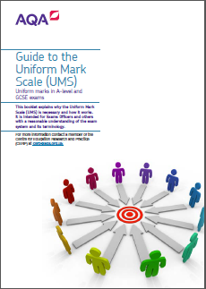Note that there is not a grade boundary for A* *per se* for individual units because it is only calculated on the A2 units combined. However, the exam boards calculate a *de facto* A*/A boundary (called a*) for each unit (at 90%), by a process of extrapolation, which can become complicated. AQA (and other exam boards) provide an online spreadsheet to help calculate the UMS score from a raw mark for any module,

<http://www.aqa.org.uk/exams-administration/about-results/uniform-mark-scale/convert-marks-to-ums>

as well as a detailed pamphlet with technical details http://store.aqa.org.uk/over/stat_pdf/UNIFORMMARKS-LEAFLET.PDF.

- see the AQA pamphlet for details (p.6 and Section 5) for details re A* incl the definition of the "cap".

OCR give a* boundaries

<http://www.ocr.org.uk/Images/176557-a2-units-showing-90-percent-conversion-points-june-2014.pdf>

Edexcel give a* boundaries and a spreadsheet

<http://www.edexcel.com/i-am-a/student/results/pages/convert-your-marks.aspx>

<http://pastpapers.edexcel.com/content/dam/pdf/Support/Grade-boundaries/A-level/1406_GCE_A_level_Grade_Boundaries.pdf>

WJEC publish boundaries

<https://www.wjecservices.co.uk/MarkToUMS/default.aspx>

5. Notional N, the A* conversion point and the ‘cap’ (from AQA pamphlet)

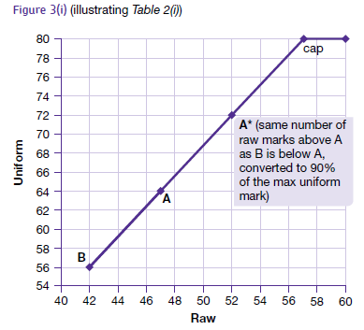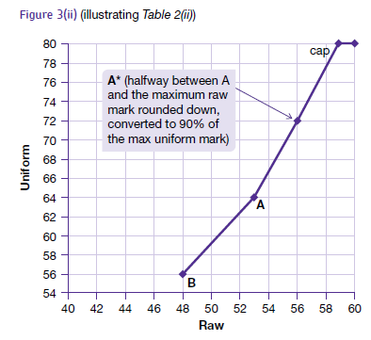"There is also a conversion point above the highest available grade called the ‘cap’ and in A2 units there is an A* conversion point. Notional N and the cap (and, in A2 units, notional A*) are used to ensure that, on conversion to uniform marks, raw marks have the same value just above and just below the boundary for both the highest available grade and the lowest available grade. When using the cap, a student with a raw mark below the maximum may sometimes obtain the maximum uniform mark."

5.2. Calculating notional A* and the cap in an A2 unit

(i) Where the mark width from the A raw mark boundary to the maximum is more than twice that from A to B, the A* conversion point is normally the same amount above A as B is below A.

(ii) Where the mark width from the A raw mark boundary to the maximum is less than or equal to twice that from A to B, the A* conversion point is normally halfway between A and the maximum raw mark. This is rounded down, where necessary, to the nearest whole number below (eg 78 ½ is rounded to 78).

(iii) The (raw mark) A* conversion point may be adjusted following a review of statistical and technical evidence.

(iv) The cap is the same number of raw marks above A* as A is below A*. This is converted to the maximum uniform mark for the unit. The A* conversion point is converted to 90% of the maximum uniform mark.

### Grade boundaries from year to year

It is appropriate that the grade boundaries for the Oral (Units 2 & 4) in AQA should be the same and stay the same as the "task" is the same each year and the assessment criteria / mark scheme the same. Equally it is appropriate that the grade boundaries in the AQA Written (+L+S) (Units 1 &3) should vary slightly from year to year and language to language as the questions will vary slightly from year to year and language to language.

## Marks at AS and at A2

In Chapter 4 - Assessment Instruments and Script Analysis of the JCQ Review - Section 1 Introduction (pp2-3), there are some striking graphs reproduced from Sutch and Wilson 2013:

This investigation focuses upon A2 assessments only. The reason for this is, as reported in Chapter 3, it appears that MFL candidates tend to gain fewer A2 UMS than AS UMS. Without at least 180 UMS from A2, it is not possible to gain an A*. Figure 1 below, (a colour reproduction of a figure from Sutch and Wilson, 2013) illustrates the AS to A2 relationship for five subjects. Candidates on or around the diagonal identity line have similar UMS from AS and A2. Those candidates above the line have more A2 UMS than AS; and those below have fewer A2 than AS UMS. We can clearly see that for both Art A-level and English Literature A-level candidates in particular, there is, generally, symmetry around the identity line. However, unlike other subjects, the French A-level candidates are not at all symmetrical as the vast majority of candidates are below the line, indicating fewer A2 UMS than AS UMS. The impact on the number of candidates reaching/qualifying for A* (crossing the lines in the upper right area in each graph) is conspicuous for French.



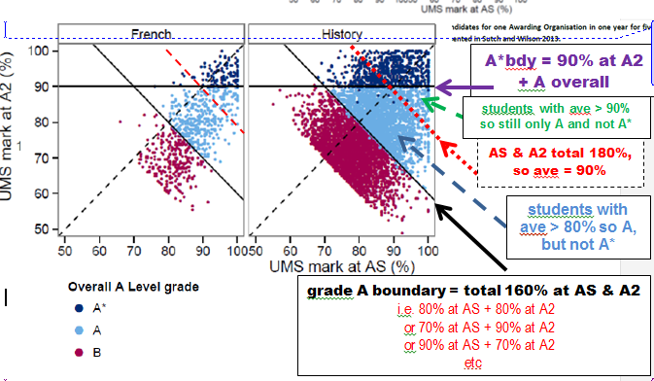

A2 UMS

> AS UMS

AS UMS

> A2 UMS

## AL ML and boundaries for 2013-14

AQA

For **AQA**, French, German and Spanish are four-unit A Level which have 400 UMS and four Units

AS: Unit 1: Listening, Reading and Writing (LRW) - max 140 UMS *(max 110 raw)*

Unit 2T: Oral (Centre Conducted) - externally marked - max 60 UMS *(max 50 raw)*

A2: Unit 3: Listening, Reading and Writing (LRW) - max 140 UMS *(max 110 raw)*

Unit 4T: Oral (Centre Conducted) - externally marked - max 60 UMS *(max 50 raw)*

Alternatively, the Oral can have an External Examiner, but the marks remain the same.

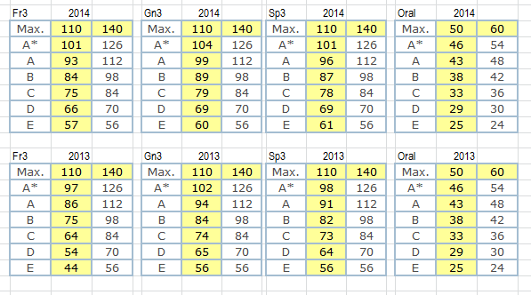

## AQA

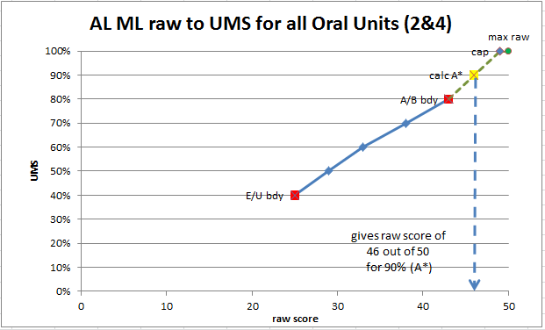

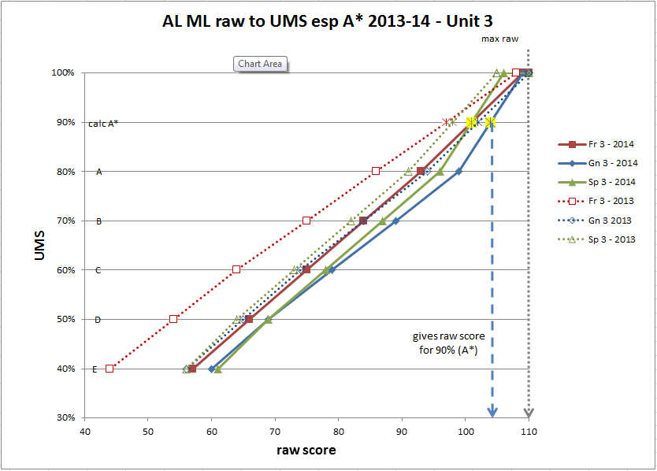

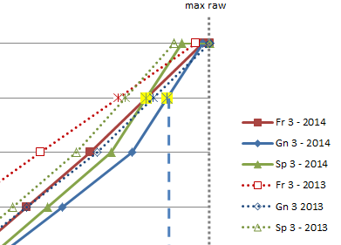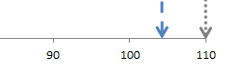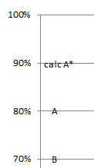

## AQA ML AL grade boundaries for June 2014

Note the difference between 2013 and 2014 for Unit 3 in Fr, Gn, Sp

French

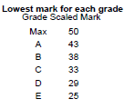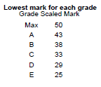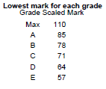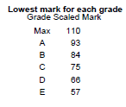

German

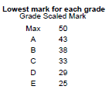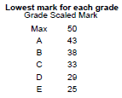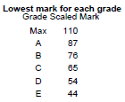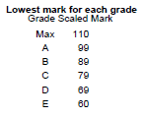

Spanish

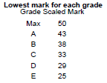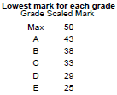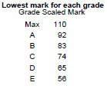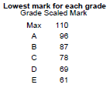

## June 2013

French 2013

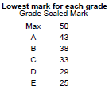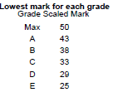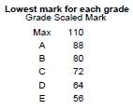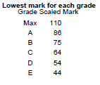

German 2013

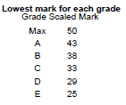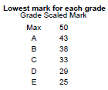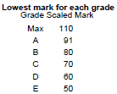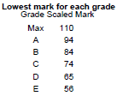

Spanish 2013

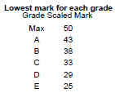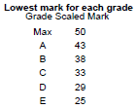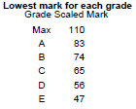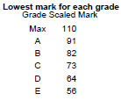

Statistics for all AQA Centres for June 2014

|  |  |  |  |
| --- | --- | --- | --- |
| **Unit** | **Max (Sca)** | **Mean** | **SD** |
| FREN1 GCE FRENCH UNIT 1 | 110 | 75.4 | 16.0 |
| FRE2T GCE FRENCH UNIT 2 CENTRE COND. ORAL | 50 | 40.9 | 6.8 |
| FREN3 GCE FRENCH UNIT 3 | 110 | 79.4 | 13.7 |
| FRE4T GCE FRENCH UNIT 4 CENTRE COND. ORAL | 50 | 40.7 | 6.3 |
|  |  |  |  |
| GERM1 GCE GERMAN UNIT 1 | 110 | 73.6 | 21.4 |
| GER2T GCE GERMAN UNIT 2 CENTRE COND. ORAL | 50 | 40.7 | 7.1 |
| GERM3 GCE GERMAN UNIT 3 | 110 | 83.2 | 15.9 |
| GER4T GCE GERMAN UNIT 4 CENTRE COND. ORAL | 50 | 40.6 | 6.6 |
|  |  |  |  |
| SPAN1 GCE SPANISH UNIT 1 | 110 | 79.8 | 16.5 |
| SPA2T GCE SPANISH UNIT 2 CENTRE COND. ORAL | 50 | 40.9 | 6.5 |
| SPAN3 GCE SPANISH UNIT 3 | 110 | 84.4 | 13.1 |
| SPA4T GCE SPANISH UNIT 4 CENTRE COND. ORAL | 50 | 39.8 | 5.9 |

Statistics for all AQA Centres for June 2013

|  |  |  |  |
| --- | --- | --- | --- |
| **Unit** | **Max (Sca)** | **Mean** | **SD** |
|  |  |  |  |
| FREN1 GCE FRENCH UNIT 1 | 110 | 76.7 | 17.0 |
| FRE2T GCE FRENCH UNIT 2 CENTRE COND. ORAL | 50 | 40.0 | 6.9 |
| FREN3 GCE FRENCH UNIT 3 | 110 | 72.4 | 15.9 |
| FRE4T GCE FRENCH UNIT 4 CENTRE COND. ORAL | 50 | 39.8 | 6.3 |
|  |  |  |  |
| GERM1 GCE GERMAN UNIT 1 | 110 | 77.6 | 18.6 |
| GER2T GCE GERMAN UNIT 2 CENTRE COND. ORAL | 50 | 39.8 | 7.1 |
| GERM3 GCE GERMAN UNIT 3 | 110 | 80.5 | 15.9 |
| GER4T GCE GERMAN UNIT 4 CENTRE COND. ORAL | 50 | 39.5 | 7.1 |
|  |  |  |  |
| SPAN1 GCE SPANISH UNIT 1 | 110 | 70.6 | 18.2 |
| SPA2T GCE SPANISH UNIT 2 CENTRE COND. ORAL | 50 | 39.9 | 6.3 |
| SPAN3 GCE SPANISH UNIT 3 | 110 | 79.0 | 13.4 |
| SPA4T GCE SPANISH UNIT 4 CENTRE COND. ORAL | 50 | 39.3 | 6.3 |

OCR

F703

A 01 French: Speaking (A2) – Externally marked (OCR Repository)

B 02 French: Speaking (A2) – Externally marked (CD)

C 03 French: Speaking (A2) – Visiting examiner

(raw / 60), UMS / 60

F704 01 French: Listening, reading and writing 2 (A2)

raw / 140; UMS / 140

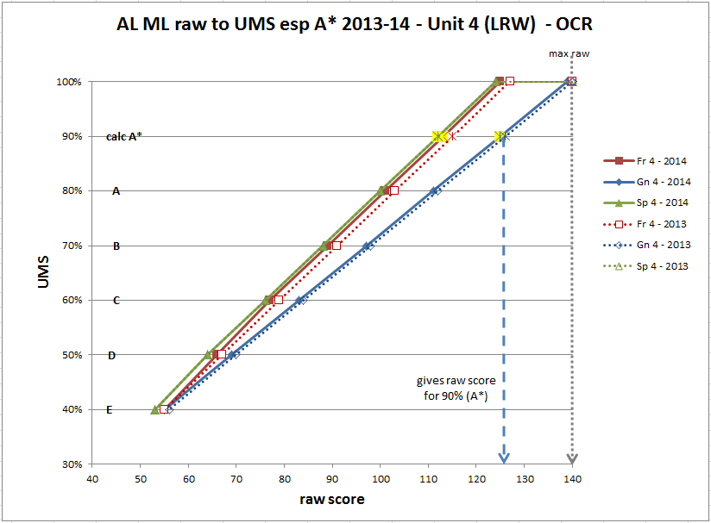

Listening, reading and writing 2 (A2) - Unit 4 Speaking / Oral (Unit 3)

|  |  |  |  |  |  |  |  |  |  |  |  |  |  |  |  |  |  |
| --- | --- | --- | --- | --- | --- | --- | --- | --- | --- | --- | --- | --- | --- | --- | --- | --- | --- |
|  |  | French |  |  |  | German |  |  |  | Spanish |  |  |  |  |  |  |  |
|  |  | F704 |  |  |  | F714 |  |  |  | F724 |  |  |  |  |  |  |  |
|  |  |  |  |  |  |  |  |  |  |  |  |  | French | |  | Germ | Span |
|  | **2014** | **2014** | **2014** |  | **2014** | **2014** | **2014** |  | **2014** | **2014** | **2014** |  | 2014 |  |  | 2014 | 2014 |
|  | **raw** | **% UMS** | **UMS** |  | **raw** | **% UMS** | **UMS** |  | **raw** | **% UMS** | **UMS** |  | **raw** | **% UMS** | **UMS** |  |  |
| Max | 140 | 100% | 140 |  | 140 | 100% | 140 |  | 140 | 100% | 140 |  | 60 | 100% | 60 | 60 |  |
| Max | 140 | 100% | 140 |  | 140 | 100% | 140 |  | 140 | 100% | 140 |  | 60 | 100% | 60 |  |  |
| cap | 125 | 100.0% | 140.0 |  | 139 | 100.0% | 140.0 |  | 124 | 100.0% | 140.0 |  | 57 | 100.0% | 60.00 |  |  |
| calc A* | 113 | 90% | 126 |  | 125 | 90% | 126 |  | 112 | 90% | 126 |  | 52 | 90% | 54 | 53 | 53 |
| A | 101 | 80% | 112 |  | 111 | 80% | 112 |  | 100 | 80% | 112 |  | 47 | 80% | 48 | 47 | 47 |
| B | 89 | 70% | 98 |  | 97 | 70% | 98 |  | 88 | 70% | 98 |  | 42 | 70% | 42 | 41 | 41 |
| C | 77 | 60% | 84 |  | 83 | 60% | 84 |  | 76 | 60% | 84 |  | 37 | 60% | 36 | 36 | 35 |
| D | 66 | 50% | 70 |  | 69 | 50% | 70 |  | 64 | 50% | 70 |  | 32 | 50% | 30 | 31 | 30 |
| E | 55 | 40% | 56 |  | 55 | 40% | 56 |  | 53 | 40% | 56 |  | 27 | 40% | 24 | 26 | 25 |
|  |  |  |  |  |  |  |  |  |  |  |  |  |  |  |  |  |  |
|  | French | F704 |  |  | Germ | F714 |  |  | Span | F724 |  |  |  |  |  |  |  |
|  |  |  |  |  |  |  |  |  |  |  |  |  | French | |  | Germ | Span |
|  | **2013** | **2013** | **2013** |  | **2013** | **2013** | **2013** |  | **2013** | **2013** | **2013** |  |  | t |  | 2013 | 2013 |
|  | **raw** | **% UMS** | **UMS** |  | **raw** | **% UMS** | **UMS** |  | **raw** | **% UMS** | **UMS** |  | **raw** | **% UMS** | **UMS** |  |  |
| Max | 140 | 100% | 140 |  | 140 | 100% | 140 |  | 140 | 100% | 140 |  | 60 | 100% | 60 |  |  |
| raw score giving 100% | 140 | 100% | 140 |  | 140 | 100% | 140 |  | 140 | 100% | 140 |  | 60 | 100% | 60 |  |  |
| cap | 127 | 100.0% | 140.00 |  | 140 | 100.0% | 140.00 |  | 124 | 100.0% | 140.00 |  | 56 | 100.0% | 60.00 |  |  |
| calc A* | 115 | 90% | 126 |  | 126 | 90% | 126 |  | 112 | 90% | 126 |  | 51 | 90% | 54 | 53 | 53 |
| A | 103 | 80% | 112 |  | 112 | 80% | 112 |  | 100 | 80% | 112 |  | 46 | 80% | 48 | 47 | 47 |
| B | 91 | 70% | 98 |  | 98 | 70% | 98 |  | 88 | 70% | 98 |  | 41 | 70% | 42 | 41 | 41 |
| C | 79 | 60% | 84 |  | 84 | 60% | 84 |  | 76 | 60% | 84 |  | 36 | 60% | 36 | 36 | 35 |
| D | 67 | 50% | 70 |  | 70 | 50% | 70 |  | 64 | 50% | 70 |  | 31 | 50% | 30 | 31 | 30 |
| E | 55 | 40% | 56 |  | 56 | 40% | 56 |  | 53 | 40% | 56 |  | 26 | 40% | 24 | 26 | 25 |

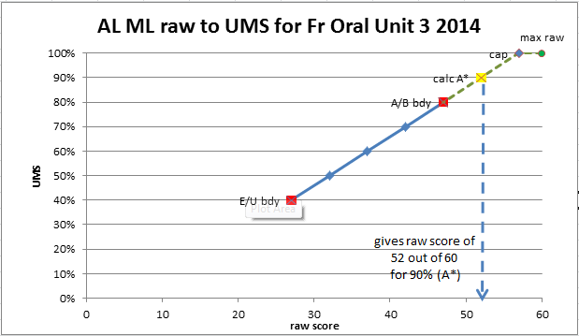

Edexcel

