圣诞节 快乐！
Christmas Happy!
来自
from
罗 德 尼
(luó = catch; dé = virtue; ní =Buddhist nun)
Rodney

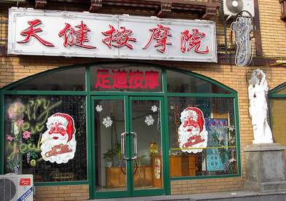

Heavenly Healthy Massage House
Foot Acupuncture Point Massage

